

Sport
300/330/360/390/420/460/520/560/650/700/800

Owner’s Manual
Manuel du Propriétaire
Manual del propietario
Handbuch für Schiffsführer

Before operating your boat, please read this manual carefully
Avant d'utiliser votre bateau, veuillez lire attentivement ce manuel
Lea atentamente este manual antes de utilizar su embarcación.
Lesen Sie vor der Nutzung Ihres Bootes bitte sorgfältig dieses Handbuch.

PLEASE KEEP THIS MANUAL IN A SECURE PLACE, AND HAND IT OVER TO THE NEW OWNER WHEN YOU SELL THE BOAT.

Content

General Introduction 3
Safety alerts 4
Safe Boating Recommendations 4
Pre-operation check list 5
Specifications: Sport300-460 6
General Arrangement 6
Specifications: Sport520-800 7
General Arrangement 7
Recommended Seating Arrangement 10
Recommended Seating Arrangement 11
Builder’s Plate: 12
Fuel System 14
Information connected with the risk of flooding and stability 14
Information connected with the risk of fire or explosion 17
Electrical Systems 19
Transporting 21
Engine Start 21
Operation 22
Man-overboard prevention and recovery 25
Maintenance 26
Warranty 29
Service assistance 30

To ensure that you gain maximum satisfaction from your Highfield boat, please read this Owner’s Manual carefully. It contains all the safety and operation instructions that you need to get the most out of your new Highfield.

General Introduction
This manual has been compiled to help you to operate your boat with safety and pleasure. It contains details of the boat; the equipment supplied or fitted; its systems and information on their operation. Please read it carefully, and familiarize yourself with the boat before using it.
This owner's manual is not a course on boating safety or seamanship. If this is your first boat, or if you are changing to a type of boat you are not familiar with, for your own comfort and safety, please ensure that you obtain handling and operating experience before “assuming command” of the boat. Your dealer or national sailing federation or yacht club will be pleased to advise you of local sea schools, or competent instructors.
Ensure that the anticipated wind and sea conditions will correspond to the design category of your boat, and that you and your crew are able to handle the boat in these conditions.
Even when your boat is categorized for them, the sea and wind conditions corresponding to the design categories A, B and C range from severe storm conditions for category A, to strong conditions for the top of category C, open to the hazards of a freak wave or gust. These are therefore dangerous conditions, where only a competent, fit and trained crew using a well maintained boat can satisfactorily operate.
This owner's manual is not a detailed maintenance or trouble-shooting guide. In the case of difficulty, refer to the boat builder or his representative. If a maintenance manual is provided, use it for the boat's maintenance.
Always use trained and competent people for maintenance, fixing or modifications. Modifications that may affect the safety characteristics of the boat shall be assessed, executed and documented by competent people. The boat builder cannot be held responsible for modifications that he has not approved.
In some countries, a driving license or authorization is required, or specific regulations are in force.
Always maintain your boat properly and make allowance for the deterioration that will occur in time and as a result of heavy use or misuse of the boat.
Any boat, no matter how strong it may be, can be severely damaged if not used properly. This is not compatible with safe boating. Always adjust the speed and direction of the boat to sea conditions.
If your boat is fitted with a life raft, carefully read its operating manual. The boat should have onboard the appropriate safety equipment (lifejackets, harness, etc.) according to the type of boat, weather conditions, etc. This equipment is mandatory in some countries. The crew should be familiar with the use of all safety equipment and emergency maneuvering (man overboard recovery, towing, etc.), sailing schools and clubs regularly organize drill sessions.
All persons should wear a suitable buoyancy aid (life jacket/personal floatation device) when on deck. Note that, in some countries, it is a legal requirement to wear a buoyancy aid that complies with their national regulations at all times.

Safety alerts
This manual uses the following safety alerts to draw your attention to special safety instructions that should be followed.
Degree of hazard and corresponding safety labels:
Danger
Denotes that an extreme intrinsic hazard exists which would result in high probability of death or irreparable injury if proper precautions are not taken.

Warning
Denotes that a hazard exists which can result in injury or death if proper precautions are not taken.

Caution
Denotes a reminder of safety practices or directs attention to unsafe practices which could result in personal injury or damage to the craft or components or to the environment.

Safe Boating Recommendations
- Always wear a life jacket
Local authorities require that you carry an approved personal flotation device, or life jacket, for each person aboard your vessel. We recommend wearing a life jacket at all times while boating.
- Use the kill switch lanyard
The operator of the boat must at all times wear a switch lanyard while driving. In the event of accidental ejection or loss of balance, the boat will shut off automatically. Wearing a switch lanyard would possibly saving the driver’s life or that of someone else.
- Know your boat
Knowing your boat is the foundation of good seamanship, which is simply the skill of managing a boat and encompasses; navigation, safety, boat handling, line handling, anchoring, troubleshooting of engine problems and appropriate emergency response.
- Take a boating safety course and know the navigation rules
A boating course will teach you the basics of seamanship mentioned above. The knowledge you will gain by taking a boating safety course will never be wasted. Learn to read nautical charts, and keep them on your vessel to become familiar with the area in which you boat. Taking a boating safety course is the next step, where you will learn to navigate using charts, GPS, RADAR and a compass.
- Boat sober
Alcoholic drinks are even more dangerous on the water than on land because the marine environment accelerates impairment. Besides the safety risks, boating while intoxicated, or BUI, is illegal and heavy penalties are enforced by both state and federal agencies.
- Avoid collisions.
Observe the rules of priority as defined in the Navigation Rules and imposed by the international regulations for preventing collisions at sea. Ensure that you always have sufficient room to stop or manoeuver if necessary in order to avoid a collision. Avoid abrupt maneuvers at full speed.
- Protect people
Always slow down and exercise extreme caution any time you are boating in area where there are people in the water.
- Respect for environment
Please be aware of local environment laws and international regulations against marine pollution and respect them as much as possible.
- Control Speed
Do not drive at top speed in areas of heavy boat traffic or in situations of reduced visibility, strong winds or heavy seas. Reduce the boat’s speed in big waves and wake out of courtesy and for your own safety and the safety of others. Observe speed limits and “NO WASH” signs.
- Others:
Do not sit in the bow cockpit when the boat is moving at high speed.

Danger
When operating, passengers must avoid standing up or hanging appendage outside of the boat. Leaking fuel is a fire hazard, inspect fuel system regularly. Shut off the engine before boarding from the water.

Warning
Shall the operator or passenger fall out of the boat, the possibility of serious injury or death from being run over by the boat can be greatly reduced by stopping the engine immediately. Always properly connect both ends of the stop switch lanyard to the stop switch and the operator.

Caution
Passengers must use suitable PFDs. Special PFDs are designed for children or watersport activities. (Personal Flotation Device)

Pre-operation check list
a). Make sure you every passenger is wearing a suitable personal flotation device.
b). Make sure there is an extra buoyant device that can be thrown to rescue person in the water.
c.) If boating with passengers, instruct at least on passenger in the basics of boat handling, staring and operation of the outboard motor.
d). Check that every passenger is securely seated and hold a safe line, grab handle or rope.
e). Make sure that there is a 4m towing rope in the boat.
f). Make sure the load in the boat is distributed evenly.
g). Make sure you respect the maximum load specified for the boat as described on the manufacturer’s plate.
h). Make sure that all safety gears is on board, e.g. whistle, floating ropes, waterproof flashlight, first aid kit, fresh water, tool kit…
i). Check that the boat is equipped with 2 paddlers or oars.
j). Make sure the outboard motor is securely fastened to the transom.
k). Make sure the drain plug is fully functional.
l). Check the pressure level in each chamber using a pressure gauge. Recommended working pressure is displayed on manufacturer’s plate.
m). Check fuel tank level and make sure it suits your plan.
n). Start the outboard motor and make sure it stops when the lanyard is disconnected from the switch.


Specifications: Sport
Description |  | Sport Models
 |  | 300 |  | 330 |  |  | 360 |  | 390 |  | 420 |  | 460
Hull Construction Material |  | 5 series marine grade aluminum alloy
Deck Construction Material |  | 5 series marine grade aluminum alloy
Tube Material |  | PVC or Hypalon coated fabrics
Overall Length | a | 3.10m |  | 3.36m |  |  | 3.62m |  | 3.90m |  | 4.24m |  | 4.60m
Inside Length | c | 1.80m |  | 2.04m |  |  | 2.36m |  | 2.50m |  | 2.72m |  | 2.91m
Beam | b | 1.83m |  | 1.82m |  |  | 1.84m |  | 1.92m |  | 2.05m |  | 2.09m
Inside Width | d | 0.84m |  | 0.90m |  |  | 0.92m |  | 0.92m |  | 1.08m |  | 1.08m
Bow Height | e | 930mm |  | 930mm |  |  | 930mm |  | 960mm |  | 1040mm |  | 966mm
Stern Height | f | 600mm |  | 600mm |  |  | 600mm |  | 710mm |  | 695mm |  | 647mm
Dead Rise |  | 15° |  | 20° |  |  | 20° |  | 20° |  | 20° |  | 20°
Airtight Chambers |  | 3 |  | 3 |  |  | 3 |  | 3 |  | 4 |  | 5
Light displacement without engine |  | 151kg | 333lb | 212kg |  | 466lb | 227kg | 500lb | 249kg | 548lb | 336kg | 740lb | 364kg | 801lb
Max Passenger |  | 4 |  | 5 |  |  | 6 |  | 7 |  | 8 |  | 9
Max Load |  | 464kg | 1023lb | 549kg | 1211lb |  | 634kg | 1398lb | 716kg | 1579lb | 791kg | 1744lb | 912kg | 2011lb
Main Propulsion |  | Motor
Max Engine Power |  | 30HP | 22.38KW | 30HP |  | 22.38KW | 40HP | 29.84KW | 60HP | 44.76KW | 70HP | 52.22KW | 90HP | 67.14KW
Engine Shaft |  | L |  | L |  |  | L |  | L |  | L |  | L
Design Category |  | C |  | C |  |  | C |  | C |  | C |  | C
Tube Diameter |  | 410mm |  | 430mm |  |  | 430mm |  | 470mm |  | 470mm |  | 470mm
Max Engine Weight |  | 124.1kg | 274lb | 124.1kg |  | 274lb | 124.1kg | 274lb | 161.7kg | 356lb | 188.5kg | 416lb | 207.6kg | 458lb
Fuel Tank Capacity |  | / |  | 30L |  |  | 30L |  | 30L |  | 55L |  | 55L

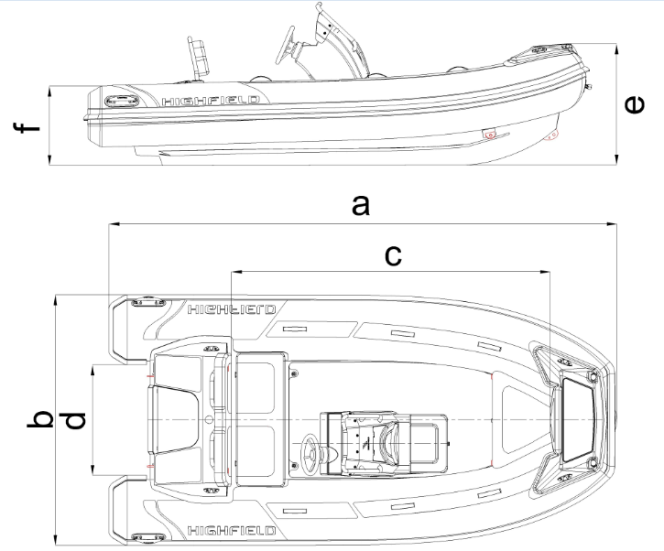
General Arrangement

Specifications: Sport
Description |  | Sport Models
 |  | 520 |  | 560 |  | 650
Hull Construction Material |  | 5 series marine grade aluminum alloy
Deck Construction Material |  | 5 series marine grade aluminum alloy
Tube Material |  | PVC or Hypalon coated fabrics
Overall Length | a | 5.23m |  | 5.66m |  | 6.35m
Inside Length | c | 3.43m |  | 3.82m |  | 4.35m
Beam | b | 2.46m |  | 2.50m |  | 2.54m
Inside Width | d | 1.30m |  | 1.35m |  | 1.34m
Bow Height | e | 1155mm |  | 1260mm |  | 1334mm
Stern Height | f | 810mm |  | 972mm |  | 890mm
Dead Rise |  | 24° |  | 24° |  | 26°
Airtight Chambers |  | 6 |  | 6 |  | 6
Light displacement without engine |  | 550kg | 1213lb | 612kg | 1349lb | 783kg | 1726lb
Max Passenger |  | 10 |  | 12 |  | 13
Max Load |  | 1058kg | 2332lb | 1188kg | 2619lb | 1366kg | 3012lb
Main Propulsion |  | Motor
Max Engine Power |  | 100HP | 74.60KW | 115HP | 85.79KW | 150HP | 111.90KW
Engine Shaft |  | L |  | XL |  | XL
Design Category |  | C |  | C |  | C
Tube Diameter |  | 520mm |  | 520-400mm |  | 531-470mm
Max Engine Weight |  | 207.6kg | 458lb | 258.6kg | 570lb | 260.7kg | 575lb
Fuel Tank Capacity |  | 105L |  | 105L |  | 140L

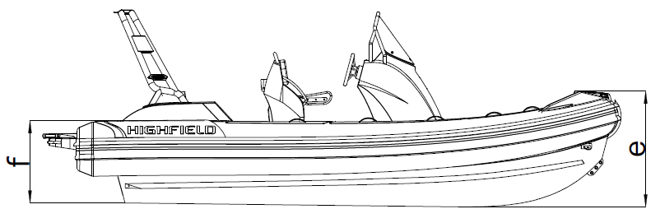
General Arrangement

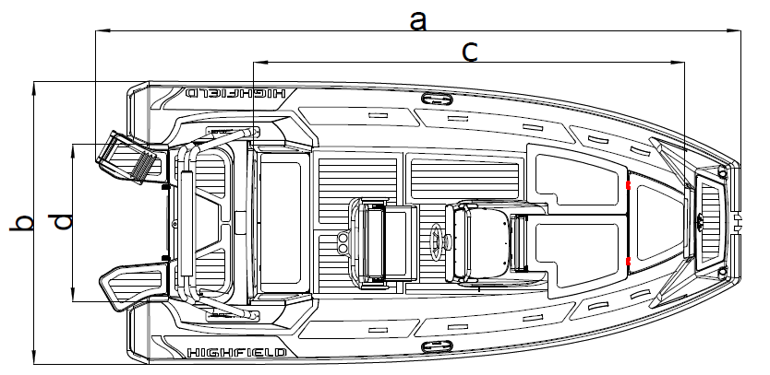

Specifications: Sport
Description |  | Sport Models
 |  | 700(Cat.B) |  |  | 700(Cat.C) |  |  | 800(Cat.B) |  |  | 800(Cat.C)
Hull Construction Material |  | 5 series marine grade aluminum alloy
Deck Construction Material |  | 5 series marine grade aluminum alloy
Tube Material |  | PVC or Hypalon coated fabrics
Overall Length | a | 6.95m |  |  | 6.95m |  |  | 8.11m |  |  | 8.11m
Inside Length | c | 4.95m |  |  | 4.95m |  |  | 5.35m |  |  | 5.35m
Beam | b | 2.54m |  |  | 2.54m |  |  | 2.94m |  |  | 2.94m
Inside Width | d | 1.34m |  |  | 1.34m |  |  | 1.74m |  |  | 1.74m
Bow Height | e | 1334mm |  |  | 1334mm |  |  | 1430mm |  |  | 1430mm
Stern Height | f | 873mm |  |  | 873mm |  |  | 940mm |  |  | 940mm
Dead Rise |  | 26° |  |  | 26° |  |  | 26° |  |  | 26°
Airtight Chambers |  | 6 |  |  | 6 |  |  | 6 |  |  | 6
Light displacement without engine |  | 895kg |  | 1973lb | 895kg |  | 1973lb | 1150kg |  | 2535lb | 1150kg |  | 2535lb
Max Passenger |  | 9 |  |  | 13 |  |  | 9 |  |  | 15
Max Load |  | 1026kg |  | 2262lb | 1366kg |  | 3012lb | 1078kg |  | 2377lb | 1588kg |  | 3501lb
Main Propulsion |  | Motor
Max Engine Power |  | 200HP | 149.20KW |  | 200HP | 149.20KW |  | 300HP | 223.80KW |  | 300HP | 223.80KW
Engine Shaft |  | XL |  |  | XL |  |  | XL |  |  | XL
Design Category |  | B |  |  | C |  |  | B |  |  | C
Tube Diameter |  | 531-470mm |  |  | 531-470mm |  |  | 550-470mm |  |  | 550-470mm
Max Engine Weight |  | 260.7kg |  | 575lb | 260.7kg |  | 575lb | 312.5kg |  | 689lb | 312.5kg |  | 689lb
Fuel Tank Capacity |  | 140L |  |  | 140L |  |  | 250L |  |  | 250L

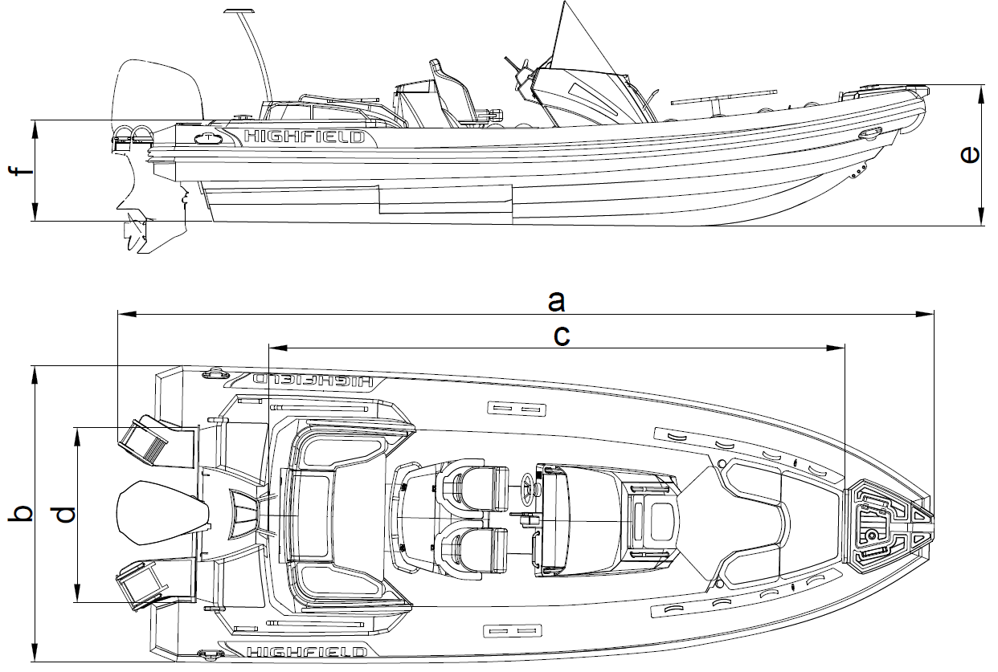
General Arrangement

Notes:
- Overall Length: Including removable parts that can be dismantled, without affecting the structure of the boat.
- Inside Length: Excluding removable parts that can be dismantled, without affecting the structure of the boat.
- Beam: Including removable parts that can be dismantled, without affecting the structure of the boat.
- Inside width: Excluding removable parts that can be dismantled, without affecting the structure of the boat.
- Fuel Tank Capacity: It may not be possible to use this capacity fully depending on the trim and load of the boat. It is recommended to keep a reserve of 20% in the fuel tanks.
- Category B: Craft designed to operate in winds up to force 8 and the associated wave heights. Such conditions may be encountered on offshore voyages of sufficient length, or on coastal waters when unsheltered from the wind and waves for several dozens of nautical miles. These conditions may also be experienced on inland seas of sufficient size for the wave height to be generated. (ISO10240)
Category C: Craft designed to operate in winds up to Beaufort force 6 and the associated wave heights (significant wave height up to 2m). Such conditions may be encountered in exposed inland waters, in estuaries, and in coastal waters in moderate weather conditions.(ISO10240)
- Load distribution
- Please refer to the maximum numbers of passengers and load capacity of the boat in this manual or on the builder’s plate. Do not exceed the maximum number.
- Position the passengers and distribute the load evenly in the boat to help counterbalance the weight of the outboard.
- In rough waters, load can be moved forward to ease the motion of the craft.
- If some of those onboard are children, the total number of people allowed onboard may be increased, provided that:
- The total weight of the children does not exceed 37.5kg; and that
- The total weight of all allowed onboard (based on about 75kg per adult) is not exceeded.

Warning
Do not exceed the maximum recommended number of persons. Regardless of the number of persons on board, the total weight of persons and equipment must never exceed the maximum recommended load. Always use the seats/ seating spaces provided.
When loading the boat, never exceed the recommended maximum load. Always load the boat carefully and distribute loads appropriately to maintain design trim (approximately level). Avoid placing heavy weights high up.
Do not install an engine in this boat with a higher rated power than that indicated on the Builder’s plate as below.
Do not operate the boat with an engine of rated power greater than the maximum recommended power. Overpowering a boat can result in serious injury, death or boat damage.
Use negative trim to go from cruising speed to planning speed and at low speeds (applicable to boats equipped with a system for directing the propeller thrust).
Do no drive the boat at high speed with a negative trim of the propulsion equipment (bow down).

Recommended Seating Arrangement
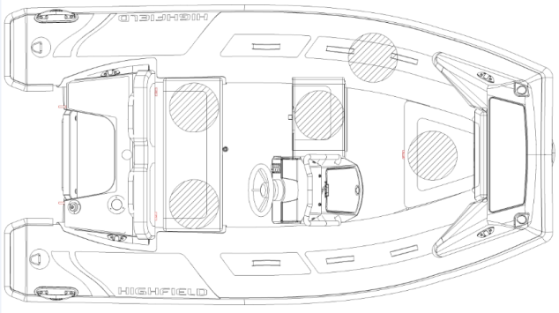
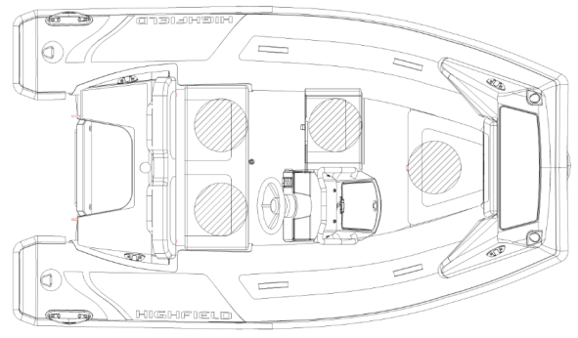


SP300 SP330
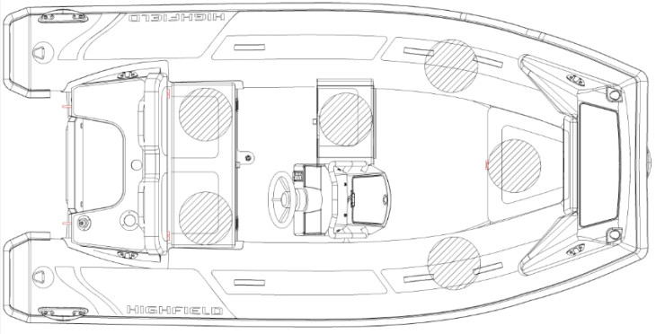
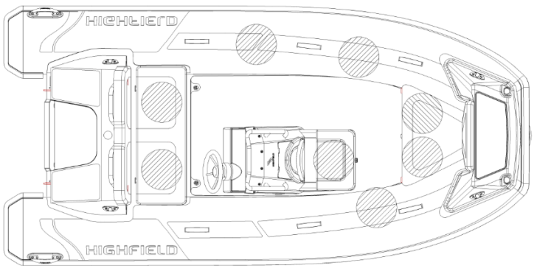

SP360 SP390

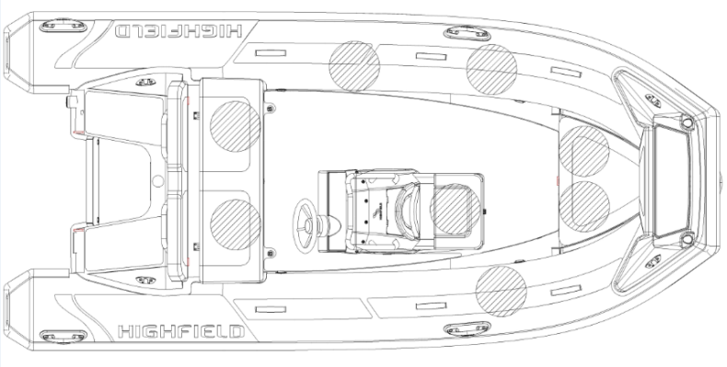

SP420
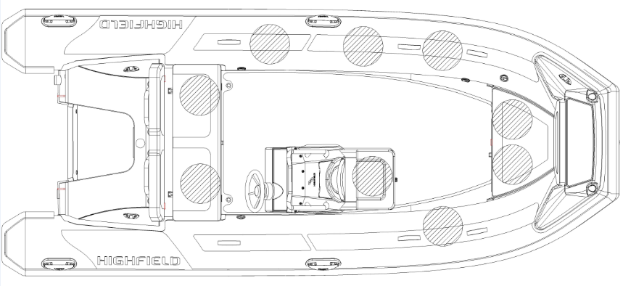

SP460

Recommended Seating Arrangement
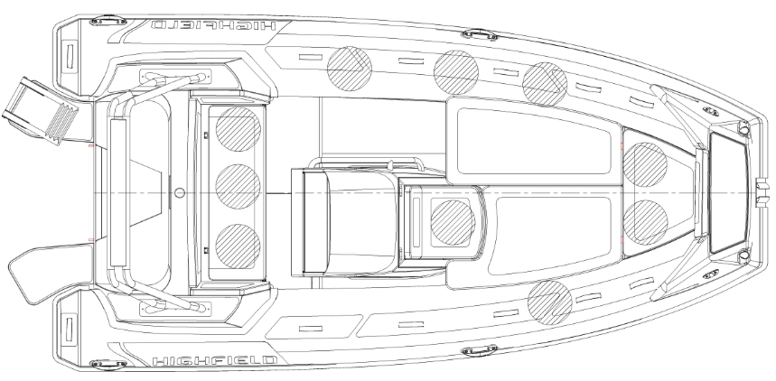

SP520
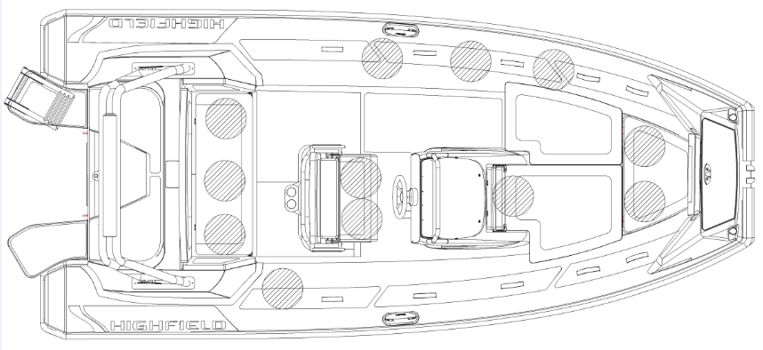

SP560
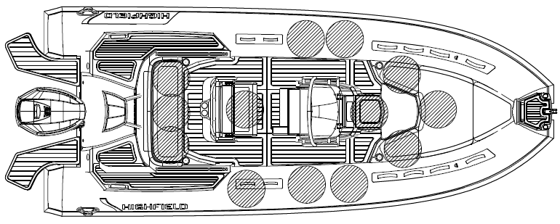

SP650

Recommended Seating Arrangement
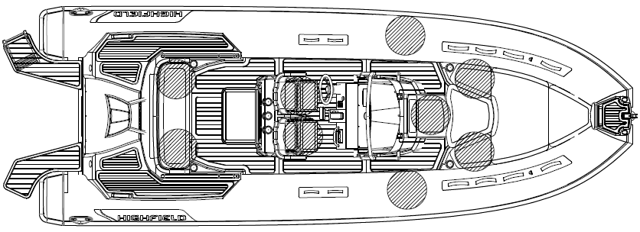

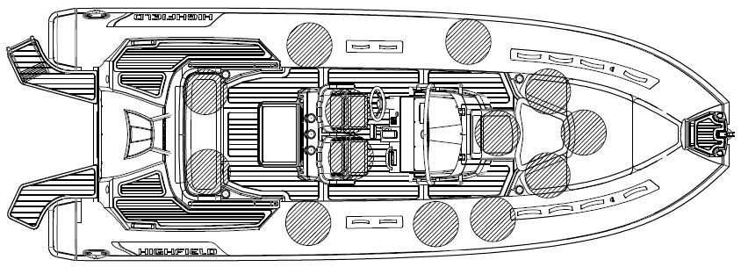
SP700(Cat.B)

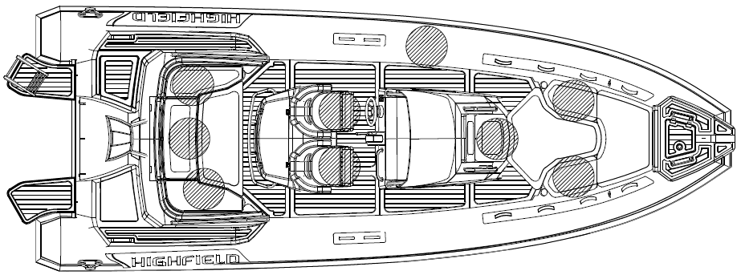
SP700(Cat.C)

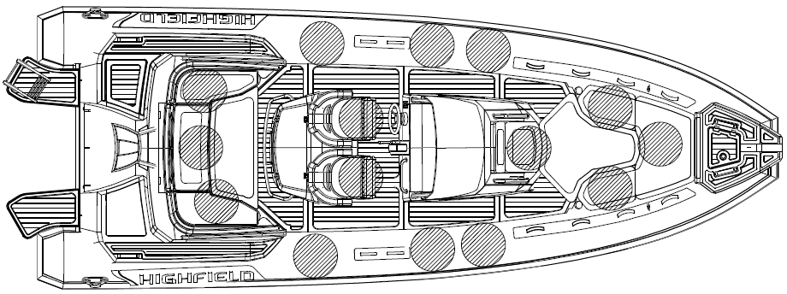
SP800(Cat.B)

SP800(Cat.C)

Builder’s Plate:
Part of the information is given on the builder’s plate affixed on the inside of the boat transom. A full explanation of this information is given in the relevant sections of this manual.
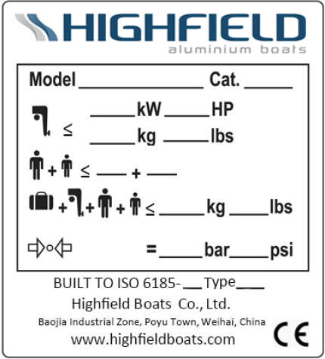
a

c
b

d

e

f

g

Notes:
a: Name of manufacturer
b: Model
c: Design category
d: Maximum motor power
e: Maximum number of passengers
f: Maximum load capacity
g: Recommended working pressure

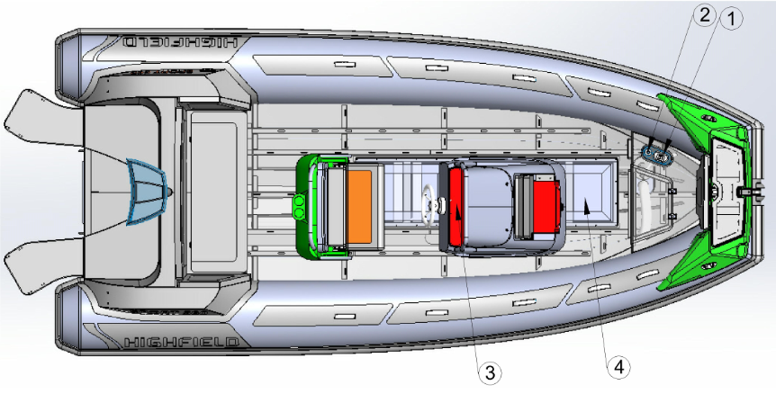
Fuel System

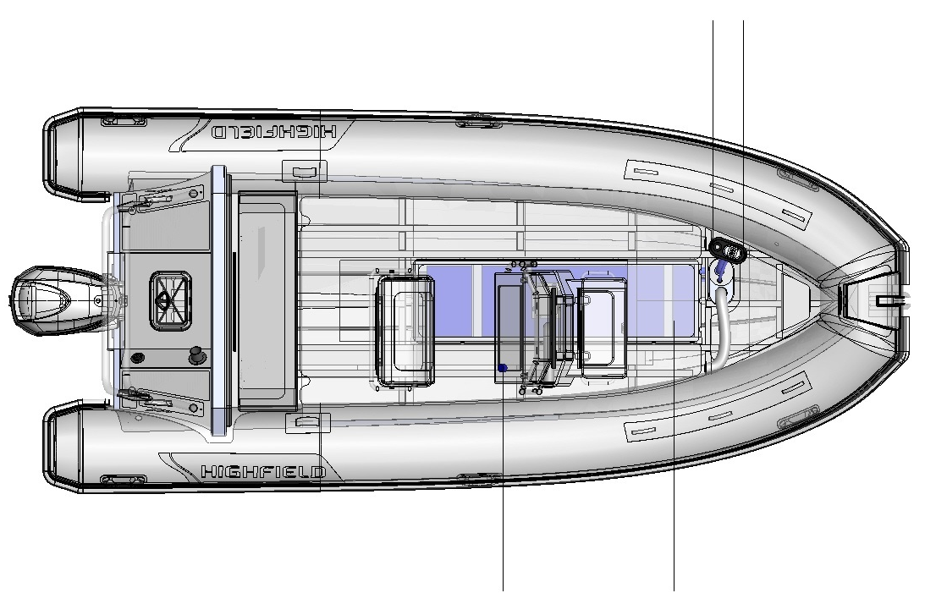 Chart of Fuel System
Reference | Designation
1 | Anti-flooding valve
2 | Fuel filler and tank vent hole
3 | Fuel gauge indicator
4 | Petrol fuel tank

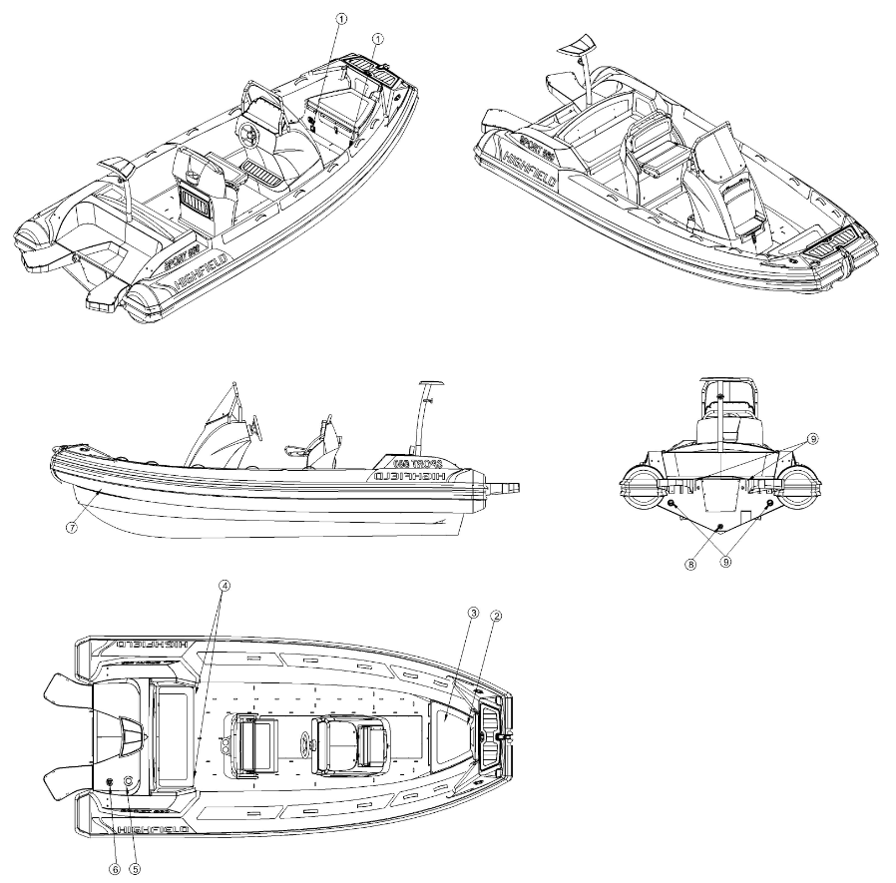
Information connected with the risk of flooding and stability
- Openings in the hull

Reference | Designation
1 | Ventilation grids
2 | Anchor locker
3 | Fuel filler
4/8 | Drain scupper-cockpit/ deck
5 | Engine rigging flange
6/9 | Motor well boot
7 | Bilge drain plug

Use of drain plug

Reference | Designation | Location | Direction for use |  |  | Picture
 |  |  | In water at rest | In water in motion | Out of water
1 | Scupper | Transom | N/A | N/A | N/A | 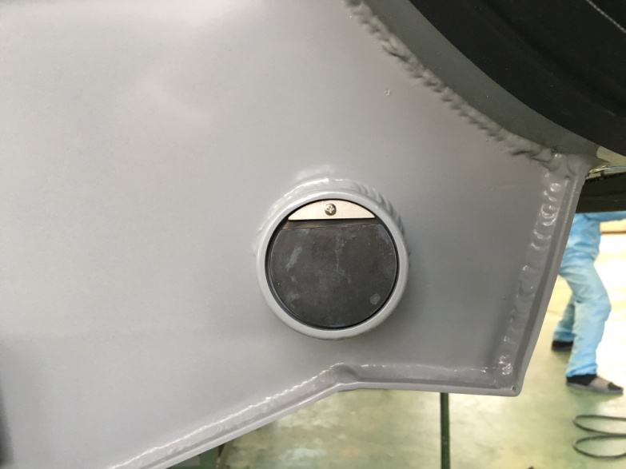
2 | Bilge drain plug | Transom | Closed | Closed | Open | 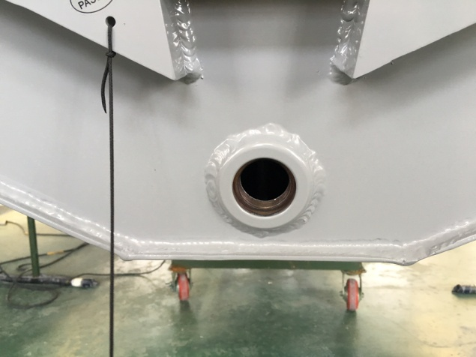  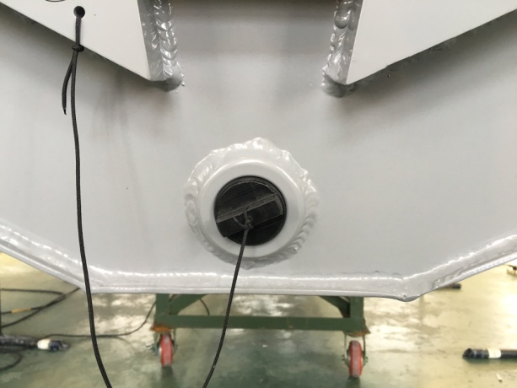
3 | Cockpit plug | Rear seat vertical panel | Closed | Open | Open | 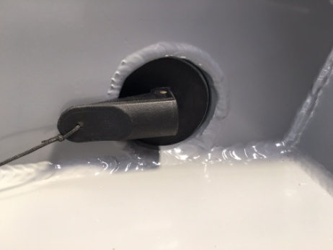  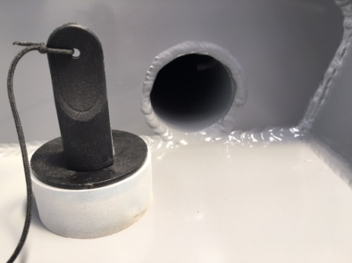

Caution
Keep the bilge drain plug open when the boat is kept outside of the water. The rain water could fill the boat and create stress and damage.

Danger
Do not open the bilge drain plug when the boat is afloat.
Do not try to access the bilge drain plug when motor is running. Propeller may cause serious injury.
- Stability and buoyancy
This boat has been assessed as capable of supported the weight of the crew, even in the event of flooding.
- Fully laden displacement was used to evaluate the stability and buoyancy of the boat. The value of this displacement can be found in paragraph “Specifications” as below.
- Any changes in the distribution of loads onboard (for example by adding a raised structure for fishing, fitting radar or in-mast furling, changing the engine etc.) can significantly affect the boat’s stability, trim and its performance.
- It is important to keep water in the bilges to a minimum.
- The boat’s stability is affected by adding to the weight of the superstructure.
- When under way, it is advisable to shut the hatches, lockers and doors to minimize the risk of flooding.
- The boat’s stability can be reduced when towing a boat or when using a davit or boom to lift a heavy load.
- Air chambers shall not be punctured.
- Breaking waves are a serious stability hazard.

Warning
Always adjust the speed and heading of your boat according to the sea conditions.
All of the watertight hatches and bilge drain plug must remain closed when at sea.

Information connected with the risk of fire or explosion
- Propulsion engine
- Make sure that the cooling water is circulating properly thru the engine.
- Ensure that ventilation openings in the compartment fuel tank are not obstructed.
- Stop the engine and refrain from smoking during fuel tank filling.
- Get your fuel circuit checked regularly by a professional engineer.
- Avoid any contact between inflammable materials and the hot sections of the engine.
- Never switch off or de-energize the electric system when the engine is running.
- Never block the access of the fuel supply valve.
- Do not obstruct or modify the ventilation system. Ensure that ventilation ducts are free.
- Never turn the engine over when the boat is on land.
- Fuel stored outside the fuel tanks (jerry cans, spare cans) must be kept in a well-ventilated place.
- Regularly check that the petrol tank compartment is clean and dry.
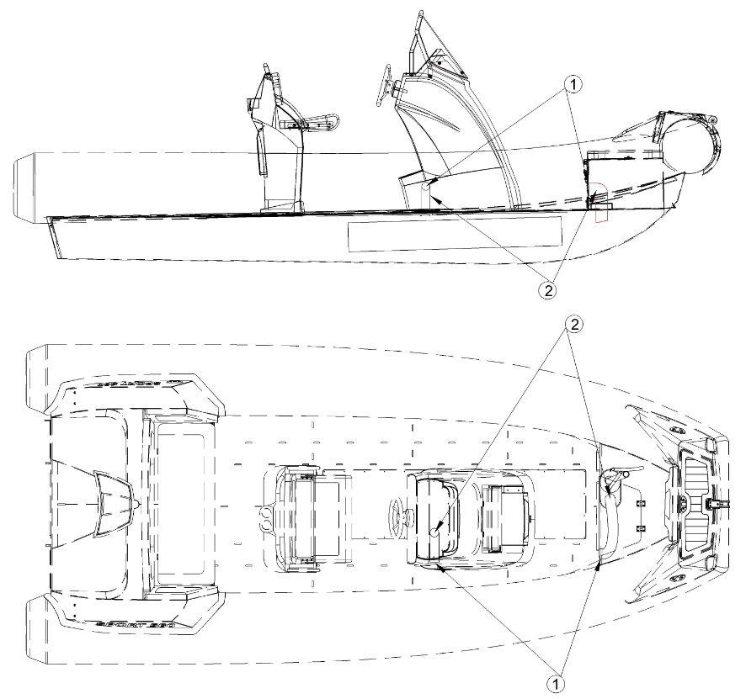
- Take all necessary precautions to avoid contact with naked flames and other hot areas.

Diagram of the layout- Ventilation of petrol tank compartment

Warning
Portable fuel tank should be filled outside of the boat.
Always fill tanks in a ventilated area, motor should be turned off.
Do not smoke when filling the tanks.
- Fire prevention and fire-fighting equipment
- Portable fire-extinguishers and fire blanket (not supplied)
- When in use, this boat must be equipped with portable fire extinguishers of the following extinguishing capacity and located in the following places.
- The location of the portable fire extinguishers is shown by the pictogram below:
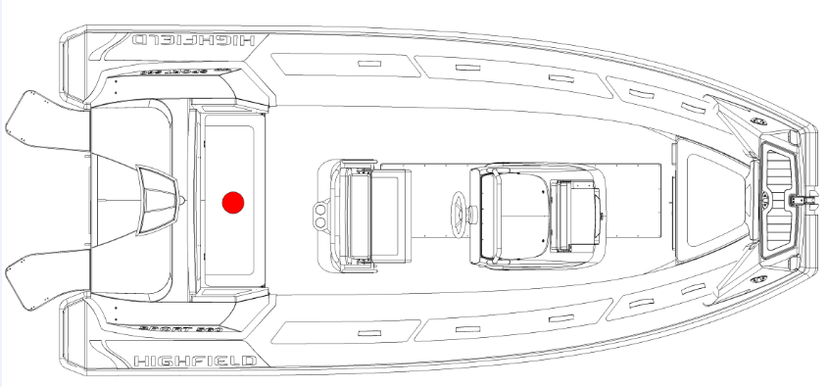


Location for portable extinguisher
Reference | Designation | Location | Minimum extinguishing capacity
1 | Portable extinguisher | seat | 8A/6B

Warning
Boats equipped with a 25kW or larger outboard engine must have onboard one or more portable fire extinguishers with a total combined capacity of at least 86/6B

The fuel tank compartment has a port that makes it possible to inject the extinguishing product inside. The fire port has been designed so that the nozzle of the portable fire extinguisher can be inserted into it and extinguishing product discharged into the fuel tank compartment.
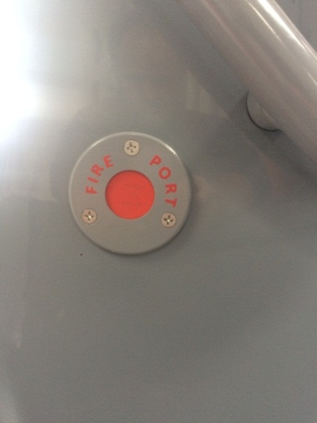

Fire port- located on the port side of the console

- Servicing of fire-fighting equipment
The boat owner/operator shall:
- Have fire-fighting equipment checked at the intervals indicated on the equipment.
- Replace portable fire extinguishers, if expired or discharged, by devices of identical fire-fighting capacity.
- Have fixed systems refilled or replaced when expired or discharged.

- Responsibility of boat owner/operator
- To ensure that fire-fighting equipment is readily accessible when the boat is occupied.
- To ensure that any drainage points in the petrol tank compartment are readily accessible.
- To inform members of the crew about: the location and operation of fire-fighting equipment, the location of discharge opening into the engine space and the location of routes and exits.
Caution
Keep the bilges clean and check for fuel and gas vapors or fuel leaks frequently. When replacing parts of the fire-fighting installation, only matching components shall be used, bearing the same designation or having equivalent technical and fire-resistant capabilities.

Electrical Systems
SP300-460:
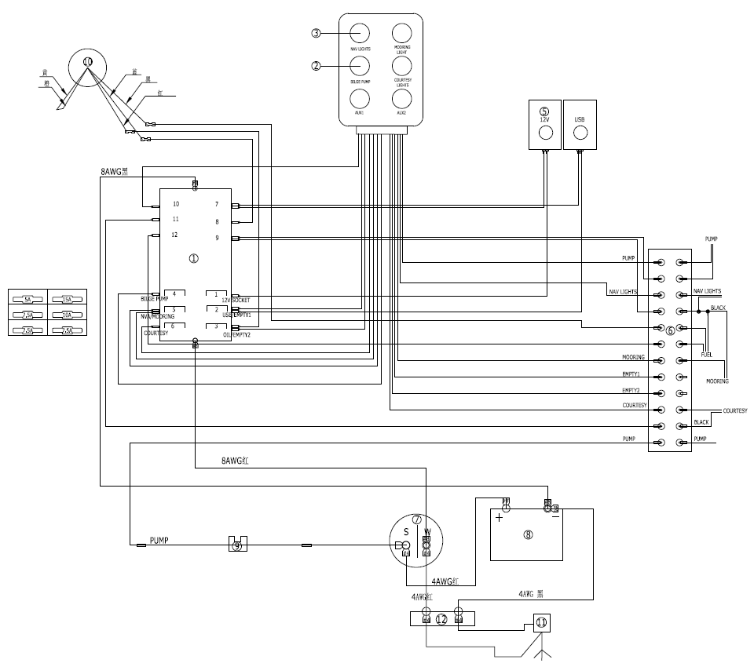

Item | Description | Quantity | Item | Description | Quantity
 | Circuit-breaker 5025B | 1 | ⑦ | Power switch | 1
 | Semi-auto switch | 1 | ⑧ | Battery | 1
 | Manual switch | 5 | ⑨ | Circuit-breaker 5064B | 1
 | USB AD2013 | 1 | ⑩ | Fuel Gauge | 1
 | Socket AD1011 | 1 | ⑪ | Engine | 1
 | Terminal | 1 | ⑫ | Insulator 2017B | 1

SP520-800:

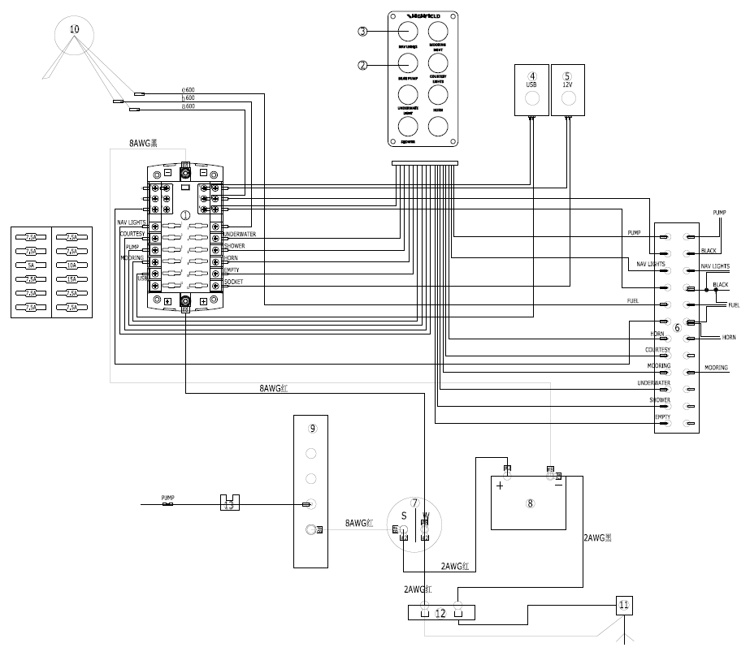

Item | Description | Quantity | Item | Description | Quantity
① | Circuit-breaker 5025B | 1 | ⑦ | Power switch | 1
② | Semi-auto switch | 1 | ⑧ | Battery | 1
③ | Manual switch | 3 | ⑨ | Bus Bar 2303B | 1
④ | USB 1039B | 1 | ⑩ | Fuel Gauge | 1
⑤ | Dash Socket 1011B | 1 | ⑪ | Engine | 1
⑥ | Terminal | 1 | ⑫ | Insulator 2017B | 1
 |  |  | ⑬ | Circuit-breaker 5064B | 1

Danger
The risks of fire or explosion may result from improper use of electric DC and AC systems.
The risks of electric-shock hazards may result from improper use of electric AC system.

Warning
Do not work on a live electrical system.
Do not modify the electrical system of the boat or the relevant diagrams: It is important that the installation, maintenance and any modifications be carried out by a technician qualified in marine electricity.
Do not change or modify the strength of the safety devices protecting against power surges.
Do not install or replace electrical equipment or materials with components which exceed the system’s nominal electrical power capacity.
Do not leave the boat unsupervised when the electrical system is live, apart from when the automatic bilge pump and the boat’s fire protection and security systems are in use.

Transporting
For optimum handling, the trailer must be properly loaded and balanced.
- Keep the center of gravity low for best handling.
- Approximately 60 percent of the boat’s weight should be positioned on the front half of the trailer and 40 percent in the rear.
- The boat should also be balance from side to side. If the vessel has side mounted fuel or water tanks and only one side is filled, then this will lend the rig to maneuver poorly. Proper balancing will also prolong the life of your trailers tires.
- The boat should be firmly secured with at least two ratchet type straps, one attached from the trailer to the stern eyes and one strap from the trailer, to the bow eye to keep the boat from shifting forward. The bow eye should also be attached to the trailer’s winch which is mounted forward of the bow. Make sure you have sufficient clearance to avoid to damage outboard or boat during transportation.
- Classic models can be accommodated/ transported on a roof rack. We recommend the boat to be protected from the roof rack that could damage the tube material. Boat should be stowed upside-down. Oars, bench seat and equipments should be removed from the boat. Boat must be secured using reliable nylon tie-down straps with cam-buckles. We recommend also tying a small rope off at the bow towing eye for extra safety.

Engine Start
Before starting the engine, it is imperative:
- To open the fuel supply valve
- To switch on the battery supply by using the battery isolator switches
- To put the control lever in neutral
- To attach the circuit-breaker/ kill switch lanyard to the pilot.
Make sure a habit of looking to see if sea water is pumped out with the exhaust gases as soon as you start the engine. If no water runs out, stop the engine immediately. Check the coolant flow.

Danger
Before using the engine, make sure you carefully read the handbook provided by the engine manufacturer.
Always start the engine with the control lever in neutral.
Learn how to judge the necessary distance of deceleration for the vessel to come to a complete stop (The reverse gear is not a brake)
Use the kill switch lanyard.

Operation
1. Inflation
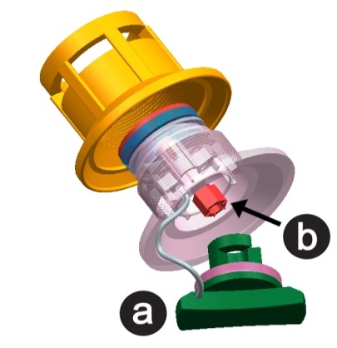
a- Valve cap
b- Plunger

- To inflate the chamber, first unscrew the valve cap by turning a quarter of a turn counterclockwise. Check that the plunger in the center of the valve is closed i.e. upper position. If closed i.e. spring compressed, down position, push the plunger down and rotate to the closed position.
- Connect the air pump to the valve, rotate the connector into the valve to lock it and start inflating. No matter you used foot pump or electrical, please do not inflate over the maximum air pressure 0.25 Bar per chamber.
- Use air gauge to measure the tube pressure.
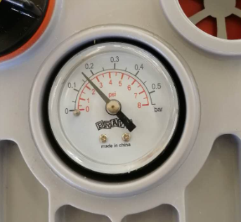
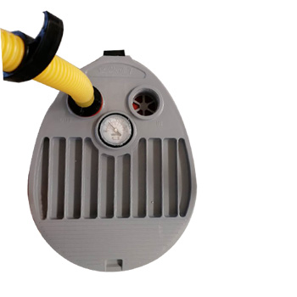

- Be sure to inflate each chamber in turn according to the sequence shown below. Do not inflate a chamber completely then move on to the next one. Start with the rear chambers. Repeat procedure until all chambers are evenly inflated to the recommended working pressure.
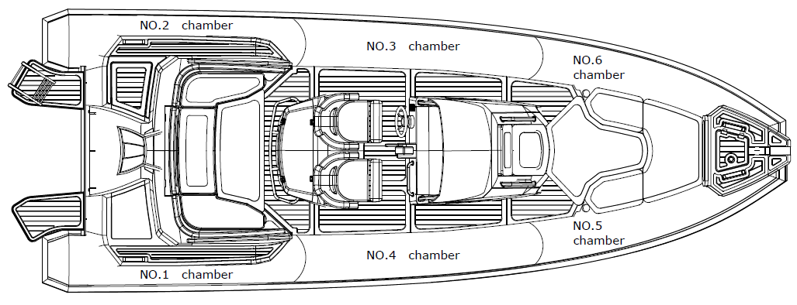

- When inflating, please keep the air pressure balance between air chambers to avoid the damage of bulkheads.
- Inflatable boats can be damaged by extreme internal air pressure. Such pressure can be caused by temperature differences. A boat properly inflated in the morning may become dangerously over-pressurized as the day warms up. The internal pressure can multiply many times as the surfaces temperature increases and under such conditions, seams can separate and bonded materials can delaminate. Avoid subjecting your inflatable to such conditions by relieving pressure in all chambers of your boat as the day heats up or before leaving the boat exposed to hot midday sun. It is highly recommended that the boat be stored in the shade or under cover when it is not being used.
- Using the boat with under inflated tubes may cause serious damage, including transom cracking.
Caution
Do not use a compressed air source to inflate the tube or you may compromise the integrity of the seam or internal baffles. Seams or baffle rupture due to non-respect of inflation procedure is not covered under the warranty.
2. Performance
- To achieve best performance, the boat must plane. If the boat does not plane you may check the following:
- Make sure the bilge/ deck is dry, drain the water otherwise.
- Make sure the tube is correctly inflated.
- Make sure you have the correct weight distribution. Sea conditions may require passengers to move forward to the boat to get the boat on plane before they return to their initial positions.
- Make sure you use a suitable outboard engine for the boat.
- The outboard engine plays a big role in the performance of the boat. Please make sure you use a suitable outboard engine for the boat.
- When you drive your boat, you will have to keep the boat balance fore and aft. To achieve that, you will have to adjust the trim angle of your boat. A properly trimmed hull has two very beneficial results: reduced fuel consumption and increased speed.
- Most outboard engines over 30 horsepower come with a trim and tilt system that is driven by a hydraulic ram located in the center of the engine mounting bracket. Its function is to raise and lower the engine, and it is controlled by an “up/down” rocker switch built into the shift and throttle control that is located directly under your right thumb for ease of access. In the “tilt” mode, the system raises the engine completely out of the water when not in use. It can also be used to raise the engine when running the boat slowly in very shallow water to prevent propeller damage.
In trim mode, the system works to adjust the angle of the engine to affect the running angle of the boat. As the boat increases speed, the engine angle provides the lift necessary to bring the boat on plane for optimal performance. In the full down position, the engine is in “negative trim”, meaning the angle of the engine shaft and propeller is slightly forward of straight down in relation to the transom. This is the position the engine should be in before throttling up from a dead stop. Negative trim exerts downward force on the hull to reduce bow rise that is common to most planning hulls under initial acceleration. The harder the initial acceleration, the greater the tendency the bow will rise. If you throttle up hard from a dead stop, (a procedure called “hole shot”) some hulls will lift the bow at a severe angle momentarily until the downward force of the engine counters the rise.
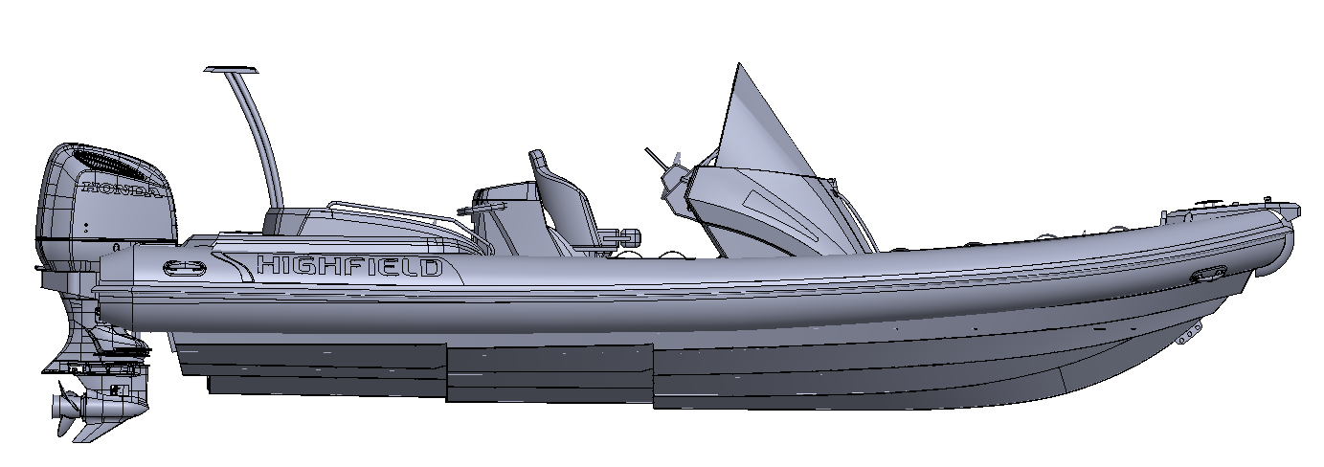
- Outboard trim angle can be adjusted to improve planning and general performance. Adjust the position of the trim rod of your motor to define the trim angle of the outboard motor in relation to the transom. Make test runs with the trim set to different angles to find the position that works best for your boat and operating condition.

Negative trimmed engine

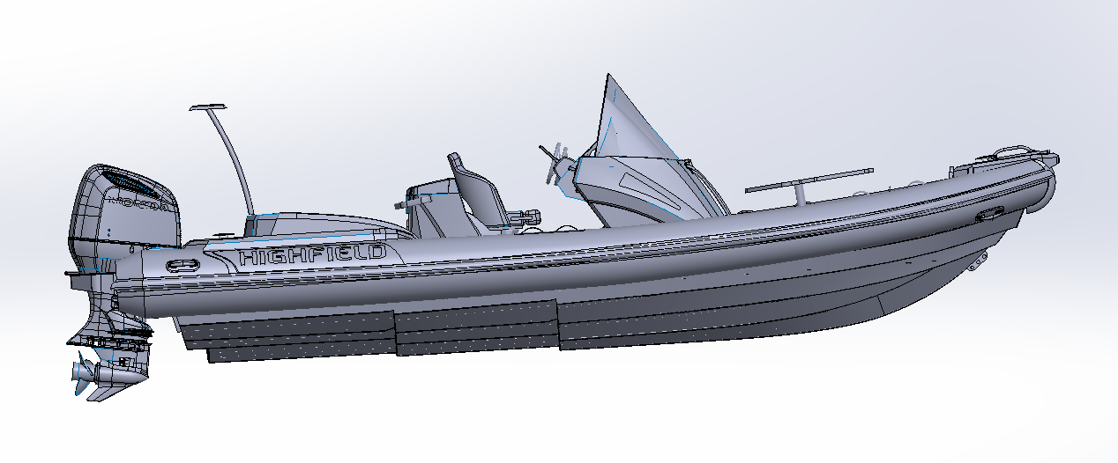

Positive trimmed engine

3. Towing
Your boat can be towed using the towing eye located at the bow. Make sure to use a tow line that is rated at least 5 times the weight of the boat being towed. The boat should only be towed using the towing eye. Molded handles, lifelines and cleats are not designed to be used for towing.
- It is recommended that the boat be towed with a bridle arrangement using the D rings on the either side of the bow.
- An extra safety line should also be attached to the welded-on aluminum eye under the bow of the hull.
- Please note that towed dinghies need to be constantly monitored and especially at night.
- When a dinghy is towed, the conditions may vary quite dramatically so the responsibility for its security rests entirely with the skipper.

Warning
The boat must be empty when towed.
Remove outboard motor, fuel tank and equipment before towing.
No passengers should be onboard.
The boat should be towed at low speed.

4. Lifting
When using a hoist to lift the boat, attach the hoist to the 3(or 4 according to your boat’s type) lifting eyes welded to the hull. Empty the boat of all equipment and make sure no passenger is onboard during lift. Make sure the deck and bilge are drained before lifting your boat. Remove the drain plug during the whole time the boat is stowed to allow water to run off. Molded handles, lifelines and cleats are not designed to be used for lifting. When lifting and slewing, ensure people are well clear below the slung vessel.
5. Beaching
We recommend the boat not to be powered on to the beach, dragged across rocks, sand, gravel or pavement as damage to the fabric and/or hull result.
- Outboard motor
Install the outboard motor on the transom so that it is positioned as close to the center as possible. Tighten the transom clamp screws evenly and securely. Occasionally check the clamp screws for tightness during operation of the outboard motor because they could become loose due to engine vibration. Make sure the outboard motor is securely fastened to the transom every time before operation. It is wise to tie the engine to the transom as well as clamping eyes are provided. Always use the kill switch lanyard properly.
The portable tank should be removed from boat when fuelling. The tank should be filled in a ventilated area. Do not smoke onboard.

Warning
Overpowering a boat can result in serious injury, death or boat damage. Do not use outboard that exceeds the maximum horsepower given on the motor plate.

Man-overboard prevention and recovery
- Man-overboard prevention
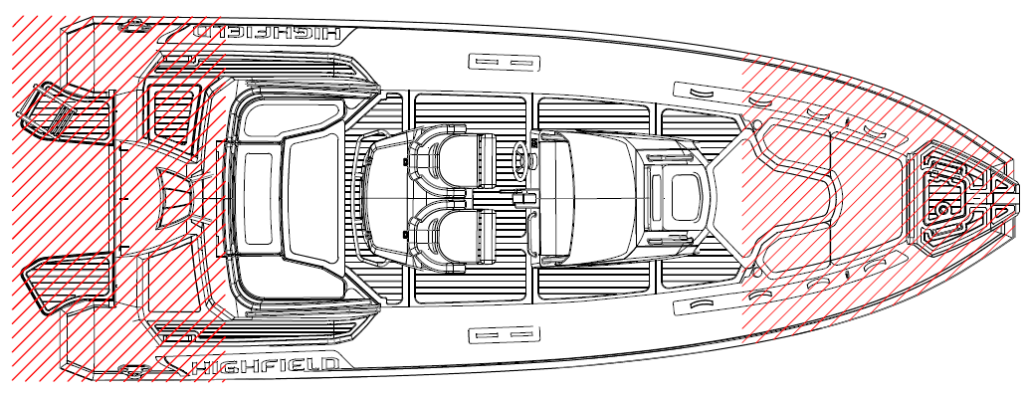

- The zones outside the working deck area are the red hatched area as above.
- The “working deck” means those areas where people stand or walk during normal use of the boat.
- Standing on the bow locker or sundeck is prohibited.
- Recovery-getting back onboard
The means for getting back onboard must be able to be deployed by one person alone in the water, with no other help. We recommend the use of the Highfield optional foldable stern ladder.
Danger
Make sure the means for getting back onboard are readily accessible and easy to use by someone alone in the water
- Danger from moving parts
Keep the engine off whenever the engine box/cover/hatch is open. The engine box/cover/hatch serves as a machinery guard. Clothing or body parts can get caught in moving parts, causing death or serious injury. Keep away from moving part.


Danger
Contact with a spinning propeller can cause injury and death.
Do not enter or exit the water when the engine is running (ON) and the propeller is spinning.
Do not get on the swim platform when the engine is running.
Do not swim towards the back of the boat if the engine is on.

Maintenance
- General care
Your inflatable has been especially designed to avoid maintenance problems as far as possible. However, periodic cleaning will help to keep your boat’s good condition especially before winter storage. Clean your boat and wash it thoroughly with soapy water. Rinse carefully and check that no dirt or foreign bodies such as shell, sand or fishing hooks are left inside that might deteriorate the fabric. For tar stains use a gentle, nonabrasive cleanser such as dishwashing soap, or use a recommended inflatable boat cleaner available from most boat chandlery outlets.
For upholstery, Highfield is using marine grade fabric to offer best resistance to UV and ageing. Periodic washing with mild detergent and warm water is the best way to keep your upholstery look good. Special vinyl cleaner can also be used to remove difficult stains.
No fabric can last forever when constantly exposed to the sun. To make sure your PVC tubes last, a UV protectant solution must be applied twice a year on the tube fabric. We recommend the use of 303® Aerospace Protectant™.
Caution
Do not use abrasive or aggressive chemical compounds.
Warm soap water is best in most situations.
Do not use any solvents, petrol, etc. (PVC models).
Use solvents sparingly only on Hypalon models.
Test any cleaner on a piece of patch material if in doubt.

- Deflation
To deflate the chamber, first unscrew the valve cap by turning a quarter of a turn counterclockwise. Check that the plunger in the center of the valve is closed i.e. upper position. If closed i.e. spring compressed, down position, push the plunger down and rotate to the closed position.
Connect the air pump to the valve, rotate the connector into the valve to lock it and start deflating.
Deflate each chamber in turn, do not deflate a chamber completely then move on to the next one. Start with the rear chambers. Repeat procedure until all chambers are completely deflated.
Caution
This is not an exhaustive list of recommendations: Your dealer will give you the advice you need and will carry out the technical maintenance of your boat.

- Storage
We recommend you to cover your boat when not in use.
- When not in use boat should be removed from water.
- Before storage the boat should be cleaned and rinsed with fresh water.
- Do not cover boat before it is completely dry or mildew could grow under the cover and damage the tube material
- The covers should be ventilated and the drain plug left out.
- Check the expiry dates of the safety equipment.
- Have the boat overhauled.
- Grease and close all the valves and through-hull fittings.
- Grease all mechanical and moving parts (bolts, hinges, locks…).
- Close all the boat’s seacocks.
- Put the covers back on the electronic screens.
- Air all of the cushions and upholstery for a good while before putting them back onboard and arranging them so as to limit the surface areas touching.
- Remove the movable upholstery.
- Disconnect the batteries. Make sure you recharge them during the winter period if the boat is left inactive for too long.
Caution
The winterization of the engine requires the skills of a professional engineer: please consult your dealer.
This is not an exhaustive list of recommendations: Your dealer will give you the advice you need and will carry out the technical maintenance of your boat.

- Tube repair
- Repair Kit contains:
- Fabric patches; b ) Ready to use tube of special glue
- Conditions necessary for a successful repair:
- Humidity max 60%.
- Temperature range between 18 and 25 degrees Celsius.
- Repairs should not be carried out in direct sunlight, wind or rain.
- Repairs should, however, be undertaken in a well-ventilated area.
- Repair PVC boats:
Highfield Inflatables that have tubes constructed with Valmex PVC coated fabrics require PU based adhesive and RC hardener. Acetone solvent is recommended to prepare the surface before gluing. Use only recommended solvent and adhesive.
- Identify the area to be patched. This can be done by running water over the suspect area or spraying or brushing with soapy water.
- If the hole is only small, cut out a round patch of no less than 60mm diameter. Large holes or cuts will require proportionately larger patches but always ensure you have at least 30mm of patch around the perimeter of the cut or hole and the corners are well radiused
- Next hold the patch on the tube and mark out around it with a pencil.
- Clean both surfaces with solvent and spread a thin layer of adhesive over them ensuring there are no lumps.
- When the first coat is dry to the touch (about 10 to 15 minutes) apply a second thin coat.
- After waiting 5 or 6 minutes, touch the adhesive with the back of your hand. If it no longer appears wet, heat both areas with a hot air gun to re-activate the glue and join the patch to the tube and then clamp or roll the surfaces together. For the best adhesion, roll over the patch with a roller or over the bottom edge of a bottle.

Caution
Do not inflate the boat fully for 24 hours.

- Repair Hypalon boats:
Highfield Inflatables that have tubes constructed with Orca Hypalon coated fabrics cannot be bonded with plastic adhesives or by welding. They require neoprene based glue and RFE hardener. MEK solvent is recommended to prepare the surface before gluing. Use only recommended solvent and adhesive.
- Identify the area to be patched. This can be done by running water over the suspect area or spraying or brushing with soapy water.
- If the hole is only small, cut out a round patch of no less than 60mm diameter. Larger holes or cuts will require proportionately larger patches but always ensure you have at least 30mm of patch around the perimeter of the cut or hole and the corners are well radiused.
- Next hold the patch on the tube and mark out around it with a pencil.
- Use a grinder, course sand paper or scratch stone, rough up both the back of the patch and the area marked on the tube.
- Clean both surfaces with solvent and spread a thin layer of adhesive over them ensuring there are no lumps.
- When the first coat is dry to the touch (about 10 to 15 minutes) apply a second thin coat. After waiting 5 or 6 minutes, touch the adhesive with the back of your hand. If it no longer appears wet, heat both areas with a hot air gun to re-active the glue and join the patch to the tube and then clamp or roll the surfaces together. For the best adhesion, roll over the patch with a roller or over the bottom edge of a bottle.
Danger
Glue and solvent used for repair are highly flammable. Perform repairs in a well-ventilated area. Avoid breathing the vapors, wear protective gears (goggles, filter respirators, latex gloves).

Warranty
The product you have purchased comes with a limited warranty from Highfield Inflatables. The terms of the warranty are set forth in the Warranty Information section of this manual. The warranty statement contains a description of what is covered, what is not covered and the duration of coverage. Please review this important information. The description and specifications contained herein were in effect at the time this manual was approved for printing. Highfield Inflatables, whose policy is one of continued improvement, reserve the right to discontinue models at any time, to change specification, designs, methods, or procedures without notice and without incurring obligation.
Record your Hull Identification Number (HIN).
The HIN is located on the transom plate of your boat. You will need this information to obtain parts, warranty service or provide information if your inflatable boat is stolen.

Highfield Boats—Retail Limited Warranty
- WHAT IS COVERED
Highfield boats are warranted to be free of defects in material and workmanship during the period described hereafter:
- DURATION OF COVERAGE
- The entire vessel is covered for a period of two (2) years from the date the product is sold.
- The hull structure is covered by a five (5) years warranty.
- For commercial use or hire, the entire vessel has a one (1) year warranty.
- POWDER COATING
The powder coating is warranted for a period of 2 years against manufacturing defects.
This warranty excludes damage due to misuse of the boat and chemical or mechanical shocks such as:
- Collision, fire, theft, riot, etc.
- Alteration, modification, and tampering.
- Environmental corrosion and shocks due to acid rain, chemical fallout, industrial pollution, bird lime, tree sap, hail, extreme weather, etc.
- CONDITION THAT MUST BE MET IN ORDER TO OBTAIN WARRANTY COVERAGE
Warranty coverage is available only to customers that purchase from an authorized Highfield dealer. Routine maintenance outlined in the Owner’s manual must be performed in a timely manner in order to maintain warranty coverage. If the retail customer performs this maintenance, Highfield Boats reserves the right to make future warranty coverage contingent on proof of proper maintenance.
- WHAT HIGHFIELD BOATS WILL DO
Highfield Boats sole exclusive obligation under this warranty is limited to, at our option, repairing a defective part, replacing such part or refunding the purchase price of the Highfield Boats product. The repair, replacement of parts, or the performance of service under this warranty does not extend the life of this warranty beyond its original expiration date.
- HOW TO OBTAIN WARRANTY COVERAGE
The customer must provide Highfield Boats with a reasonable opportunity to repair, and reasonable access to the product for warranty service. Warranty claims shall be made by delivering the product for inspection to a Highfield Boats dealer authorized to service the product. If the service provided is not covered by this warranty, the purchaser shall pay for all related labor and material, and any other expenses associated with that service. The purchaser shall not, unless requested by Highfield Boats, ship the product or parts of the product directly to Highfield Boats. Proof of registered ownership must be presented to the dealer at the time warranty service is requested in order to obtain coverage.
- WHAT IS NOT COVERED
- This limited warranty does not include damage due to misuse abuse, negligence, improper or inadequate storage or transportation, or to any Highfield boat which is used in a manner contrary to directions or instructions indicated in the Highfield Owner’s Manual.
- The warranty does not cover routine maintenance items, adjustments, normal wear and tear, puncture, discoloration, oxidation, abrasion, mildew or damages due to theft, loss, modification or alternation.
- Wear parts including but not limited to rubbing strake, keel guards, ropes are not covered by the warranty.
- This warranty shall be ineffective if the boat has been operated without proper inflation, or with an outboard motor which exceeds the maximum horsepower rating listed on the serial plate attached to the transom.
- Powder coating condition is not covered by our warranty due to the specific exposed nature of the product.
- For best long term protection, ensure that your surfaces are rinsed with fresh water after every use and are cleaned immediately of any substances that my stick to the paint surface and cause discoloration or damage.
- We recommend scratches and dents to be repaired as soon as possible after they occur.
- Use of the product for racing or other competitive activity voids the retail warranty.
- Expenses related to haul-out, launch, towing, storage, transportation, telephone, rental, inconvenience, slip fees, insurance coverage, loan payments, loss of time, loss of income, or any other type of incidental or consequential damages are not covered by this warranty.
- TRANSFER OF WARRANTY
The limited warranty is transferable to a subsequent purchaser, but only for the remainder of the unused portion of the limited warranty. This does not apply if the vessel is used for rental or commercial use.
To transfer warranty please send an email with the below information to warranty@highfieldboats.com.
- Copy of the sale agreement.
- HIN of the boat
- Name, address, email address of new owner.
Product Information
Model
HIN
Purchase Date
Dealer’s Information
Name
Address
Phone
Dealer’s Stamp
Customer’s Information
Name
Address
Email Address
Phone

Service assistance
For assistance please contact your Highfield dealer and visit Highfield Inflatable website:
www.highfieldboats.com

VEUILLEZ CONSERVER CE MANUEL DANS UN ENDROIT SÛR ET LE REMETTRE AU NOUVEAU PROPRIÉTAIRE EN CAS DE VENTE DU BATEAU.
Sommaire

Introduction générale 32
Avertissements de sécurité 33
Recommandations de sécurité nautique 33
Check-list avant le départ 34
Spécifications : Sport 35
Agencement général 35
Spécifications : Sport 36
Agencement général 36
Spécifications : Sport 37
Agencement général 37
Agencement recommandé des places assises (Sport) 39
Agencement recommandé des places assises (Sport) 40
Agencement recommandé des places assises (Sport) 41
Plaque constructeur : 42
Système de carburant 43
Informations relatives au risque de submersion et à la stabilité 43
Informations relatives au risque d'incendie et à l'explosion 46
Transport 50
Démarrage du moteur 50
Utilisation 51
Prévention de chute d'homme à la mer et récupération 54
Entretien 55
Garantie 58
Service assistance 60

Pour vous assurer d'obtenir un maximum de satisfaction de votre bateau Highfield, veuillez lire attentivement le présent manuel. Il contient toutes les instructions de sécurité et d'utilisation dont vous aurez besoin pour tirer le meilleur parti de votre nouveau bateau Highfield.

Introduction générale
Le présent manuel a été rédigé afin de vous aider à utiliser votre bateau en toute sécurité et obtenir un maximum de satisfaction. Il décrit en détails le bateau et les équipements fournis ou intégrés, le système et son fonctionnement. Veuillez le lire attentivement et vous familiariser avec le bateau avant de l'utiliser.
Le Manuel du Propriétaire n'est pas un cours de sécurité nautique ni de bon usage marin. Qu'il s'agisse de votre premier bateau ou que vous changiez pour un type de bateau dont vous n'avez pas l'habitude, pour votre propre confort et votre sécurité, veuillez vous assurer d'acquérir suffisamment d'expérience quant à la manipulation et au fonctionnement du bateau avant d'en « prendre les commandes ». Votre revendeur ou la fédération nationale de navigation ou encore le yacht club se feront un plaisir de vous recommander des écoles de navigation locales ou des formateurs compétents.
Assurez-vous que le vent et les conditions marines prévues correspondent bien à la catégorie de conception de votre bateau et que vous-même et votre équipage serez capables de manipuler le bateau dans ces conditions.
Même si votre bateau est classé pour ces conditions, la mer et les conditions de vent correspondant aux catégories de conception A, B et C vont de conditions de violente tempête pour la catégorie A, à des conditions strictes pour la catégorie C supérieure, compatibles avec les risques de vagues exceptionnelles ou de coup de vent. Il existe en conséquence des conditions dangereuses dans lesquelles seul un équipage compétent, apte et entraîné utilisant un bateau bien entretenu peut opérer de manière satisfaisante.
Le présent Manuel du Propriétaire n'est pas un guide détaillé de maintenance ni un guide de dépannage. En cas de difficulté, adressez-vous au fabricant ou à son représentant. Si un manuel de maintenance est fourni, utilisez-le pour l'entretien du bateau.
Faites toujours appel à des personnes expérimentées et compétentes pour l'entretien, les réparations et les modifications. Les modifications susceptibles d'affecter les caractéristiques de sécurité du bateau doivent être évaluées, exécutées et documentées par des personnes compétentes. Le fabricant du bateau ne pourra être tenu responsable des modifications qui n'auront pas été préalablement approuvées.
Dans certains pays, un permis de conduire ou une autorisation sont requis ou certaines règlementations spécifiques en vigueur.
Veillez à ce que votre bateau soit toujours entretenu correctement et tenez compte des détériorations qui résulteront d'une utilisation intense ou d'une utilisation non conforme du bateau.
N'importe quel bateau, aussi solide soit-il, peut être gravement endommagé s'il n'est pas utilisé correctement. Un tel comportement n'est pas compatible avec une navigation de plaisance en toute sécurité. Adaptez toujours votre vitesse et le cap du bateau aux conditions marines.
Si votre bateau est équipé d'un canot de sauvetage, lisez le manuel d'utilisation du canot. Le bateau doit disposer à son bord de l'équipement de sécurité approprié (gilets de sauvetage, harnais etc.) selon le type de bateau, les conditions météorologiques etc. Dans certains pays, cet équipement est obligatoire. L'équipage doit avoir l'expérience de tous les équipements de sécurité et des manœuvres d'urgence (récupération d'un homme à la mer, remorquage, etc.), sachant que les écoles et les clubs nautiques organisent régulièrement des stages.
Toutes les personnes se trouvant sur le pont doivent porter des aides à la flottabilité adéquates (gilet de sauvetage/vêtement de flottaison individuel). Veuillez noter que, dans certains pays, il est obligatoire de porter une aide à la flottabilité conforme aux réglementations nationales à tout moment.

Avertissements de sécurité
Le présent manuel utilise les avertissements suivants pour attirer votre attention sur les consignes de sécurité spécifiques devant être suivies.
Degré de danger et signalisation de sécurité correspondante :
Danger
Indique qu’un danger intrinsèque extrême existe ce qui aboutirait à une forte probabilité de décès ou de préjudice irréparable si les précautions nécessaires ne sont pas prises.

Avertissement
Indique qu’un risque existe pouvant entraîner des blessures ou la mort si les précautions nécessaires ne sont pas prises.

Attention
Indique un rappel des pratiques de sécurité ou attire l’attention sur des pratiques dangereuses qui pourraient causer des blessures ou des dommages au bateau à ses composants ou à l’environnement.

Recommandations de sécurité nautique
- Toujours porter un gilet de sauvetage
Les autorités locales exigent que vous disposiez d'un vêtement de flottaison individuel ou d'un gilet de sauvetage pour chaque personne présente sur votre embarcation. Nous recommandons le port d'un gilet de sauvetage en permanence pendant la navigation.
- Utiliser le cordon du coupe-circuit d'urgence
Le conducteur du bateau doit porter à tout moment un cordon coupe-circuit lorsqu'il est aux commandes. En cas d'éjection accidentelle ou de perte d'équilibre, le bateau s'arrêtera immédiatement. Porter un cordon coupe-circuit d'urgence peut éventuellement sauver la vie du conducteur ou celle de quelqu'un d'autre.
- Connaître votre bateau
Bien connaître votre bateau est la base de l'art de la navigation de plaisance, c'est-à-dire la capacité de gérer votre bateau, ce qui comprend : la navigation, la sécurité, la manipulation du bateau, la manipulation des cordages, l'ancrage, le dépannage des problèmes de moteur et les réactions appropriées en cas d'urgence.
- Suivre un cours de sécurité nautique et apprendre les règles de navigation
Un cours de navigation vous enseignera les rudiments de la navigation de plaisance mentionnés ci-dessus. Les connaissances que vous allez acquérir ne seront jamais perdues. Apprenez à lire les cartes marines et gardez-les sur votre embarcation pour vous familiariser avec la zone dans laquelle vous naviguez. Suivre un cours de sécurité nautique est la prochaine étape, afin d'apprendre à naviguer à l'aide des cartes, du GPS, du RADAR et d'une boussole.
- Navigation et sobriété
Les boissons alcoolisées sont encore plus dangereuses sur l'eau que sur terre en raison de la nature du milieu marin qui en accélère les effets. Hormis les risques pour la sécurité, naviguer en état d'ébriété, ou naviguer sous influence (BUI) est illégal et de lourdes sanctions sont appliquées par les organismes régionaux (États) et fédéraux.
- Éviter les collisions
Respecter les règles de priorité telles que définies dans les Règles de Navigation et imposées par les réglementations internationales pour prévenir les collisions en mer. S’assurer d'avoir toujours suffisamment d'espace pour s’arrêter ou manœuvrer si nécessaire pour éviter une collision. Éviter les manœuvres abruptes à pleine vitesse.
- Protéger les personnes
Toujours ralentir et faire preuve de la plus extrême prudence lorsque vous naviguez dans une zone où il y a des gens dans l'eau.
- Respect de l'environnement
Tenir compte de la législation locale sur l'environnement et des règles internationales de lutte contre la pollution marine et les respecter dans la mesure du possible.
- Contrôle de la vitesse
Ne pas conduire à pleine vitesse dans les zones de forte circulation ou dans les situations de visibilité réduite, de vents forts ou de mer agitée. Réduire la vitesse du bateau en présence de grosses vagues ou du sillage d'autres embarcations par courtoisie et pour votre sécurité et celle des autres. Respecter les limitations de vitesse et les signaux « SILLAGE INTERDIT ».
- Autres :
Ne pas séjourner dans le cockpit avant lorsque le bateau avance à grande vitesse.
Danger
Pendant la navigation, les passagers doivent éviter de se lever ou de laisser pendre des membres à l'extérieur du bateau. Les fuites de carburant présentant un risque d'incendie, inspecter régulièrement le système de carburant. Éteindre entièrement le moteur avant de monter à bord depuis
l'eau.

Avertissement
Si le conducteur ou un passager tombe hors du bateau, le risque de blessure grave ou de mort en se faisant percuter par le bateau peut être considérablement réduit par l'arrêt immédiat du moteur. Toujours connecter correctement les deux extrémités du cordon du coupe-circuit entre l'interrupteur d'arrêt et le pilote.

Attention
Les passagers doivent utiliser des vêtements de flottaison individuels (VFI) appropriés. Des vêtements de flottaison individuels spéciaux existent pour les enfants ou les sports nautiques. (Vêtement de flottaison individuel)

Check-list avant le départ
a). S'assurer que chaque passager porte un vêtement de flottaison individuel approprié.
b). S'assurer qu'une aide à la flottabilité est disponible et peut être jetée pour sauver une personne tombée à l'eau.
c.) En cas de navigation avec des passagers, former au moins l'un des passagers aux rudiments de la manœuvre de l'embarcation, des commandes et du fonctionnement du moteur hors-bord.
d). Vérifier que chaque passager est assis de manière sûre et tient un cordon de sécurité, une poignée ou un câble.
e). S'assurer de la présence d'un câble de remorquage de 4 m sur le bateau.
f). S'assurer que la charge présente sur le bateau est uniformément répartie.
g). S'assurer de respecter la capacité de charge maximale du bateau telle qu'indiquée sur la plaque constructeur.
h). S'assurer que tous les équipements de sécurité sont à bord, comme par ex le sifflet, les cordages flottants, les lampes de poche étanches, la trousse de premiers secours, de l'eau fraîche, la boîte à outils...
i). Vérifier que le bateau est équipé de 2 pagayeuses ou rames.
j). S'assurer que le moteur hors-bord est correctement fixé au tableau arrière.
k). S'assurer que le bouchon de vidange fonctionne correctement.
l). Vérifier le niveau de pression de chaque chambre à air à l'aide d'un manomètre. La pression d'utilisation recommandée est indiquée sur la plaque constructeur.
m). Vérifier le niveau du réservoir de carburant pour s'assurer qu'il correspond au trajet prévu.
n). Démarrer le moteur hors-bord et s'assurer qu'il s'arrête lorsque le cordon est déconnecté de l'interrupteur.

Spécifications : Sport
Description |  | Modèles Sport
 |  | 300 |  | 330 |  | 360 |  | 390 |  | 420 |  | 460
Matériau de construction de la coque |  | alliage d'aluminium marin série 5
Matériau de construction du pont |  | alliage d'aluminium marin série 5
Matériau du tube |  | PVC ou tissu enduit d'Hypalon
Longueur totale | a | 3,10m |  | 3,36m |  | 3,62m |  | 3,90m |  | 4,24m |  | 4,60m
Longueur intérieure | c | 1,80m |  | 2,04m |  | 2,36m |  | 2,50m |  | 2,72m |  | 2,91m
Largeur | b | 1,83m |  | 1,82m |  | 1,84m |  | 1,92m |  | 2,05m |  | 2,09m
Largeur intérieure | d | 0,84m |  | 0,90m |  | 0,92m |  | 0,92m |  | 1,08m |  | 1,08m
Hauteur à la proue | e | 930mm |  | 930mm |  | 930mm |  | 960mm |  | 1040mm |  | 966mm
Hauteur à la poupe | f | 600mm |  | 600mm |  | 600mm |  | 710mm |  | 695mm |  | 647mm
Angle de carène |  | 15° |  | 20° |  | 20° |  | 20° |  | 20° |  | 20°
Chambres étanches |  | 3 |  | 3 |  | 3 |  | 3 |  | 4 |  | 5
Déplacement lège sans moteur |  | 151kg | 333lb | 212kg | 466lb | 227kg | 500lb | 249kg | 548lb | 336kg | 740lb | 364kg | 801lb
Nombre max. de passagers |  | 4 |  | 5 |  | 6 |  | 7 |  | 8 |  | 9
Charge max. |  | 464kg | 1023lb | 549kg | 1211lb | 634kg | 1398lb | 716kg | 1579lb | 791kg | 1744lb | 912kg | 2011lb
Propulsion principale |  | Motor
Puissance max. du moteur |  | 30HP | 22,38  KW | 30HP | 22,38  KW | 40HP | 29,84  KW | 60HP | 44,76  KW | 70HP | 52,22  KW | 90HP | 67,14  KW
Arbre moteur |  | L |  | L |  | L |  | L |  | L |  | L
Catégorie de conception |  | C |  | C |  | C |  | C |  | C |  | C
Diamètre tube |  | 410mm |  | 430mm |  | 430mm |  | 470mm |  | 470mm |  | 470mm
Poids max. du moteur |  | 124,1  Kg | 274lb | 124,1  kg | 274lb | 124,1  kg | 274lb | 161,7  kg | 356lb | 188,5  kg | 416lb | 207,6  kg | 458lb
Capacité du réservoir de carburant |  | / |  | 30L |  | 30L |  | 30L |  | 55L |  | 55L

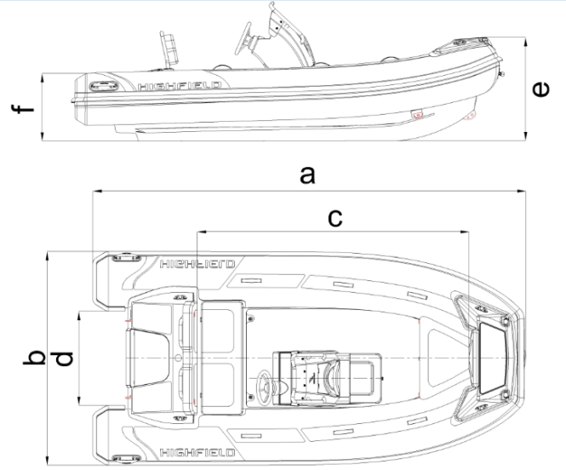
Agencement général

Spécifications : Sport
Description |  | Modèles Sport
 |  | 520 |  | 560 |  | 650
Matériau de construction de la coque |  | alliage d'aluminium marin série 5
Matériau de construction du pont |  | alliage d'aluminium marin série 5
Matériau du tube |  | PVC ou tissu enduit d'Hypalon
Longueur totale | a | 5,23m |  | 5,66m |  | 6,35m
Longueur intérieure | c | 3,43m |  | 3,82m |  | 4,35m
Largeur | b | 2,46m |  | 2,50m |  | 2,54m
Largeur intérieure | d | 1,30m |  | 1,35m |  | 1,34m
Hauteur à la proue | e | 1155mm |  | 1260mm |  | 1334mm
Hauteur à la poupe | f | 810mm |  | 972mm |  | 890mm
Angle de carène |  | 24° |  | 24° |  | 26°
Chambres étanches |  | 6 |  | 6 |  | 6
Déplacement lège sans moteur |  | 550kg | 1213lb | 612kg | 1349lb | 783kg | 1726lb
Nombre max. de passagers |  | 10 |  | 12 |  | 13
Charge max. |  | 1058kg | 2332lb | 1188kg | 2619lb | 1366kg | 3012lb
Propulsion principale |  | Motor
Puissance max. du moteur |  | 100HP | 74,60KW | 115HP | 85,79KW | 150HP | 111,90KW
Arbre moteur |  | L |  | XL |  | XL
Catégorie de conception |  | C |  | C |  | C
Diamètre tube |  | 520mm |  | 520-400mm |  | 531-470mm
Poids max. du moteur |  | 207,6kg | 458lb | 258,6kg | 570lb | 260,7kg | 575lb
Capacité du réservoir de carburant |  | 105L |  | 105L |  | 140L

Agencement général

Spécifications : Sport
Description |  | Modèles Sport
 |  | 700(Cat.B) |  | 700(Cat.C) |  | 800(Cat.B) |  | 800(Cat.C)
Matériau de construction de la coque |  | alliage d'aluminium marin série 5
Matériau de construction du pont |  | alliage d'aluminium marin série 5
Matériau du tube |  | PVC ou tissu enduit d'Hypalon
Longueur totale | a | 6,95m |  | 6,95m |  | 8,11m |  | 8,11m
Longueur intérieure | c | 4,95m |  | 4,95m |  | 5,35m |  | 5,35m
Largeur | b | 2,54m |  | 2,54m |  | 2,94m |  | 2,94m
Largeur intérieure | d | 1,34m |  | 1,34m |  | 1,74m |  | 1,74m
Hauteur à la proue | e | 1334mm |  | 1334mm |  | 1430mm |  | 1430mm
Hauteur à la poupe | f | 873mm |  | 873mm |  | 940mm |  | 940mm
Angle de carène |  | 26° |  | 26° |  | 26° |  | 26°
Chambres étanches |  | 6 |  | 6 |  | 6 |  | 6
Déplacement lège sans moteur |  | 895kg | 1973lb | 895kg | 1973lb | 1150kg | 2535lb | 1150kg | 2535lb
Nombre max. de passagers |  | 9 |  | 13 |  | 9 |  | 15
Charge max. |  | 1026kg | 2262lb | 1366kg | 3012lb | 1078kg | 2377lb | 1588kg | 3501lb
Propulsion principale |  | Motor
Puissance max. du moteur |  | 200HP | 149,20KW | 200HP | 149,20KW | 300HP | 223,80KW | 300HP | 223,80KW
Arbre moteur |  | XL |  | XL |  | XL |  | XL
Catégorie de conception |  | B |  | C |  | B |  | C
Diamètre tube |  | 531-470mm |  | 531-470mm |  | 550-470mm |  | 550-470mm
Poids max. du moteur |  | 260,7kg | 575lb | 260,7kg | 575lb | 312,5kg | 689lb | 312,5kg | 689lb
Capacité du réservoir de carburant |  | 140L |  | 140L |  | 250L |  | 250L

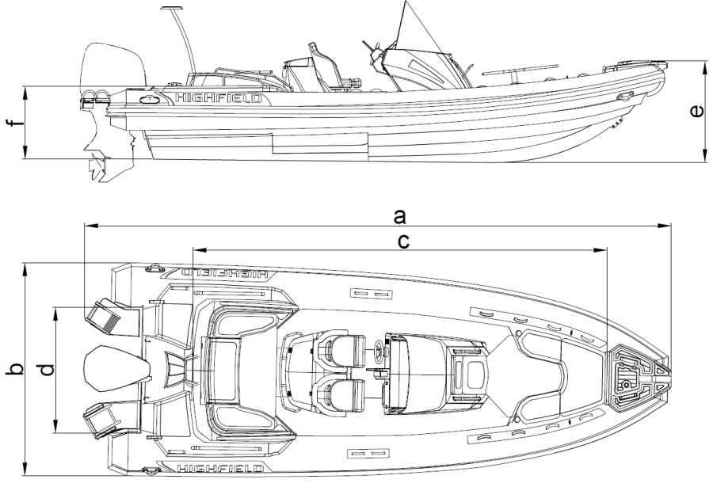
Agencement général

Notes explicatives :
- Longueur totale : inclut les parties amovibles pouvant être démontées sans affecter la structure du bateau.
- Longueur intérieure : hormis les parties amovibles pouvant être démontées sans affecter la structure du bateau.
- Largeur : inclut les parties amovibles pouvant être démontées sans affecter la structure du bateau.
- Largeur intérieure : hormis les parties amovibles pouvant être démontées sans affecter la structure du bateau.
- Capacité du réservoir de carburant : il est possible qu'on ne puisse pas utiliser entièrement cette capacité, selon l'assiette et la charge du bateau. Il est recommandé de laisser une réserve de 20 % dans le réservoir.
- Catégorie B : bateau conçu pour naviguer dans des vents ne dépassant pas la force 8 (Beaufort) et dans les vagues correspondantes. Ces conditions peuvent être rencontrées sur les voyages en mer d’une longueur suffisante, ou sur les eaux côtières non-abritées du vent et des vagues sur plusieurs dizaines de miles nautiques. Ces conditions peuvent également être expérimentées sur les mers intérieures d’une taille suffisante pour que la hauteur des vagues puisse être générée.
Catégorie C : bateau conçu pour naviguer dans des vents ne dépassant pas Beaufort force 6 et dans les vagues correspondantes (vagues de hauteur significative inférieure ou égale à 2 m). Des conditions de ce type peuvent être rencontrées dans les eaux intérieures exposées, dans les estuaires et dans les eaux côtières avec des conditions météorologiques modérées (selon ISO10240).
- Répartition de la charge
- Veuillez vous référer au nombre de passagers et à la capacité de charge maximale du bateau indiqués dans le présent manuel ou sur la plaque constructeur. Ne pas dépasser le nombre maximum.
- Positionner les passagers et répartir la charge uniformément dans le bateau pour contrebalancer le poids du hors-bord.
- Dans les eaux agitées, la charge peut être déplacée vers l'avant pour faciliter l'avance du bateau.
- S'il y a des enfants à bord, le nombre total de personnes autorisées peut être augmenté, à condition que
- le poids total des enfants ne dépasse pas 37,5 kg ; et que
- le poids total de personnes autorisé à bord (basé sur environ 75 kg par adulte) ne soit pas dépassé.

Avertissement
Ne pas dépasser le nombre maximum de personnes recommandé. Quel que soit le nombre de personnes présentes à bord, le poids total des personnes et de l'équipement ne doit jamais dépasser la capacité de charge maximale recommandée. Toujours utiliser les sièges / places assises existants.
Lors du chargement du bateau, ne jamais dépasser la capacité de charge maximale recommandée. Toujours charger le bateau avec précaution et répartir les charges correctement pour maintenir l'assiette correspondant à la conception (niveau approximatif). Éviter de placer des poids élevés en hauteur.
Ne pas installer sur ce bateau un moteur plus puissant que celui indiqué sur la plaque constructeur.
Ne pas utiliser le bateau avec un moteur d'une puissance supérieure à la puissance maximale recommandée. Surmotoriser le bateau peut entraîner des blessures graves, la mort ou des dommages matériels.
Utiliser le trim négatif pour passer de la vitesse de croisière à la vitesse de déjaugeage et à vitesse réduite (applicable aux bateaux équipés d'un système de direction de la poussée de l'hélice).
Ne pas conduire le bateau à grande vitesse avec un trim négatif de l'équipement de propulsion (proue vers le bas).

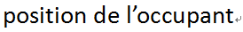
Agencement recommandé des places assises (Sport)

SP300 SP330

SP360 SP390

SP420

SP460

Agencement recommandé des places assises (Sport)

SP520

SP560

SP650

Agencement recommandé des places assises (Sport)

SP700(Cat.B)

SP700(Cat.C)

SP800(Cat.B)

SP800(Cat.C)

Plaque constructeur :
Une partie des informations est indiquée sur la plaque constructeur fixée à l'intérieur du tableau arrière du bateau. Ces informations sont expliquées en détail dans les sections correspondantes du présent manuel.
a

b
c

d

e

f

g

L’altération de la coque ou des accessoires permanents peut invalider les caractéristiques figurant sur cette plaque.
Le nombre maximum de personnes et la charge maximale doivent être réduits en cas de mauvais temps ou quand le bateau est utilisé au large. Se référer au Manuel du Propriétaire avant toute utilisation.

Notes explicatives :
a : Nom du fabricant
b : Modèle
c : Catégorie de conception
d : Puissance maximale du moteur
e : Nombre de passagers maximum
f : Capacité de charge maximale
g : Pression d'utilisation recommandée

Système de carburant

Tableau du système de carburant
Référence | Désignation
1 | Valve anti-submersion
2 | Orifice de remplissage du carburant et de ventilation du réservoir
3 | Indicateur de la jauge de carburant
4 | Réservoir de carburant

Informations relatives au risque de submersion et à la stabilité
- Ouvertures dans la coque

Référence | Désignation
1 | Grilles de ventilation
2 | Puits à chaîne
3 | Réservoir
4/8 | Dalot de drainage cockpit / pont
5 | Flasque du moteur
6/9 | Coffre moteur
7 | Bouchon de vidange de la cale

Utilisation du bouchon de vidange
Votre bateau est équipé des types de bouchons de vidange suivants. Lorsque vous conduisez le bateau, ouvrez le bouchon pour évacuer l'eau sur le sol. L'eau sera automatiquement évacuée par l'effet Venturi. Lorsque vous mettez le bateau à l'eau ou que vous vous arrêtez sur l'eau, nous vous recommandons de laisser le bouchon scellé. Lorsque le bateau est soulevé, rangé, stocké, non utilisé ou transporté, le bouchon de vidange doit rester ouvert pour évacuer l'eau qui pourrait submerger le pont.
Référence | Désignation | Emplacement | Mode d'emploi |  |  | Image
 |  |  | Dans l'eau au repos | Dans l'eau en mouve-  ment | Hors de l'eau
1 | Dalot | Tableau arrière | N/A | N/A | N/A
2 | Bouchon de vidange de la cale | Tableau arrière | Fermé | Fermé | Ouvert
3 | Bonde cockpit | Panneau vertical siège arrière | Fermé | Ouvert | Ouvert

Attention
Laisser le bouchon de vidange du fond de cale ouvert lorsque le bateau est stocké hors de l'eau. L'eau de pluie pourrait s'accumuler dans le bateau, exercer une pression et provoquer des dommages.

Danger
Ne pas ouvrir le bouchon de vidange du fond de cale lorsque le bateau est à flot.
Ne pas tenter d'accéder au bouchon de vidange du fond de cale lorsque le moteur est en marche. L'hélice peut provoquer des blessures graves.

- Stabilité et flottabilité
Ce bateau a été évalué comme étant capable de supporter le poids de l'équipage, même en cas de submersion.
- Le déplacement en pleine charge a été utilisé pour évaluer la stabilité et la flottabilité du bateau. La valeur de ce déplacement figure dans le paragraphe « Spécifications » ci-après.
- Tout changement dans la répartition des charges à bord (par ex. par l'ajout d'une structure surélevée pour la pêche, d'un radar ou d'un mât à enrouleur, un changement de moteur etc.) peut considérablement affecter la stabilité du bateau, de son assiette et de ses performances.
- Il est important de maintenir le niveau d'eau dans les cales à un minimum.
- La stabilité du bateau est affectée par l'ajout d'un poids à la superstructure.
- Lorsque vous êtes en route, il est conseillé de fermer les écoutilles, les vestiaires et les portes pour minimiser le risque de submersion.
- La stabilité du bateau peut être réduite lors du remorquage d'un bateau ou lorsque l'on utilise un bossoir ou une flèche pour soulever une charge lourde.
- Les chambres à air ne doivent pas être perforées.
- Les vagues déferlantes sont un risque sérieux pour la stabilité.
Avertissement
Toujours adapter votre vitesse et le cap de votre bateau aux conditions marines.
Toutes les écoutilles étanches et le bouchon de vidange du fond de cale doivent rester fermés lorsque le bateau est en mer.

Informations relatives au risque d'incendie et à l'explosion
- Démarrage du moteur
- S'assurer que l'eau de refroidissement circule correctement dans le moteur.
- S'assurer que les orifices de ventilation du réservoir de carburant ne sont pas obstrués.
- Arrêter le moteur et ne pas fumer pendant le remplissage du réservoir.
- Faire contrôler régulièrement le circuit du carburant par un technicien professionnel.
- Éviter tout contact entre des matières inflammables et les parties chaudes du moteur.
- Ne jamais éteindre ni couper l'alimentation électrique pendant que le moteur tourne.
- Ouvrir le robinet d'alimentation du carburant.
- Ne pas obstruer ni modifier le système de ventilation. S'assurer que les conduits sont libres.
- Ne jamais retourner le moteur lorsque le bateau n'est pas à l'eau.
- Le carburant stocké en dehors des réservoirs (jerrycans, bidons de réserve) doit être conservé dans un endroit bien ventilé.
- Contrôler régulièrement que le compartiment du réservoir à essence est propre et sec.
- Prendre toutes les précautions nécessaires pour éviter tout contact avec des flammes nues ou d'autres zones chaudes.

Schéma d'implantation de la ventilation du compartiment du réservoir d'essence.

Avertissement
Le réservoir de carburant portatif doit être rempli à l'extérieur du bateau.
Toujours remplir les réservoirs dans un endroit ventilé, le moteur éteint.
Ne pas fumer lors du remplissage des réservoirs.
- Prévention et équipement anti-incendie
- Extincteurs à incendie portatifs et couverture antifeu (non fournis)
- Lorsqu'il est utilisé, ce bateau doit être équipé d'extincteurs à incendie portatifs dotés des capacités d'extinction suivantes et conservés dans les endroits suivants.
- L'emplacement des extincteurs à incendie est indiqué sur le pictogramme ci-après :

Position de l'extincteur portatif
Référence | Désignation | Emplacement | Capacité d'extinction minimale
1 | Extincteur portatif | siège | 8A/6B

Avertissement
Les bateaux équipés d'un moteur hors-bord de 25 kW ou plus doivent être équipés d'un ou plusieurs extincteurs à incendie d'une capacité cumulée d'au moins 86/6B
Le compartiment du réservoir de carburant est équipé d'un port pour l'injection du produit d'extinction. Le port a été conçu de manière à ce que la buse de l'extincteur portatif puisse être insérée à l'intérieur et le produit d'extinction déversé dans le compartiment du réservoir de carburant.

Port incendie - situé du côté du port de la console
- Entretien de l'équipement anti-incendie
Le propriétaire/l'utilisateur du bateau doit :
- Faire contrôler l'équipement anti-incendie à intervalles réguliers conformément aux indications figurant sur l'équipement.
- Remplacer les extincteurs portatifs, si leur validité a expiré ou s'ils sont déchargés, par des dispositifs de capacité d'extinction identique.
- Faire procéder au remplissage ou au remplacement des systèmes fixes lorsque leur validité a expiré ou lorsqu'ils sont déchargés.
- Responsabilité du propriétaire/de l'utilisateur du bateau
- S'assurer que l'équipement de lutte anti-incendie est facilement accessible lorsque le bateau est occupé.
- S'assurer que les points de vidange du compartiment du réservoir d'essence sont facilement accessibles.
- Informer les membres de l'équipage de l'emplacement et du fonctionnement de l'équipement de lutte anti-incendie, de l'emplacement des orifices de déversement dans l'espace du moteur et l'emplacement des voies d'évacuation et des sorties de secours.
Attention
Maintenir les cales propres et vérifier fréquemment qu'il n'y a ni vapeurs de carburant ni de gaz, ni de fuites de carburant. Lors du remplacement de parties de l'installation anti-incendie, utiliser uniquement des composants compatibles, dotés de la même désignation ou de capacités techniques et de résistance au feu équivalentes.
Systèmes électriques
Danger
Une utilisation incorrecte des systèmes de courant DC et AC peut générer des risques d'incendie ou d'explosion.
Une utilisation incorrecte du système AC peut générer un risque de choc électrique.

Avertissement
Ne pas travailler sur un système électrique sous tension.
Ne pas modifier le système électrique du bateau ou les schémas correspondants. Il est important que l'installation, l'entretien et toutes les modifications soient exécutés par un technicien qualifié en électricité marine.
Ne pas changer ni modifier la puissance des dispositifs de sécurité de protection contre les surtensions
Ne pas installer ni remplacer l'équipement électrique ni les matériaux dont les composants excèdent la puissance électrique nominale.
Ne pas laisser le bateau sans surveillance lorsque le système électrique est sous tension, sauf lorsque la pompe automatique de la cale et les systèmes de protection et de sécurité anti-incendie du bateau sont en cours d'utilisation.
SP300-460:

Élément | Description | Quantité | Élément | Description | Quantité
① | Coupe-circuit 5025B | 1 | ⑦ | Interrupteur principal | 1
② | Commutateur semi-automatique | 1 | ⑧ | Batterie | 1
③ | Commutateur manuel | 5 | ⑨ | Coupe-circuit 5064B | 1
④ | USB AD2013 | 1 | ⑩ | Jauge de carburant | 1
⑤ | Prise AD1011 | 1 | ⑪ | Moteur | 1
⑥ | Borne | 1 | ⑫ | Isolateur | 1
SP520-800:

Élément | Description | Quantité | Élément | Description | Quantité
① | Coupe-circuit 5025B | 1 | ⑦ | Interrupteur principal | 1
② | Commutateur semi-automatique | 1 | ⑧ | Batterie | 1
③ | Commutateur manuel | 3 | ⑨ | Collecteur 2303B | 1
④ | USB 1039B | 1 | ⑩ | Jauge de carburant | 1
⑤ | Prise 1011B | 1 | ⑪ | Moteur | 1
⑥ | Borne | 1 | ⑫ | Isolateur | 1
 |  |  | ⑬ | Coupe-circuit 5064B | 1

Transport
Pour une manipulation optimale, la remorque doit être correctement chargée et équilibrée.
- Maintenir le centre de gravité au plus bas pour manœuvrer le mieux possible.
- Environ 60 % du poids du bateau doit être positionné sur la moitié avant de la remorque et 40 % à l'arrière.
- Le bateau doit être équilibré d'un côté à l'autre. Si celui-ci est équipé de réservoirs de carburant ou d'eau montés latéralement et remplis d'un seul côté, la remorque se prêtera plus difficilement aux manœuvres. Un bon équilibrage prolongera également la vie des pneus de vos remorques.
- Le bateau doit être fermement sécurisé avec au moins deux sangles d'amarrage à cliquet, l'une de la remorque aux anneaux de poupe et l'autre de la remorque à l'anneau de proue pour empêcher le bateau de basculer vers l'avant. L'anneau de proue doit également être attaché au treuil de la remorque qui est monté à l'avant de la proue. S’assurer de disposer d'un espace suffisant pour éviter d'endommager le moteur hors-bord ou le bateau pendant le transport.
- Les modèles Classic peuvent être placés/transportés sur une galerie de toit. Nous recommandons de protéger les zones de contact entre la bateau et les barres de toit qui pourraient endommager le matériau du tube. Le bateau doit être stocké à l'envers. Rames, siège et équipements doivent être retirés du bateau. Le bateau doit être sécurisé à l'aide de solides sangles à cliquets en nylon. Nous recommandons également d'attacher une corde dans l'anneau de remorquage de la proue pour plus de sécurité.

Démarrage du moteur
Avant de démarrer le moteur, impérativement :
- ouvrir le robinet d'alimentation du carburant
- allumer l'alimentation de la batterie à l'aide des interrupteurs coupe-batterie
- mettre le levier de commande en position neutre
- Relier le coupe-circuit/cordon coupe-circuit d'urgence au pilote.
Prendre l'habitude de regarder si de l'eau de mer est évacuée avec les gaz d'échappement dès que vous démarrez le moteur. Si aucune eau ne sort, arrêter le moteur immédiatement. Contrôler le débit de réfrigérant.
Danger
Avant d'utiliser le moteur, lire attentivement le manuel fourni par le fabricant du moteur.
Toujours démarrer le moteur avec le levier de commande en position neutre.
Apprendre à évaluer la distance de décélération nécessaire jusqu'à l'arrêt complet du bateau (la marche arrière n'est pas un frein)
Utiliser le cordon coupe circuit d'urgence.

Utilisation
1. Gonflage
a- Capuchon de la valve
b- Piston

- Pour gonfler la chambre, dévisser d'abord le capuchon de la valve en tournant d'un quart de tour en sens inverse horaire. Vérifier que le piston au centre de la valve est fermé, c'est-à-dire en position haute. S'il est ouvert, c'est-à-dire si le ressort est comprimé, en position basse, pousser le piston vers le bas et faites le pivoter en position fermée.
- Raccorder la pompe à air à la valve, tourner le connecteur dans la valve pour la verrouiller et commencer à gonfler. Que vous utilisiez une pompe à pédale ou une pompe électrique ne gonflez pas au-delà de la pression recommandée de 0,2 bars par chambre.
- Utiliser un manomètre pour mesurer la pression du tube.

- Il est important de gonfler les chambres tour à tour conformément à la procédure indiquée plus bas. Ne pas gonfler une chambre complètement puis passer à la suivante. Commencer par les chambres arrière. Répéter la procédure jusqu'à ce que toutes les chambres soient uniformément gonflées à la pression d'utilisation recommandée.

- Pendant le gonflage, veiller à ce que la pression entre les chambres à air soit équilibrée afin de ne pas endommager les cloisons de pressurisation.
- Les bateaux pneumatiques peuvent être endommagés par une pression d'air interne trop élevée. Une pression trop élevée peut être provoquée par des différences de température. Un bateau correctement gonflé le matin peut se retrouver dangereusement en surpression lorsque la chaleur augmente au cours de la journée. La pression interne peut être multipliée plusieurs fois alors que la température des surfaces augmente et, dans ces conditions les assemblages peuvent se désolidariser et les matières liées se décoller. Éviter de soumettre votre pneumatique à de telles conditions en réduisant la pression dans toutes les chambres de votre bateau lorsque la chaleur augmente au cours de la journée ou avant de laisser le bateau exposé au soleil de midi. Il est fortement recommandé de ranger le bateau à l'ombre ou à l'abri lorsqu'il n'est pas utilisé.
- Utiliser le bateau avec des tubes sous-gonflés peut entraîner des dommages importants, y compris des fissures sur le tableau arrière.
Attention
Ne pas utiliser une source d'air comprimé pour gonfler le tube sous peine de compromettre l'intégrité des assemblages ou des cloisons internes. Les ruptures d'assemblage ou de cloisons en raison du non-respect de la procédure de gonflage ne sont pas couvertes par la garantie.
2. Performance
- Pour atteindre la meilleure performance, le bateau doit « déjauger » Si le bateau ne déjauge pas, vous pouvez vérifier les points suivants :
- Assurez-vous que la cale / le pont est sec, sinon drainez l'eau.
- Assurez-vous que le tube est correctement gonflé.
- Assurez-vous que le poids est correctement réparti. Les conditions marines peuvent parfois exiger que les passagers se déplacent vers l'avant du bateau pour lui permettre de déjauger, avant de retourner à leurs positions initiales.
- Assurez-vous que le moteur hors-bord convient bien au type de bateau.
- Le moteur hors-bord joue un grand rôle dans la performance du bateau et doit être adapté au type de bateau.
- Lorsque vous conduisez votre bateau, vous devez le garder en équilibre à l'avant et à l'arrière. À cet effet, vous devez régler l'angle de l'assiette du bateau. Une coque à la bonne assiette présente deux avantages : une consommation réduite de carburant et une vitesse accrue.
- La plupart des moteurs hors-bord de plus de 30 chevaux sont équipés d'un système de réglage d'assiette et de relevage commandé par un vérin hydraulique situé au centre du support de montage du moteur. Il est destiné à relever et baisser le moteur et est commandé par un interrupteur à bascule « haut/bas » intégré à la manette de changement de vitesse et des gaz située directement sous votre pouce droit pour un accès facile. En mode « relevage », le système relève le moteur entièrement hors de l'eau lorsqu'il n'est pas utilisé. Il peut également être utilisé pour relever le moteur lorsque l'on conduit lentement dans des eaux très peu profondes pour éviter d'endommager l'hélice.
En mode « assiette », le système s'emploie à régler l'angle du moteur pour jouer sur l'angle de conduite du bateau. Au fur et à mesure que le bateau prend de la vitesse, l'angle du moteur assure la remontée nécessaire au déjaugeage du bateau pour une performance optimale. En position la plus basse, le moteur est en « trim négatif », c'est-à-dire que l'angle de l'arbre du moteur et de l'hélice est un peu plus vers l'avant qu'à la verticale par rapport au tableau arrière. Ceci est la position que devrait avoir le moteur avant remettre les gaz après un arrêt brutal. Un trim négatif exerce une force descendante sur la coque pour limiter la levée de la proue qui est courante avec les coques qui déjaugent sous l'effet de l'accélération initiale. Plus l'accélération initiale est brutale, plus la proue a tendance à se lever. Si vous remettez les gaz brutalement après un arrêt, (une procédure appelée « déjaugeage ») certaines coques soulèvent momentanément la proue à un angle aigu jusqu'à ce que la force descendante du moteur compense cette élévation.
- L'angle du moteur hors-bord peut être ajusté pour améliorer l'assiette et la performance générale. Ajuster la position du moteur pour définir l'angle de l'assiette du moteur hors-bord par rapport au tableau arrière. Effectuer des tests avec le moteur fixé à des angles différents pour trouver la position qui convient le mieux à votre bateau et aux conditions d'utilisation.

Moteur avec trim négatif

Moteur avec trim positif
3. Remorquage
Votre bateau peut être remorqué à l'aide de l'anneau de remorquage situé sur la proue. Assurez-vous d'utiliser un câble de remorquage calibré pour au moins 5 fois le poids du bateau à remorquer. Le bateau doit être remorqué uniquement à l'aide de l'anneau de remorquage. Les poignées moulées, les bouées de sauvetage et les taquets d'amarrage ne sont pas conçus pour le remorquage.
- Il est recommandé de remorquer le bateau à l'aide d'un système de bride en utilisant les anneaux en D situés de part et d'autre de la proue.
- Une ligne de sécurité supplémentaire doit être également attachée à l'anneau en aluminium soudé à l'avant de la coque.
- Veuillez noter que les canots pneumatiques remorqués doivent être surveillés en permanence, en particulier la nuit.
- Lorsque l'on remorque un canot pneumatique, les conditions peuvent varier considérablement, c'est pourquoi la sécurité incombe exclusivement au capitaine.
Avertissement
Pour être remorqué, le bateau doit être vide.
Retirer le moteur hors-bord, le réservoir de carburant et l'équipement avant le remorquage.
Aucun passager ne doit se trouver à bord.
Le bateau doit être remorqué à vitesse réduite.
4. Levage
Lorsque l'on utilise un palan pour soulever le bateau, il convient de fixer le crochet aux 3 (ou 4 selon le type de bateau) anneaux de levage soudés à la coque. Vider le bateau de tout son équipement et s'assurer qu'aucun passager ne se trouve à bord. S'assurer que le pont et la cale ont été drainés avant le levage. Retirer le bouchon de vidange pendant toute la période où le bateau est rangé pour permettre à l'eau de s'écouler. Les poignées moulées, les bouées de sauvetage et les taquets d'amarrage ne sont pas des outils de levage. Lors du levage et de la manutention, s'assurer que personne ne se trouve sous le bateau élingué.
5. Beacher son bateau
Nous recommandons de ne pas propulser le bateau sur la plage, ni de le traîner sur les rochers, le sable, du gravier ou la chaussée car il pourrait en résulter des dommages sur le tissu et/ou la coque.
6.Moteur hors-bord
Installer le moteur hors-bord sur le tableau arrière de manière à ce qu'il soit placé aussi près que possible du centre. Serrer les vis de fixation du tableau arrière de manière uniforme et sécurisée. Vérifier de temps en temps que les vis de fixation sont bien serrées pendant le fonctionnement du moteur hors-bord car elles peuvent se desserrer en raison des vibrations. S'assurer avant chaque utilisation que le moteur hors-bord est solidement fixé au tableau arrière. Il est conseillé d'attacher également le moteur au tableau arrière puisque des œillets de fixation sont disponibles. Toujours utiliser le cordon coupe-circuit d'urgence correctement.
Le réservoir portatif doit être retiré du bateau lors du remplissage. Le réservoir doit être rempli dans un endroit bien ventilé. Ne pas fumer à bord.
Avertissement
Surmotoriser le bateau peut entraîner des blessures graves, la mort ou des dommages matériels. Ne pas utiliser de moteur hors-bord qui dépasse la puissance maximale indiquée sur la plaque signalétique du moteur.

Prévention de chute d'homme à la mer et récupération
- Prévention de chute d'homme à la mer

- Les zones situées en dehors de l'aire de travail sur le pont correspondent aux aires hachurées en rouge comme ci-dessus.
- Le « pont de travail » correspond aux aires dans lesquelles les gens se tiennent debout ou marchent dans le cadre de l'utilisation normale du bateau.
- Il est interdit de se tenir sur le coffre avant ou le pont promenade.
2. Récupération - remonter à bord
Les moyens de remonter à bord doivent être déployés par une seule personne dans l'eau, sans autre aide. Nous recommandons d’utiliser une échelle de poupe pliable optinnelle.
Danger
S'assurer que les moyens de récupération à bord sont effectivement accessibles et faciles à utiliser pour une personne seule dans l'eau.
3. Danger émanant des parties en mouvement
Laisser le moteur éteint lorsque le boîtier/le capot/hayon du moteur est ouvert. Le boîtier/capot/hayon du moteur sert de dispositif de protection. Les vêtements ou des parties du corps peuvent être happés par des parties en mouvement entraînant la mort ou des blessures graves. Rester à l'écart des parties en mouvement.

Danger
Le contact avec une hélice en rotation peut entraîner des blessures ou la mort.
Ne pas entrer ni sortir de l'eau lorsque le moteur tourne (ON) et que l'hélice est en rotation.
Ne pas monter sur la plate-forme de bain lorsque le moteur tourne.
Ne jamais nager en direction de l'arrière du bateau lorsque le moteur est en marche.

Entretien
- Entretien de base
Votre pneumatique a été spécialement conçu pour éviter dans la mesure du possible les problèmes d'entretien. Cependant, un nettoyage périodique vous permettra de garder votre bateau en bon état, notamment avant le remisage hivernal. Nettoyer votre bateau et le laver soigneusement à l'eau savonneuse. Rincer soigneusement et vérifier qu'aucune saleté ni corps étrangers tels que des coquillages, du sable ou des hameçons de pêche pouvant détériorer le tissu ne sont restés à l'intérieur. Pour éliminer les taches de goudron, utiliser un nettoyant doux, non abrasif comme du liquide vaisselle ou un nettoyant recommandé pour les bateaux pneumatiques que vous trouverez dans la plupart des magasins d'accastillage.
Pour les coussins et les capitonnages, Highfield utilise des tissus de qualité marine qui offrent la meilleure résistance aux UV et au vieillissement. Un lavage périodique à l'aide d'un nettoyant doux et d'eau chaude est la meilleure façon d'entretenir les coussins de votre bateau. Un nettoyant spécial vinyle peut également être utilisé pour éliminer les taches rebelles. Aucun tissu ne peut durer éternellement lorsqu'il est en permanence exposé aux éléments.
Aucun tissu ne peut durer éternellement quand il est constamment exposé au soleil. Pour assurer la durabilité de vos flotteurs en PVC, une solution de protection contre les rayons UV doit être appliquée deux fois par an sur le tissu de foltteur. Nous recommandons d’utiliser 303® Aerospace Protectant ™.
Attention
Ne pas utiliser de produits chimiques abrasifs ou agressifs.
L'eau chaude savonneuse est le meilleur moyen dans la plupart des cas.
Ne pas utiliser de solvants, d'essence etc. (modèles PVC).
Utiliser des solvants avec parcimonie uniquement sur les modèles en Hypalon.
En cas de doute, tester au préalable tout nouveau nettoyant sur un bout de tissu.
- Dégonflage
Pour dégonfler la chambre, dévisser d'abord le capuchon de la valve en tournant d'un quart de tour en sens inverse horaire. Vérifier que le piston au centre de la valve est fermé, c'est-à-dire en position haute. S'il est fermé, c'est-à-dire si le ressort est comprimé, en position basse, pousser le piston vers le bas et faites le pivoter en position fermée.
Raccorder la pompe à air à la valve, tourner la fiche dans la valve pour la bloquer et commencer à dégonfler.
Dégonfler les chambres l'une après l'autre, ne pas dégonfler une chambre complètement puis passer à la suivante. Commencer par les chambres arrière. Répéter la procédure jusqu'à ce que toutes les chambres soient entièrement dégonflées.
Attention
Ceci n'est pas une liste exhaustive de recommandations : votre revendeur vous conseillera si nécessaire et se chargera de l'entretien technique de votre bateau.
- Stockage
Nous vous recommandons de couvrir votre bateau lorsqu'il n'est pas utilisé.
- Lorsqu'il n'est pas utilisé, le bateau doit être sorti de l'eau.
- Avant d'être remisé, le bateau doit être nettoyé et rincé à l'eau douce.
- Ne pas couvrir le bateau avant qu'il ne soit complètement sec, sinon des moisissures pourraient apparaître sous la housse et endommager le matériau du tube.
- Les housses doivent être ventilées et le bouchon de vidange retiré.
- Vérifier les dates d'expiration de l'équipement de sécurité.
- Le bateau doit être régulièrement révisé.
- Graisser et fermer toutes les valves et les passe-coque.
- Graisser toutes les pièces mécaniques et mobiles (boulons, charnières, fermetures...).
- Fermer tous les robinets du bateau.
- Replacer les caches sur les écrans électroniques.
- Aérer tous les coussins et capitonnages pendant un certain temps avant de les remettre à bord et de les arranger de manière à limiter les zones de contact.
- Ôter les capitonnages amovibles.
- Déconnecter les batteries. Veiller à les recharger pendant l'hiver si le bateau reste inutilisé pendant une longue période.
Attention
L'hivérisation du moteur doit être effectuée par un ingénieur professionnel : veuillez consulter votre revendeur.
Ceci n'est pas une liste exhaustive de recommandations : votre revendeur vous conseillera si nécessaire et se chargera de l'entretien technique de votre bateau.
- Réparation du tube
- Le kit de réparation contient :
- des pièces de tissu ; b) un tube de colle spéciale prête à l'emploi
- Conditions idéales de réparation :
- Humidité max. 60 %
- Température ambiante entre 18 et 25°C.
- Les réparations ne doivent pas être effectuées directement au soleil, au vent ou sous la pluie.
- Par contre, elles doivent être effectuées dans un endroit bien ventilé.
- Réparation des bateaux en PVC :
Les bateaux pneumatiques de Highfield dont les tubes construits avec du tissu PVC Valmex exigent des colles à base de PU et des durcisseurs RC. Un solvant à l'acétone est recommandé pour préparer la surface avant le collage. Utiliser uniquement le solvant et la colle recommandés.
- Identifier la zone à réparer. À cet effet, faire couler de l'eau sur la zone suspecte, ou l'asperger ou la brosser avec de l'eau savonneuse.
- Si le trou est de petite taille, découper une pièce ronde d'au moins 60 mm de diamètre. Pour les trous ou les coupures plus grands, découper une pièce proportionnellement plus grande, mais s'assurer de toujours de disposer de 30 mm de marge autour de la coupure ou du trou. Tous les angles de la pièce devront avoir été préalablement arrondis.
- Ensuite, placer la pièce sur le tube et marquer le contour.
- Nettoyer les deux surfaces avec du solvant et appliquer une fine couche de colle en veillant à ce qu'il n'y ait pas de grumeaux.
- Lorsque la première couche est sèche au toucher (au bout 10 à 15 minutes env.), appliquer une seconde couche fine.
- Au bout de 5 à 6 minutes, toucher la colle avec le dos de la main. Si elle ne semble plus humide, chauffer les deux surfaces à l'aide d'un pistolet à air chaud pour réactiver la colle et placer le patch sur le tube puis presser les surfaces l’une contre l’autre à l'aide d'une pince ou d'un rouleau. Pour une adhésion optimale, passer un rouleau ou le fond d'une bouteille sur le patch.
Attention
Ne pas gonfler entièrement le bateau pendant 24 heures.
- Réparation de bateaux en Hypalon :
Les bateaux pneumatiques Highfield équipés de tubes en tissu enduit en Hypalon Orca ne peuvent pas être collés avec des colles pour plastique ou par soudure. Ils nécessitent une colle à base de néoprène et un durcisseur RFE. Un solvant MEK est recommandé pour préparer la surface avant le collage. Utiliser uniquement le solvant et la colle recommandés.
- Identifier la zone à réparer. À cet effet, faire couler de l'eau sur la zone suspecte, ou l'asperger ou la brosser avec de l'eau savonneuse.
- Si le trou est de petite taille, découper une pièce ronde d'au moins 60 mm de diamètre. Les trous ou coupures plus grands nécessitent des pièces proportionnellement plus grandes mais assurez-vous de toujours disposer de 30 mm de marge autour de la coupure ou du trou. Tous les angles de la pièce devront avoir été préalablement arrondis.
- Ensuite, placer la pièce sur le tube et marquer le contour.
- Utiliser une lime, du papier de verre grossier ou une pierre ponce afin d'émeriser le dos du patch et la zone marquée sur le tube.
- Nettoyer les deux surfaces avec du solvant et appliquer une fine couche de colle en veillant à ce qu'il n'y ait pas de grumeaux.
- Lorsque la première couche est sèche au toucher (au bout 10 à 15 minutes env.), appliquer une seconde couche fine. Au bout de 5 à 6 minutes, toucher la colle avec le dos de la main. Si elle ne semble plus humide, chauffer les deux surfaces à l'aide d'un pistolet à air chaud pour réactiver la colle et placer le patch sur le tube puis presser les surfaces l’une contre l’autre à l'aide d'une pince ou d'un rouleau. Pour une adhésion optimale, passer un rouleau ou le fond d'une bouteille sur le patch.
Danger
La colle et le solvant utilisés pour les réparations sont hautement inflammables. Effectuer les réparations dans un endroit bien ventilé. Éviter de respirer les vapeurs, porter des équipements de protection (lunettes, masques respiratoires filtrants, gants en latex).

Garantie
Le produit que vous avez acheté est fourni avec une garantie limitée de Highfield. Les conditions de garantie figurent dans la section correspondante du présent manuel. Celle-ci contient une description de ce qui est couvert, de ce qui ne l'est pas et de la durée de validité de la garantie. Veuillez prendre connaissance de ces informations importantes. La description et les spécifications contenues de ce document étaient en vigueur au moment où ce manuel a été approuvé pour impression. Highfield, dont la politique est celle de l'amélioration continue, se réserve le droit de discontinuer certains modèles à tout moment, de modifier les spécifications, les designs, les méthodes ou les procédures sans préavis et sans encourir aucune obligation.
Enregistrez le numéro d'identification de la coque (NIC).
Le NIC est situé sur le tableau arrière de votre bateau. Vous aurez besoin de cette information pour commander des pièces de rechange, pour toute demande de service sous garantie et en cas de vol de votre bateau.

Highfield - Garantie limitée pour le client au détail
- CE QUI EST COUVERT
Les bateaux Highfield sont garantis exempts de vices de matériel et de fabrication pendant la période mentionnée ci-après :
- DURÉE DE LA GARANTIE
- L'intégralité du bateau est garantie pendant une période de deux (2) ans à compter de la date de vente du produit.
- La structure de la coque est garantie pendant une période de cinq (5) ans.
- En cas d'utilisation commerciale ou de location, l'intégralité du bateau est garantie pendant une période d’un (1) an.
- REVÊTEMENT DE PEINTURE (poudre)
Le revêtement de peinture en poudre est garanti pendant une période de 2 ans contre les vices de fabrication.
Cette garantie n'inclut pas les dommages causés par une utilisation non conforme du bateau et dus à des chocs chimiques ou mécaniques tels que :
- la collision, l'incendie, le vol, les émeutes etc.
- l'altération, la modification et le sabotage.
- La corrosion ambiante et les chocs dus aux pluies acides, aux retombées chimiques, à la pollution industrielle, à la glu pour oiseaux, à la sève des arbres, à la grêle, aux intempéries etc.
- CONDITIONS À REMPLIR POUR BÉNÉFICIER DE LA GARANTIE
La garantie est valide uniquement pour les clients qui achètent auprès d'un revendeur autorisé Highfield. L'entretien périodique décrit dans le Manuel du Propriétaire doit être effectué en temps voulu afin de conserver le bénéfice de la garantie. Si le propriétaire procède à un entretien régulier, Highfield se réserve le droit de conditionner le bénéfice de la garantie aux preuves de l'entretien en bonne et due forme.
- CE QUE FERA HIGHFIELD
La seule obligation qui lie Hifghfield aux termes de cette garantie est limitée, à notre discrétion, à la réparation d'une pièce défectueuse, à son remplacement ou au remboursement du prix d'achat du produit Highfield. La réparation, le remplacement des pièces ou la prestation de service sous garantie ne prolonge pas la durée de validité de ladite garantie au-delà de sa date d'expiration initiale.
- COMMENT BENEFICIER DE LA GARANTIE
Le client doit donner la possibilité à Highfield de procéder à la réparation, et un accès raisonnable au produit pour lui permettre de s'acquitter du service sous garantie. Les demandes de garantie doivent être faites moyennant la remise du produit pour inspection à un revendeur Highfield autorisé à réparer le produit. Si le service fourni n'est pas couvert par la garantie, l'acheteur devra s'acquitter du prix de la main d'œuvre et des pièces et de tous les autres frais liés à la réparation. L’acheteur ne doit pas, sauf si Highfield le demande, expédier le produit ou des parties du produit directement à Highfield. Un justificatif de propriété doit être présenté au revendeur au moment de la demande de service sous garantie pour pouvoir bénéficier de la garantie.
- CE QUI N'EST PAS COUVERT
- La garantie limitée ne couvre pas les dommages dus à une utilisation non conforme, un abus, une négligence, un stockage ou un transport incorrect ou inadéquat, et ne s’appliquera pas à tout bateau Highfield utilisé en dépit des consignes et des instructions figurant dans le Manuel du Propriétaire Highfield.
- La garantie ne couvre pas l'entretien de routine, les ajustements, l'usure normale et la déchirure, la perforation, la décoloration, l'oxydation, l'abrasion, les moisissures ou les dommages dus au vol, à la perte, à la modification ou à l'altération.
- Les pièces d'usure, y compris mais non limitées à la bande de protection, aux protections de la quille, aux cordes ne sont pas couvertes par la garantie.
- Cette garantie sera sans effet si le bateau a été utilisé avec une pression du tube incorrecte ou avec un moteur hors-bord dépassant la puissance maximale indiquée sur la plaque constructeur fixée sur le tableau arrière.
- L'état du revêtement de peinture (poudre) n'est pas couvert par la garantie en raison de la nature spécifique de l'exposition du produit.
- Pour une meilleure protection à long terme, veiller à ce que toutes les surfaces soient rincées à l'eau douce après chaque utilisation et nettoyées immédiatement de toutes substances pouvant coller à la surface et provoquer des décolorations ou des dommages.
- Nous vous recommandons de faire réparer le plus rapidement possible les rayures et les bosses.
- Toute utilisation du produit pour des courses ou toute autre activité de compétition annule cette garantie limitée.
- Les dépenses liées au halage, au lancement, au remorquage, au stockage, au transport, au téléphone, à la location, aux inconvénients, aux frais de glissement, aux frais d'assurance, à la perte de temps, à la perte de revenus ou à tout autre type de dommages directs ou indirects ne sont pas couvertes par cette garantie.
- TRANSFERT DE LA GARANTIE
La garantie limitée est transférable à un acheteur ultérieur, mais uniquement pour le reste de la durée résiduelle de la garantie limitée. Ceci ne s'applique pas si le bateau est utilisé à des fins de location ou à des fins commerciales.
Pour transférer la garantie, merci d'envoyer un e-mail avec les informations ci-après à l'adresse suivante : warranty@highfieldboats.com.
- Copie du contrat de vente
- Numéro NIC du bateau
- Nom, adresse, adresse e-mail du nouveau propriétaire.

Informations produit
Modèle
NIC (HIN)
Date d'achat
Informations sur le revendeur
Nom
Adresse
Téléphone
Cachet du revendeur
Informations sur le client
Nom
Adresse
Adresse e-mail
Téléphone

Service assistance
Pour toute demande d'assistance, veuillez contacter votre revendeur Highfield et consulter le site Web de Highfield :
www.highfieldboats.com

GUARDE ESTE MANUAL EN UN LUGAR SEGURO Y ENTRÉGUELO AL NUEVO PROPIETARIO CUANDO VENDA LA EMBARCACIÓN.
Índice de contenido

Introducción general 62
Advertencias de seguridad 63
Recomendaciones para una navegación segura 63
Lista de comprobación antes del uso 64
Especificaciones: Sport 65
Disposición general 65
Especificaciones: Sport 66
Disposición general 66
Especificaciones: Sport 67
Disposición general 68
Disposición recomendada para sentarse 69
Disposición recomendada para sentarse 70
Disposición recomendada para sentarse 71
Placa de características del fabricante: 72
Sistema de combustible 72
Información relacionada con el riesgo de inundación y la estabilidad 73
Información relacionada con el riesgo de fuego o explosión 76
Sistemas eléctricos 78
Transporte 80
Arrancar el motor 80
Funcionamiento 81
Prevención y recuperación del hombre al agua 84
Mantenimiento 85
Garantía 88
Asistencia técnica 90

Lea atentamente este manual del propietario para que pueda disfrutar al máximo de su embarcación Highfield. Contiene todas las instrucciones de seguridad y operación necesarias para sacar el máximo partido a su nueva Highfield.

Introducción general
Este manual se ha recopilado para ayudarle a utilizar su embarcación con seguridad y satisfacción. Contiene detalles sobre la embarcación, el equipo suministrado o incorporado, sus sistemas e información sobre su operación. Léalo atentamente y familiarícese con la embarcación antes de usarla.
Este manual del propietario no es un curso sobre seguridad náutica ni navegación. Si es su primera embarcación o si ha cambiado a un tipo de embarcación con el que no está familiarizado, para su propio confort y seguridad debe adquirir experiencia de maniobra y operación antes de "asumir el mando" de la embarcación. Su distribuidor o la federación de navegación de su país o el club náutico estarán encantados de asesorarle sobre escuelas de navegación locales o instructores competentes.
Asegúrese de que las condiciones de viento y mar previstas se correspondan con la categoría de diseño de su embarcación y de que tanto usted como su tripulación están capacitados para maniobrar la embarcación en estas condiciones.
Aunque su embarcación tenga la categoría de diseño adecuada a las condiciones de mar y viento (A, B o C), estas varían desde condiciones de tormenta fuerte para la categoría A hasta condiciones fuertes para la parte alta de la categoría C, y no pueden descartarse los riesgos de olas gigantes o rachas inesperadas. Estas condiciones son peligrosas y solo una tripulación competente, en forma y bien preparada puede manejarlas correctamente con una embarcación bien mantenida.
El presente manual del propietario no es una guía detallada de mantenimiento ni solución de problemas. En caso de dificultades, consulte al fabricante de la embarcación o a su representante. Si se ha proporcionado un manual de mantenimiento, utilícelo para el mantenimiento de la embarcación.
Encargue siempre el mantenimiento, las reparaciones o las modificaciones a personas competentes y preparadas. Las modificaciones que puedan afectar las características de seguridad de la embarcación deben ser evaluadas, ejecutadas y documentadas por personas competentes. El fabricante de la embarcación no puede asumir responsabilidad alguna por las modificaciones realizadas sin su consentimiento.
En algunos países se requiere una licencia o autorización de pilotaje, o bien están vigentes normativas específicas.
Realice siempre un mantenimiento adecuado de su embarcación y tenga en cuenta el deterioro que sufrirá esta con el tiempo como resultado del uso intensivo o del mal uso de la embarcación.
Cualquier embarcación, independientemente de lo robusta que sea, puede sufrir graves daños si no se usa de forma adecuada. Dichos daños no son compatibles con una navegación segura. Adapte siempre la velocidad y el rumbo de la embarcación a las condiciones marítimas.
Si su embarcación dispone de balsa salvavidas, lea atentamente su manual de uso. La embarcación debería tener a bordo el equipo de seguridad adecuado (chalecos salvavidas, arneses, etc.) de acuerdo con el tipo de embarcación, las condiciones meteorológicas, etc. Dicho equipo es obligatorio en algunos países. La tripulación debería estar familiarizada con el uso de todo el equipo de seguridad y las maniobras de emergencia (rescate de hombre al agua, remolque, etc.); las escuelas de navegación y los clubes náuticos organizan sesiones de simulacros regulares.
Todas las personas deberían llevar una ayuda a la flotabilidad adecuada (chaleco salvavidas/equipo de flotación individual) cuando estén en cubierta. Recuerde que algunos países imponen la obligación legal de llevar en todo momento ayudas a la flotabilidad que cumplan sus normativas nacionales.

Advertencias de seguridad
El presente manual utiliza las siguientes advertencias de seguridad para captar su atención acerca de instrucciones de seguridad especiales que deben seguirse.
Nivel de riesgo y etiquetas de seguridad correspondientes:
Peligro
Indica que existe un riesgo intrínseco extremo que provocará con gran probabilidad la muerte o lesiones irreparables si no se toman las precauciones adecuadas.

Advertencia
Indica que existe un peligro que puede ocasionar una lesión o la muerte si no se toman las precauciones adecuadas.

Precaución
Indica un recordatorio de prácticas de seguridad o destaca prácticas no seguras que podrían ocasionar una lesión personal o daños en los componentes de la embarcación o en el medio ambiente.

Recomendaciones para una navegación segura
- Lleve siempre chaleco salvavidas
Las autoridades locales le obligan a tener a bordo un equipo de flotación individual homologado, o un chaleco salvavidas, para cada persona que se encuentre a bordo de su embarcación. Recomendamos llevar puesto siempre un chaleco salvavidas durante la navegación.
- Utilice el cable desconectador "hombre al agua"
El piloto de la embarcación debe llevar siempre un cable desconectador durante el pilotaje. En caso de expulsión accidental o pérdida de equilibrio, la embarcación se parará automáticamente. El hecho de llevar un cable desconectador puede salvar la vida del piloto o de otra persona.
- Conozca su embarcación
Conocer la embarcación es básico para una buena práctica náutica, que consiste simplemente en la capacidad de controlar una embarcación, e incluye: navegación, seguridad, maniobra de la embarcación, manejo de los cabos, fondeo, solución de problemas en el motor y reacción adecuada en caso de emergencia.
- Asista a un curso de seguridad náutica y aprenda las normas de navegación
Un curso de navegación le aportará los conocimientos básicos sobre práctica náutica mencionados anteriormente. Los conocimientos adquiridos en un curso de seguridad náutica no se desperdiciarán nunca. Aprenda a leer cartas náuticas y guárdelas en su embarcación para familiarizarse con la zona en la que navega. La asistencia a un curso de seguridad náutica es el próximo paso, y allí aprenderá a navegar utilizando cartas, GPS, radar y compás.
- Navegue sobrio
Las bebidas alcohólicas son incluso más peligrosas en el agua que en tierra, porque el entorno marino acelera la perturbación. Además de los riesgos para la seguridad, pilotar en estado de embriaguez es ilegal y está penalizado con fuertes multas tanto por el estado como por las agencias federales.
- Evite los abordajes
Observe las reglas de preferencia definidas en las normas de navegación e impuestas por el reglamento internacional de prevención de abordajes en la mar. Asegúrese de tener siempre espacio suficiente para detener la embarcación o maniobrar si fuera necesario para evitar un abordaje. No realice maniobras abruptas a toda velocidad.
- Proteja a las personas
Reduzca la velocidad y tome precauciones extremas siempre que navegue en una zona en la que haya gente dentro del agua.
- Respete el entorno
Tome en consideración las leyes medioambientales locales y las normativas internacionales contra la contaminación marina, y respételas al máximo posible.
- Controle la velocidad
No pilote a toda velocidad en zonas de tráfico marino intenso o en situaciones de visibilidad reducida, vientos fuertes o mar agitado. Reduzca la velocidad de la embarcación cuando haya olas grandes y deje una gran estela, tanto por cortesía como para su propia seguridad y la de los demás. Observe los límites de velocidad y las señales de "NO SALPICAR".
- Otros:
No se siente en la bañera de proa cuando la embarcación se desplace a gran velocidad.
Peligro
Cuando la embarcación esté en marcha, los ocupantes no deben estar de pie ni con las extremidades colgando fuera de la embarcación. Las fugas de combustible suponen un riesgo de incendio; revise regularmente el sistema de combustible. Apague el motor antes de subir a bordo desde el agua.

Advertencia
Si el piloto o un ocupante cayera fuera de la embarcación, la posibilidad de ser arrollado por la embarcación y morir o sufrir lesiones graves puede reducirse considerablemente parando de inmediato el motor. Conecte siempre un extremo del cable desconectador "hombre al agua" al interruptor de parada y ponga el otro extremo al piloto.

Precaución
Los ocupantes deben llevar EFIs adecuados. Hay EFIs especiales diseñados para niños o actividades de náutica deportiva. (EFI = equipo de flotación individual)

Lista de comprobación antes del uso
a). Asegúrese de que todos los ocupantes llevan un equipo de flotación individual adecuado.
b). Asegúrese de disponer de un equipo flotante adicional que pueda lanzarse para rescatar a un persona del agua.
c.) Si navega con ocupantes, enseñe al menos a uno de ellos las maniobras básicas de la embarcación, así como a arrancar y manejar el motor fueraborda.
d). Compruebe que todos los ocupantes estén sentados de forma segura y que se hayan agarrado a una línea de seguridad, un asa o un cabo.
e). Asegúrese de que tener un cabo de remolque de 4 m en la embarcación.
f). Asegúrese de que el peso está distribuido homogéneamente en la embarcación.
g). Asegúrese de respetar la carga máxima especificada para la embarcación tal como se describe en la placa de características del fabricante.
h). Asegúrese de tener a bordo todo el material de seguridad, como silbato, cabos flotantes, linterna estanca, botiquín de primeros auxilios, agua dulce, caja de herramientas...
i). Compruebe que la embarcación disponga de 2 palas o remos.
j). Asegúrese de que el motor fueraborda está bien sujeto al espejo de popa.
k). Asegúrese de que el tapón de drenaje está perfectamente operativo.
l). Compruebe la presión de todas las cámaras con un manómetro. La presión de trabajo recomendada está impresa en la placa de características del fabricante.
m). Compruebe el nivel del depósito de combustible y asegúrese de que es suficiente para sus planes.
n). Arranque el motor fueraborda y asegúrese de que se para cuando el cable se desconecta del interruptor.

Especificaciones: Sport
Descripción |  | Modelos Sport
 |  | 300 |  | 330 |  | 360 |  | 390 |  | 420 |  | 460
Material del casco |  | Aleación de aluminio marino serie 5
Material de la cubierta |  | Aleación de aluminio marino serie 5
Material de los flotadores |  | Tejido con revestimiento de hypalon o PVC
Eslora total | a | 3,10m |  | 3,36m |  | 3,62m |  | 3,90m |  | 4,24m |  | 4,60m
Eslora interior | c | 1,80m |  | 2,04m |  | 2,36m |  | 2,50m |  | 2,72m |  | 2,91m
Manga total | b | 1,83m |  | 1,82m |  | 1,84m |  | 1,92m |  | 2,05m |  | 2,09m
Manga interior | d | 0,84m |  | 0,90m |  | 0,92m |  | 0,92m |  | 1,08m |  | 1,08m
Altura de la proa | e | 930mm |  | 930mm |  | 930mm |  | 960mm |  | 1040mm |  | 966mm
Altura de la popa | f | 600mm |  | 600mm |  | 600mm |  | 710mm |  | 695mm |  | 647mm
Arrufadura |  | 15° |  | 20° |  | 20° |  | 20° |  | 20° |  | 20°
Cámaras estancas |  | 3 |  | 3 |  | 3 |  | 3 |  | 4 |  | 5
Desplazamiento ligero sin motor |  | 151kg | 333lb | 212kg | 466lb | 227kg | 500lb | 249kg | 548lb | 336kg | 740lb | 364kg | 801lb
N.º máx. de ocupantes |  | 4 |  | 5 |  | 6 |  | 7 |  | 8 |  | 9
Carga máx. |  | 464kg | 1023lb | 549kg | 1211lb | 634kg | 1398lb | 716kg | 1579lb | 791kg | 1744lb | 912kg | 2011lb
Propulsión principal |  | Motor
Potencia máx. del motor |  | 30HP | 22,38  KW | 30HP | 22,38  KW | 40HP | 29,84  KW | 60HP | 44,76  KW | 70HP | 52,22  KW | 90HP | 67,14  KW
Eje del motor |  | L |  | L |  | L |  | L |  | L |  | L
Categoría de diseño |  | C |  | C |  | C |  | C |  | C |  | C
Diámetro de los flotadores |  | 410mm |  | 430mm |  | 430mm |  | 470mm |  | 470mm |  | 470mm
Peso máx. del motor |  | 124,1  Kg | 274lb | 124,1  kg | 274lb | 124,1  kg | 274lb | 161,7  kg | 356lb | 188,5  kg | 416lb | 207,6  kg | 458lb
Capacidad del depósito de combustible |  | / |  | 30L |  | 30L |  | 30L |  | 55L |  | 55L

Disposición general

Especificaciones: Sport
Descripción |  | Modelos Sport
 |  | 520 |  | 560 |  | 650
Material del casco |  | Aleación de aluminio marino serie 5
Material de la cubierta |  | Aleación de aluminio marino serie 5
Material de los flotadores |  | Tejido con revestimiento de hypalon o PVC
Eslora total | a | 5,23m |  | 5,66m |  | 6,35m
Eslora interior | c | 3,43m |  | 3,82m |  | 4,35m
Manga total | b | 2,46m |  | 2,50m |  | 2,54m
Manga interior | d | 1,30m |  | 1,35m |  | 1,34m
Altura de la proa | e | 1155mm |  | 1260mm |  | 1334mm
Altura de la popa | f | 810mm |  | 972mm |  | 890mm
Arrufadura |  | 24° |  | 24° |  | 26°
Cámaras estancas |  | 6 |  | 6 |  | 6
Desplazamiento ligero sin motor |  | 550kg | 1213lb | 612kg | 1349lb | 783kg | 1726lb
N.º máx. de ocupantes |  | 10 |  | 12 |  | 13
Carga máx. |  | 1058kg | 2332lb | 1188kg | 2619lb | 1366kg | 3012lb
Propulsión principal |  | Motor
Potencia máx. del motor |  | 100HP | 74,60KW | 115HP | 85,79KW | 150HP | 111,90KW
Eje del motor |  | L |  | XL |  | XL
Categoría de diseño |  | C |  | C |  | C
Diámetro de los flotadores |  | 520mm |  | 520-400mm |  | 531-470mm
Peso máx. del motor |  | 207,6kg | 458lb | 258,6kg | 570lb | 260,7kg | 575lb
Capacidad del depósito de combustible |  | 105L |  | 105L |  | 140L

Disposición general

Especificaciones: Sport
Descripción |  | Modelos Sport
 |  | 700(Cat.B) |  | 700(Cat.C) |  | 800(Cat.B) |  | 800(Cat.C)
Material del casco |  | Aleación de aluminio marino serie 5
Material de la cubierta |  | Aleación de aluminio marino serie 5
Material de los flotadores |  | Tejido con revestimiento de hypalon o PVC
Eslora total | a | 6,95m |  | 6,95m |  | 8,11m |  | 8,11m
Eslora interior | c | 4,95m |  | 4,95m |  | 5,35m |  | 5,35m
Manga total | b | 2,54m |  | 2,54m |  | 2,94m |  | 2,94m
Manga interior | d | 1,34m |  | 1,34m |  | 1,74m |  | 1,74m
Altura de la proa | e | 1334mm |  | 1334mm |  | 1430mm |  | 1430mm
Altura de la popa | f | 873mm |  | 873mm |  | 940mm |  | 940mm
Arrufadura |  | 26° |  | 26° |  | 26° |  | 26°
Cámaras estancas |  | 6 |  | 6 |  | 6 |  | 6
Desplazamiento ligero sin motor |  | 895kg | 1973lb | 895kg | 1973lb | 1150kg | 2535lb | 1150kg | 2535lb
N.º máx. de ocupantes |  | 9 |  | 13 |  | 9 |  | 15
Carga máx. |  | 1026kg | 2262lb | 1366kg | 3012lb | 1078kg | 2377lb | 1588kg | 3501lb
Propulsión principal |  | Motor
Potencia máx. del motor |  | 200HP | 149,20KW | 200HP | 149,20KW | 300HP | 223,80KW | 300HP | 223,80KW
Eje del motor |  | XL |  | XL |  | XL |  | XL
Categoría de diseño |  | B |  | C |  | B |  | C
Diámetro de los flotadores |  | 531-470mm |  | 531-470mm |  | 550-470mm |  | 550-470mm
Peso máx. del motor |  | 260,7kg | 575lb | 260,7kg | 575lb | 312,5kg | 689lb | 312,5kg | 689lb
Capacidad del depósito de combustible |  | 140L |  | 140L |  | 250L |  | 250L

Disposición general

Notas:
- Eslora total: incluye partes desmontables que pueden quitarse sin que esto afecte a la estructura de la embarcación.
- Eslora interior: no incluye partes desmontables que pueden quitarse sin que esto afecte a la estructura de la embarcación.
- Manga total: incluye partes desmontables que pueden quitarse sin que esto afecte a la estructura de la embarcación.
- Manga interior: no incluye partes desmontables que pueden quitarse sin que esto afecte a la estructura de la embarcación.
- Capacidad del depósito de combustible: es posible que no pueda utilizarse toda la capacidad según sean el asiento y la carga de la embarcación. Se recomienda tener una reserva del 20% en los depósitos de combustible.
- Categoría B: la embarcación está concebida para funcionar con vientos hasta de fuerza 8 (escala Beaufort) y las alturas de olas asociadas. Este tipo de condiciones se pueden producir en viajes por alta mar suficientemente largos, o en aguas costeras sin protección ante el viento y las olas a lo largo de varias decenas de millas náuticas. Estas condiciones también se pueden producir en mares interiores de tamaño suficiente para que se genere la altura de olas correspondiente.
Categoría C: embarcación diseñada para navegar en vientos con fuerzas de hasta Beaufort 6 y con las alturas de olas correspondientes (altura significativa de ola hasta 2m). Estas condiciones pueden darse en aguas interiores expuestas, estuarios y aguas costeras en condiciones meteorológicas moderadas (ISO10240).
- Distribución de la carga
- Consulte el número máximo de ocupantes y la capacidad de carga de la embarcación en el presente manual o en la placa de características del fabricante. No exceda el número máximo.
- Coloque a los ocupantes y distribuya la carga homogéneamente dentro de la embarcación para ayudar a compensar el peso del fueraborda.
- En aguas bravas puede desplazarse la carga hacia la proa para facilitar el movimiento de la embarcación.
- Si algunos de los ocupantes son niños, puede incrementarse el número total de personas permitidas a bordo, siempre que:
- El peso total de los niños no sea superior a 37,5kg y
- No se exceda el peso total de todas las personas permitidas a bordo (basado en unos 75kg por adulto).
Advertencia
No exceda el número máximo recomendado de personas. Independientemente del número de personas a bordo, el peso total de las personas y el equipaje no debe exceder la carga total recomendada. Utilice siempre los asientos o lugares previstos para sentarse.
Al cargar la embarcación no exceda nunca la carga máxima recomendada. Cargue siempre la embarcación con cuidado y distribuya las cargas de forma adecuada para mantener el asiento diseñado (aproximadamente plano). Evite apilar cargas pesadas en altura.
No instale en la embarcación un motor con una potencia nominal superior a la indicada en la placa de características del fabricante que se muestra más abajo.
No utilice la embarcación con un motor que tenga una potencia nominal superior a la máxima recomendada. Esto podría provocar lesiones graves, la muerte o daños materiales en la embarcación.
Use un asiento negativo para pasar de la velocidad de crucero a la velocidad de planeo y a velocidades reducidas (es aplicable a embarcaciones equipadas con un sistema para dirigir el empuje de la hélice).
No pilote la embarcación a gran velocidad con un asiento negativo del equipo propulsor (proa hacia abajo).

Disposición recomendada para sentarse

SP300 SP330

SP360 SP390

SP420

SP460

Disposición recomendada para sentarse

SP520

SP560

SP650

Disposición recomendada para sentarse

SP700(Cat.B)

SP700(Cat.C)

SP800(Cat.B)

SP800(Cat.C)

Placa de características del fabricante:
Parte de la información se da en la placa de características del fabricante situada en la parte interior del espejo de popa de la embarcación. En los apartados correspondientes del presente manual se ofrece una explicación completa de dicha información.
a

c
b

d

e

f

g

Notas:
a: Nombre del fabricante
b: Modelo
c: Categoría de diseño
d: Potencia máxima del motor
e: Número máximo de pasajeros
f: Capacidad de carga máxima
g: Presión de trabajo recomendada

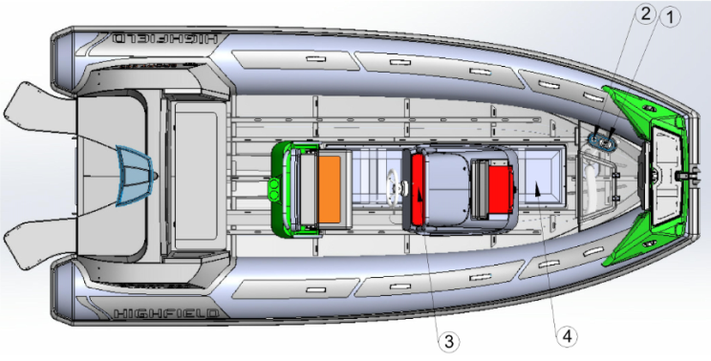
Sistema de combustible

Gráfico del sistema de combustible
Referencia | Nombre
1 | Válvula de seguridad contra inundaciones
2 | Boca de llenado de combustible y orificio de ventilación del depósito
3 | Indicador de nivel de combustible
4 | Depósito de combustible

Información relacionada con el riesgo de inundación y la estabilidad
- Orificios del casco

Referencia | Nombre
1 | Rejillas de ventilación
2 | Compartimento del ancla
3 | Boca de llenado
4/8 | Embornales de bañera y cubierta
5 | Soporte de montaje del motor
6/9 | Protectores de salida del cable de dirección
7 | Tapón de drenaje de la sentina

Uso del tapón de drenaje
Su embarcación está equipada con los siguientes tipos de tapones de drenaje. Mientras pilota la embarcación, abra el tapón para drenar el agua que haya en el suelo. El agua se drenará automáticamente por el efecto Venturi. Al botar la embarcación o detenerla en el agua recomendamos que mantenga el tapón cerrado. Cuando la embarcación esté izada, estibada, guardada, no se utilice o se transporte, el tapón de drenaje debería permanecer abierto para que salga el agua que pueda llenar la cubierta.
Referencia | Nombre | Ubicación | Información de uso |  |  | Fotografía
 |  |  | En el agua y parado | En el agua y en movimiento | Fuera del agua
1 | Imbornal | Popa | N/A | N/A | N/A | 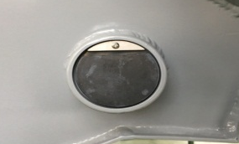
2 | Tapón de drenaje de la sentina | Popa | Cerrado | Cerrado | Abierto | 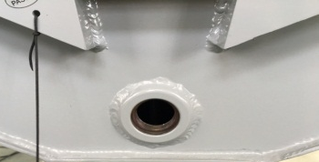  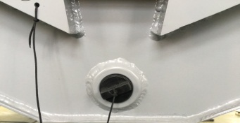
3 | Tapón de la bañera | Panel vertical del asiento posterior | Cerrado | Abierto | Abierto | 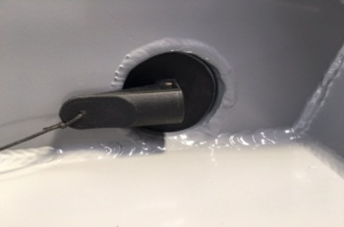  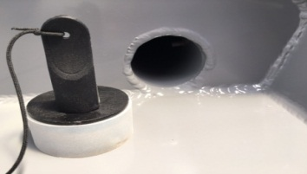

Precaución
Deje abierto el tapón de drenaje de la sentina cuando la embarcación esté fuera del agua. El agua de lluvia podría llenar la embarcación y generar tensiones y daños.

Peligro
No abra el tapón de drenaje de la sentina cuando la embarcación esté a flote.
No intente acceder al tapón de drenaje de la sentina cuando el motor esté en marcha. La hélice podría provocar lesiones graves.

- Estabilidad y flotabilidad
Esta embarcación ha sido calculada para que sea capaz de soportar el peso de la tripulación incluso en caso de inundación.
- El desplazamiento completamente cargado se ha utilizado para evaluar la estabilidad y flotabilidad de la embarcación. El valor de dicho desplazamiento se encuentra en el apartado "Especificaciones" a continuación.
- Cualquier cambio en la distribución de las cargas a bordo (por ejemplo añadir una estructura elevada para pescar, montar un radar o un enrollador en el palo, cambiar el motor, etc.) puede afectar significativamente la estabilidad, el asiento y el rendimiento de la embarcación.
- Es importante mantener al mínimo el agua acumulada en las sentinas.
- La estabilidad de la embarcación se ve afectada cuando se agrega peso a la superestructura.
- Durante la marcha es recomendable cerrar las escotillas, los cofres y las puertas para minimizar el riesgo de inundación.
- La estabilidad de la embarcación puede reducirse cuando se remolca otra embarcación o cuando se utilizan pescantes o la botavara para izar una carga pesada.
- Las cámaras de aire no deben perforarse.
- Las olas rompientes son un riesgo serio para la estabilidad.
Advertencia
Adapte siempre la velocidad y el rumbo de la embarcación a las condiciones marítimas.
Todas las escotillas estancas y el tapón de drenaje de la sentina deben permanecer cerrados cuando se está en el agua.

Información relacionada con el riesgo de fuego o explosión
- Motor de propulsión
- Asegúrese de que el agua de refrigeración circula adecuadamente por el motor.
- Asegúrese de que las aberturas de ventilación del compartimento del depósito de combustible no están obstruidos.
- Detenga el motor y no fume mientras llena el depósito de combustible.
- Pida a un mecánico profesional que compruebe regularmente el circuito de combustible.
- Evite cualquier contacto entre materiales inflamables y las secciones calientes del motor.
- Nunca desconecte o corte la energía del sistema eléctrico mientras el motor está en marcha.
- Nunca bloquee el acceso de la válvula de suministro de combustible.
- No obstruya o modifique el sistema de ventilación. Asegúrese de que los conductos de ventilación están libres.
- Nunca ponga el motor al revés cuando la embarcación esté en tierra.
- Mantenga los bidones de combustible adicional en un lugar debidamente ventilado.
- Compruebe regularmente que el depósito de petróleo está limpio y seco.
- Tome todas las precauciones necesarias para evitar un contacto con llamas vivas y otras zonas calientes.

Diagrama del diseño de ventilación del compartimento del depósito de combustible
Advertencia
Los bidones de combustible portátiles deben llenarse fuera del barco.
Llene siempre los bidones en un lugar ventilado con el motor parado.
No fume mientras llena los depósitos.
- Equipo de prevención y lucha contra incendios
- Extintores portátiles y manta contra incendios (no suministrados)
- Cuando esté en uso, este barco debe estar equipado con un extintor contra incendios portátil con la capacidad de extinción siguiente.
- La ubicación del extintor contra incendios portátil se muestra el la imagen inferior:

Ubicación del extintor portátil
Referencia | Nombre | Ubicación | Capacidad de extinción mínima
1 | Extintor portátil | asiento | 8A/6B

Advertencia
Las embarcaciones equipadas con un motor fueraborda de 25 kW o superior deben tener a bordo uno o más extintores de fuego portátiles con una capacidad total combinada de 86/6B.
El compartimento del depósito de combustible tiene un orificio que posibilita inyectar en su interior el producto del extintor. El orificio de extinción se ha diseñado de forma que pueda insertarse por él la boquilla del extintor y descargarse todo el producto en el compartimento del depósito de combustible.

Orificio de extinción ubicado en el lado de babor de la consola.
- Mantenimiento del equipo de lucha contra incendios
El propietario/usuario del barco debe:
- Hacer revisar el equipo de lucha contra incendios en los intervalos indicados en el equipo de lucha contra incendios.
- Sustituir los extintores de incendios portátiles caducados o descargados por extintores con la misma capacidad de lucha contra incendios.
- Rellenar o sustituir los sistemas fijos cuando hayan caducado o estén descargados.
- Responsabilidad del propietario/usuario dee la embarcación
- Asegurar que el equipo contra incendios esté listo y disponible cuando la embarcación esté en uso.
- Asegurar que los puntos de drenaje del compartimento del depósito de combustible funcionen debidamente.
- Informar a los miembros de la tripulación sobre: la ubicación y operación del equipo de lucha contra incendios, la ubicación del orificio de descarga del compartimento del motor y la ubicación de las rutas y salidas de emergencia.
Precaución
Mantenga la sentina limpia y busque con frecuencia posibles fugas de combustible y gas. Cuando sustituya componentes de la instalación de extinción de incendios, solo debe emplear componentes iguales que tengan el mismo nombre o que tengan capacidades técnicas y de resistencia al fuego equivalentes.

Sistemas eléctricos
Peligro
El riesgo de incendio o explosión puede resultar de un uso inapropiado de los sistemas eléctricos DC o AC.
El riesgo de peligro de choque eléctrico puede resultar de un uso inapropiado del sistema eléctrico AC.

Advertencia
No trabaje en sistemas eléctricos sometidos a corriente eléctrica.
No modifique el sistema eléctrico del barco o los diagramas relevantes: Es importante que la instalación, el mantenimiento y cualquier modificación sea ejecutada por un técnico cualificado en electricidad náutica.
No cambie o modifique la potencia de los dispositivos de seguridad que protegen contra sobrecargas de energía.
No instale o cambie equipamiento o materiales eléctricos con componentes que excedan la capacidad de potencia eléctrica nominal del sistema.
No deje el barco sin supervisión cuando esté conectado el sistema eléctrico, excepto cuando la bomba de sentina y los sistemas de seguridad y protección contra incendios automáticos estén en uso.
SP300-460

Posición | Descripción | Cantidad | Posición | Descripción | Cantidad
① | Cortacircuitos 5025B | 1 | ⑦ | Interruptor de encendido | 1
② | Interruptor semi-automático | 1 | ⑧ | Batería | 1
③ | Interruptor manual | 5 | ⑨ | Cortacircuitos 5064B | 1
④ | USB AD2013 | 1 | ⑩ | Indicador de nivel de combustible | 1
⑤ | Conector AD1011 | 1 | ⑪ | Motor | 1
⑥ | Terminal | 1 | ⑫ | Aislante | 1
SP520-800

Posición | Descripción | Cantidad | Posición | Descripción | Cantidad
① | Cortacircuitos 5025B | 1 | ⑦ | Interruptor de encendido | 1
② | Interruptor semi-automático | 1 | ⑧ | Batería | 1
③ | Interruptor manual | 3 | ⑨ | Colector 2303B | 1
④ | USB 1039B | 1 | ⑩ | Indicador de nivel de combustible | 1
⑤ | Conector 1011B | 1 | ⑪ | Motor | 1
⑥ | Terminal | 1 | ⑫ | Aislante | 1
 |  |  | ⑬ | Cortacircuitos 5064B | 1

Transporte
Para poder maniobrar correctamente, el remolque debe estar bien cargado y equilibrado.
- Mantenga bajo el centro de gravedad para poder maniobrar mejor.
- Aproximadamente el 60% del peso de la embarcación debe colocarse sobre la mitad delantera del remolque y el 40% sobre la trasera.
- La embarcación también debe estar equilibrada lateralmente. Si la embarcación dispone de depósitos de combustible o agua montados en los laterales y solo hay un lado lleno, esto perjudicará la maniobra del aparejo. Un buen equilibrio también prolongará la vida útil de los neumáticos del remolque.
- La embarcación debe asegurarse firmemente con al menos dos cinchas con trinquete, una que vaya del remolque a los ollaos de popa y otra que vaya del remolque al ollao de proa, para evitar que la embarcación se mueva hacia delante. El ollao de la proa también debe afirmarse al chigre del remolque, que está montado por delante de la proa. Asegúrese de que mantener una distancia suficiente para evitar dañar el fueraborda o la embarcación durante el transporte.
- Los modelos Classic pueden alojarse/transportarse sobre una baca. Recomendamos proteger la embarcación de la baca, que podría dañar el material de los flotadores. La embarcación debería estibarse boca abajo. Los remos, el banco y el equipamiento debe quitarse de la embarcación. La embarcación debe asegurarse con cinchas de anclaje de nylon con hebillas de leva. Recomendamos atar también un cabo pequeño al ollao de remolque de proa para mayor seguridad.

Arrancar el motor
Antes de arrancar el motor es imprescindible:
- Abrir la válvula de entrada de combustible
- Conectar la alimentación de la batería por medio de los interruptores seccionadores de la batería
- Poner la palanca de mando en posición neutra
- Atar el cortacircuito / cable desconectador "hombre al agua" al piloto.
Acostúmbrese a mirar si sale agua de mar con los gases de escape en cuanto arranque el motor. Si no sale agua, pare el motor de inmediato. Compruebe el flujo de refrigerante.
Peligro
Antes de utilizar el motor, asegúrese de leer atentamente el manual suministrado por el fabricante del motor.
Arranque siempre el motor con la palanca de mando en posición neutra.
Aprenda a calcular la distancia de deceleración necesaria para que la embarcación se pare por completo (la marcha atrás no es un freno).
Utilice el cable desconectador "hombre al agua".

Funcionamiento
1. Inflado
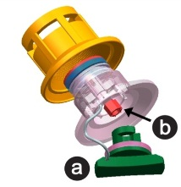
a- Tapa de la válvula
b- Pistón

- Para inflar la cámara, desenrosque la tapa de la válvula girándola un cuarto de vuelta en sentido antihorario. Compruebe que el pistón en el centro de la válvula está cerrado, es decir, en la posición de arriba. Si está abierto, es decir, el muelle comprimido en la posición de abajo, presione el pistón hacia abajo y gírelo hasta la posición cerrada.
- Conecte la bomba de aire a la válvula, gire el conector hasta que encaje en la válvula y empiece a inflar. Puede utilizar tanto una bomba de pie como eléctrica, pero asegúrese de no inflar por encima de la presión de aire recomendada de 0,2 bar por cámara.
- Utilice un manómetro de aire para medir la presión de los flotadores.

- Asegúrese de inflar cada cámara sucesivamente siguiendo la secuencia mostrada abajo. No infle una cámara por completo y continúe después con la siguiente. Empiece por las cámaras traseras. Repita el procedimiento hasta que todas las cámaras estén infladas homogéneamente a la presión de trabajo recomendada.

- A la hora de inflar, mantenga la presión de aire equilibrada entre las cámaras de aire para evitar dañar los mamparos.
- Las embarcaciones neumáticas pueden sufrir daños debido a una presión de aire interna extrema. Dicha presión puede ser causada por diferencias de temperatura. Una embarcación bien inflada por la mañana puede sufrir una sobrepresión peligrosa a medida que aumenta la temperatura por el día. La presión interna puede multiplicarse muchas veces a medida que aumenta la temperatura de la superficie y, en estas condiciones, las costuras pueden separarse y los materiales pegados pueden deslaminarse. Evite someter su embarcación neumática a estas condiciones liberando presión en todas las cámaras a medida que aumenta la temperatura por el día o antes de dejar la embarcación expuesta al sol de mediodía. Se recomienda encarecidamente guardar la embarcación a la sombra o bajo una funda cuando no se utiliza.
- Si se utiliza la embarcación con los flotadores poco inflados puede sufrir daños graves, incluso fisuras del espejo de popa.
Precaución
No utilice una fuente de aire comprimido para inflar los flotadores, porque podría ponerse en peligro la integridad de las costuras o los separadores internos. La rotura de las costuras o los separadores debido a que no se ha respetado el procedimiento de inflado no está cubierta por la garantía.
2. Rendimiento
- Para conseguir el mejor rendimiento, la embarcación debe planear. Si la embarcación no planea puede comprobar lo siguiente:
- Asegúrese de que la sentina / cubierta está seca; en caso contrario, drene el agua.
- Asegúrese de que los flotadores están bien inflados.
- Asegúrese de que ha distribuido el peso correctamente. Las condiciones marítimas pueden hacer necesario que los ocupantes tengan que desplazarse hacia delante en la embarcación para conseguir que esta planee antes de regresar a sus posiciones iniciales.
- Asegúrese de utilizar un motor fueraborda adecuado a la embarcación.
- El motor fueraborda desempeña un papel importante en el rendimiento de la embarcación. Asegúrese de utilizar un motor fueraborda adecuado a la embarcación.
- Cuando pilote la embarcación, debe mantener el balance de la embarcación a proa y popa. Para conseguir esto, debe ajustar el ángulo de trimado de su embarcación. Un casco debidamente trimado ofrece dos resultados beneficiosos: reducir el consumo de combustible y aumentar la velocidad.
- La mayoría de los motores fueraborda de más de 30 caballos de potencia disponen de un sistema de trimado (Trim) e inclinación (Tilt) accionado por un cilindro hidráulico ubicado en el centro del soporte de montaje del motor. Su función es la de subir y bajar el motor. Está controlado por un interruptor basculante que se encuentra en la palanca de cambio de marcha y de gas justo debajo de su pulgar derecho para que su acceso sea simple. En modo "Tilt" el sistema levanta el motor completamente fuera del agua cuando no se usa. También puede emplearse para levantar el motor lentamente cuando se opera la embarcación de forma muy lenta en aguas poco profundas y con el objetivo de prevenir daños en el motor.
En modo "Trim" el sistema trabaja para ajustar el ángulo del motor con el objetivo de influir en el ángulo de operación de la embarcación. Con el aumento de la velocidad de la embarcación, el ángulo del motor procura la inclinación necesaria para hacer planear la embarcación y garantizar que el rendimiento sea óptimo. En la posición de abajo completa, el motor está en "trimado negativo", es decir, el ángulo del eje y de la hélice del motor están ligeramente adelantados con respecto al espejo de popa. Esta es la posición en la que debería estar el motor antes de acelerar desde cero. El trimado negativo ejerce una fuerza hacia abajo sobre el casco para reducir el levantamiento de la proa que suele darse en la mayoría de los cascos planeadores durante la aceleración inicial. Cuanto más brusca sea la aceleración inicial mayor será la tendencia de la proa a levantarse. Si acelera bruscamente desde cero, algunos cascos levantarán momentáneamente la proa a un ángulo considerable hasta que la fuerza descendente del motor contrarreste la elevación.
- Existe la posibilidad de ajustar el ángulo de inclinación del fueraborda para mejorar el rendimiento tanto de planeo como general. Ajuste la posición del pasador de trimado del motor para definir el ángulo de inclinación del motor fueraborda con respecto al espejo de popa. Realice algunos recorridos de prueba con el trimado ajustado a diferentes ángulos hasta encontrar la posición que funcione mejor para su embarcación y las condiciones de uso.

Motor con trimado negativo

Motor con trimado positivo
3. Remolque
Su embarcación puede remolcarse utilizando el ollao de remolque situado en la proa. Asegúrese de utilizar un cabo de remolque con una carga de rotura al menos 5 veces superior al peso de la embarcación que debe remolcarse. La embarcación solo debe remolcarse por el ollao de remolque. Las asas moldeadas, las líneas de vida y las cornamusas no están diseñadas para ser utilizadas para remolque.
- Se recomienda remolcar la embarcación con un aparejo de pata de gallo afirmado a las anillas D de ambos lados de la proa.
- También debería afirmarse una línea de seguridad adicional al ollao de aluminio soldado debajo de la proa del casco.
- Tenga en cuenta que las embarcaciones auxiliares remolcadas deben vigilarse continuamente, sobre todo por la noche.
- Cuando se remolca una embarcación auxiliar, las condiciones pueden variar drásticamente, por lo que la responsabilidad de su seguridad recae únicamente en el patrón.
Advertencia
La embarcación debe estar vacía cuando se remolca.
Quite el motor fueraborda, el depósito de combustible y el equipamiento antes del remolque.
No debe haber ocupantes a bordo.
La embarcación debe remolcarse a poca velocidad.
4. Izado
Si se utiliza una grúa para izar la embarcación, afirme la grúa a los 3 (o 4, según sea el tipo de embarcación) ollaos de izado soldados al casco. Quite todo el equipamiento de la embarcación y asegúrese de que no hay ningún ocupante a bordo durante el izado. Asegúrese de que la cubierta y la sentina están drenadas antes de izar la embarcación. Quite el tapón de drenaje y déjelo quitado mientras la embarcación esté estibada para que el agua pueda salir. Las asas moldeadas, las líneas de vida y las cornamusas no están diseñadas para ser utilizadas para el izado. Al izar y girar la embarcación, asegúrese de que no hay nadie debajo de la misma.
5. Varado en la playa
Recomendamos no llevar la embarcación hasta la playa ni arrastrarla entre las rocas, arena, grava o pavimento, pues podrían dañarse tanto el tejido como el casco.
- Motor fueraborda
Monte el motor fueraborda en el espejo de popa de forma que quede tan centrado como sea posible. Apriete homogénea y firmemente los tornillos fijadores al espejo de popa. De vez en cuando, durante el funcionamiento del motor fueraborda, compruebe que los tornillos fijadores estén bien apretados, pues podrían aflojarse debido a la vibración del motor. Asegúrese de que el motor fueraborda está bien sujeto al espejo de popa antes de cada uso. Es aconsejable afirmar el motor al espejo de popa utilizando los ollaos de sujeción previstos para tal fin. Utilice siempre el cable desconectador "hombre al agua" de forma adecuada.
El depósito portátil debe extraerse de la embarcación para llenarlo. El depósito debe llenarse en una zona ventilada. No fume a bordo.
Advertencia
Esto podría provocar lesiones graves, la muerte o daños materiales en la embarcación. No utilice un fueraborda que exceda la potencia máxima indicada en la placa de características del motor.

Prevención y recuperación del hombre al agua
- Prevención del hombre al agua

- Las zonas fuera del área de la cubierta de trabajo son las áreas que arriba se han marcado en rojo.
- La "cubierta de trabajo" es aquella área donde permanecen o caminan las personas durante el uso normal de la embarcación.
- Está prohibido permanecer de pie en el compartimento de proa o en el solárium.
- Recomendaciones para volver a bordo:
Los medios para volver a bordo deben ser desplegados por una persona sola en el agua, sin otra ayuda, Recomendamos el uso de la escalera de popa plegable Highfield Opcional.
Peligro
Asegúrese de que los medios para volver a bordo sean accesibles y fáciles de usar por alguien que se encuentre solo en el agua.
- Peligro causado por partes en movimiento
El motor debe estar parado siempre que el compartimento, la cubierta o la escotilla de motor estén abiertos. El compartimento, la cubierta o la escotilla de motor sirven como resguardo para la maquina. Las piezas en movimiento pueden atrapar la ropa o determinadas partes del cuerpo causando la muerte o lesiones graves. Manténgase alejado de las partes en movimiento.

Peligro
El contacto con una hélice en marcha puede causar lesiones y la muerte.
No entre o salga del agua cuando el motor esté en marcha (ON) y la hélice esté girando.
No suba a la plataforma de baño cuando el motor esté marcha.
No nade hacia la popa de la embarcación cuando el motor esté en marcha.

Mantenimiento
- Cuidados generales
Su embarcación neumática ha sido especialmente diseñada para evitar problemas de mantenimiento en la medida de lo posible. Sin embargo, una limpieza periódica le ayudará a mantener la embarcación en buenas condiciones, especialmente antes de guardarla para el invierno. Limpie la embarcación y lávela a fondo con agua jabonosa. Enjuáguela con cuidado y compruebe que no queden suciedad ni cuerpos extraños, como conchas, arena o anzuelos, dentro de la embarcación, pues podrían deteriorar el tejido. Quite las manchas de alquitrán con un producto de limpieza no abrasivo y suave, como detergente para lavavajillas, o utilice un producto de limpieza recomendado para embarcaciones neumáticas, que encontrará en la mayoría de tiendas náuticas.
Para la tapicería Highfield utiliza tejido marino, que ofrece la mejor resistencia a los rayos ultravioleta y al envejecimiento. El lavado periódico con detergente suave y agua caliente es la mejor forma de mantener el buen aspecto de la tapicería. También es posible utilizar un producto de limpieza para vinilo con el fin de eliminar manchas persistentes. Ningún tejido dura para siempre cuando está expuesto constantemente a los elementos.
Ningún material de tela puede durar para siempre, cuando se expone constantemente al sol. Para asegurarse que los tubulares de PVC duren, se debe aplicar una solución de protección UV, Dos veces al año en los flotadores.
Recomendamos el uso de 303 Aerospace Protectant .
Precaución
No utilice compuestos químicos abrasivos ni agresivos.
Agua caliente con jabón es la mejor solución en la mayoría de los casos.
No utilice disolventes, gasolina, etc. (modelos de PVC).
Utilice disolventes con moderación solo en modelos de hypalon.
Si tiene dudas, pruebe primero el producto de limpieza en un pequeño rincón.
- Desinflado
Para desinflar la cámara, desenrosque la tapa de la válvula girándola un cuarto de vuelta en sentido antihorario. Compruebe que el pistón en el centro de la válvula está cerrado, es decir, en la posición de arriba. Si está abierto, es decir, el muelle comprimido en la posición de abajo, presione el pistón hacia abajo y gírelo hasta la posición cerrada.
Conecte la bomba de aire a la válvula, gire el conector hasta que encaje en la válvula y empiece a desinflar.
Desinfle cada cámara sucesivamente, no desinfle una cámara por completo y continúe después con la siguiente. Empiece por las cámaras traseras. Repita el procedimiento hasta que todas las cámaras estén completamente desinfladas.
Precaución
Esta no es una lista completa de recomendaciones: su distribuidor le dará los consejos necesarios y realizará el mantenimiento técnico de la embarcación.
- Almacenamiento
Recomendamos cubrir la embarcación cuando no se utilice.
- La embarcación debe sacarse del agua cuando no se usa.
- Antes de guardar la embarcación, debe limpiarse y enjuagarse con agua dulce.
- No cubra la embarcación antes de que esté completamente seca, pues de lo contrario podría formarse moho debajo de la cubierta y dañar el material de los flotadores.
- Las cubiertas deben estar ventiladas y el tapón de drenaje quitado.
- Compruebe las fechas de caducidad del material de seguridad.
- Haga revisar la embarcación.
- Engrase y cierre todas las válvulas y todos los pasacascos.
- Engrase todas las piezas mecánicas y móviles (pernos, bisagras, cerraduras...).
- Cierre todos los grifos de fondo de la embarcación.
- Ponga las tapas en las pantallas electrónicas.
- Airee todos los cojines y toda la tapicería durante un buen tiempo antes de volver a ponerlos a bordo y colóquelos de forma que las superficies en contacto sean limitadas.
- Quite la tapicería extraíble.
- Desconecte las baterías. Asegúrese de recargarlas durante el período invernal si la embarcación permanece inactiva todo ese tiempo.
Precaución
La invernada del motor requiere los conocimientos de un ingeniero profesional; consulte a su distribuidor al respecto.
Esta no es una lista completa de recomendaciones: su distribuidor le dará los consejos necesarios y realizará el mantenimiento técnico de la embarcación.
- Reparación de los flotadores
- El kit de reparación contiene:
- Parches de tejido; b ) Tubo de pegamento especial listo para usar
- Condiciones necesarias para una buena reparación:
- Humedad máxima 60%.
- Rango de temperatura entre 18 y 25 grados centígrados.
- Las reparaciones no deben efectuarse bajo la radiación solar directa, viento o lluvia.
- No obstante, las reparaciones deben realizarse en una zona bien ventilada.
- Reparación de embarcaciones de PVC:
Las embarcaciones neumáticas de Highfield que tienen flotadores construidos con tejido revestido de PVC de Valmex requieren un adhesivo basado en PU y endurecedor RC. Se recomienda preparar la superficie con disolvente de acetona antes de proceder al encolado. Utilice únicamente el disolvente y el adhesivo recomendados.
- Localice la zona en la que debe ponerse el parche. Para ello puede tirarse agua corriente sobre la zona o rociarse o cepillarse con agua jabonosa.
- Si la perforación es pequeña, corte un parche redondo de 60mm de diámetro como mínimo. Los agujeros grandes o cortes necesitarán parches más grandes en correspondencia, pero asegúrese siempre de dejar al menos 30mm de parche alrededor del perímetro del corte o agujero y de que las esquinas estén bien redondeadas.
- A continuación, ponga el parche sobre el flotador y marque el perímetro con un lápiz.
- Limpie las dos superficies con disolvente y esparza una capa fina de adhesivo por encima de ellas asegurándose de que no quedan grumos.
- Cuando la primera capa esté seca al tacto (aprox. 10-15 minutos), aplique una segunda capa fina.
- Espere 5 o 6 minutos y toque el adhesivo con el dorso de la mano. Si ya no parece estar húmedo, caliente las dos zonas con una pistola de aire caliente para reactivar el pegamento y peque el parche al flotador; seguidamente, apriete las superficies con pinzas o con un rodillo. Para conseguir una adherencia óptima, pase un rodillo o la parte inferior de una botella por encima del parche.
Precaución
No infle la embarcación hasta pasadas 24 horas.
- Reparación de embarcaciones de hypalon:
Las embarcaciones neumáticas de Highfield que tienen flotadores construidos con tejido revestido de hypalon de Orca no pueden pegarse con adhesivos plásticos ni soldarse. Requieren un pegamento basado en neopreno y undurecedor RFE. Se recomienda preparar la superficie con disolvente MEK antes de proceder al encolado. Utilice únicamente el disolvente y el adhesivo recomendados.
- Localice la zona en la que debe ponerse el parche. Para ello puede tirarse agua corriente sobre la zona o rociarse o cepillarse con agua jabonosa.
- Si la perforación es pequeña, corte un parche redondo de 60mm de diámetro como mínimo. Los agujeros grandes o cortes necesitarán parches más grandes en correspondencia, pero asegúrese siempre de dejar al menos 30mm de parche alrededor del perímetro del corte o agujero y de que las esquinas estén bien redondeadas.
- A continuación, ponga el parche sobre el flotador y marque el perímetro con un lápiz.
- Utilice una amoladora, papel de lija grueso o piedra de rascar para dejar ásperas tanto la parte posterior del parche como la zona marcada en el flotador.
- Limpie las dos superficies con disolvente y esparza una capa fina de adhesivo por encima de ellas asegurándose de que no quedan grumos.
- Cuando la primera capa esté seca al tacto (aprox. 10-15 minutos), aplique una segunda capa fina. Espere 5 o 6 minutos y toque el adhesivo con el dorso de la mano. Si ya no parece estar húmedo, caliente las dos zonas con una pistola de aire caliente para reactivar el pegamento y pegue el parche al flotador; seguidamente, apriete las superficies con pinzas o con un rodillo. Para conseguir una adherencia óptima, pase un rodillo o la parte inferior de una botella por encima del parche.
Peligro
El pegamento y el disolvente utilizados para la reparación son altamente inflamables. Realice las reparaciones en una zona bien ventilada. Evite aspirar los vapores, póngase un equipo de protección (gafas protectoras, máscaras de respiración con filtro, guantes de látex).

Garantía
El producto que ha adquirido dispone de una garantía limitada de Highfield Inflatables. Las condiciones de la garantía se explican en el apartado Información sobre la garantía del presente manual. La declaración de garantía contiene una descripción de lo que se cubre, lo que no se cubre y la duración de la cobertura. Repase esta información importante. La descripción y las especificaciones contenidas aquí estaban en vigor en el momento en que se autorizó la impresión de este manual. Highfield Inflatables, que practica una política de mejora continua, se reserva el derecho de dejar de fabricar determinados modelos en cualquier momento, cambiar especificaciones, diseños, métodos o procedimientos sin previo aviso y sin contraer obligaciones.
Anote el número de identificación del casco.
Dicho número se encuentra en la placa de características que hay en el espejo de popa de la embarcación. Necesitará esta información para comprar piezas, para el servicio de garantía o para proporcionar información en caso de que le roben su embarcación neumática.

Highfield Boats—Garantía limitada de venta minorista
- QUÉ SE CUBRE
Highfield garantiza que sus embarcaciones están libres de defectos de material y mano de obra durante el período descrito a continuación:
- DURACIÓN DE LA COBERTURA
- La embarcación completa está cubierta por un período de dos (2) años a partir de la fecha de venta del producto.
- La estructura del casco está cubierta por una garantía de cinco (5) años.
- En caso de uso comercial o alquiler, la embarcación completa tiene una garantía de un (1) año.
- RECUBRIMIENTO EN POLVO
El recubrimiento en polvo está garantizado por un período de 2 años contra defectos de fabricación.
Esta garantía excluye los daños causados por un mal uso de la embarcación y por choques químicos o mecánicos, como:
- Colisión, fuego, robo, disturbios, etc.
- Alteración, modificación y manipulación.
- Corrosión ambiental y choques causados por lluvia ácida, lluvia química, contaminación industrial, excrementos calcáreos de aves, savia de árbol, meteorología extrema, etc.
- CONDICIONES QUE DEBEN CUMPLIRSE PARA OBTENER UNA COBERTURA DE LA GARANTÍA
La cobertura de la garantía solo está disponible para clientes que compran el producto a un distribuidor autorizado de Highfield. El mantenimiento regular explicado en el manual del propietario debe realizarse puntualmente para obtener la cobertura de la garantía. Si el cliente final realiza este mantenimiento, Highfield Boats se reserva el derecho de realizar una futura cobertura de la garantía supeditada a la comprobación de un mantenimiento adecuado.
- QUÉ HARÁ HIGHFIELD BOATS
La única obligación exclusiva de Highfield Boats en esta garantía está limitada a reparar una pieza defectuosa, sustituir dicha pieza o reembolsar el precio de compra del producto de Highfield Boats, a nuestra elección. La reparación o sustitución de piezas, o la realización de un servicio en garantía no amplía la duración de dicha garantía más allá de su fecha de expiración original.
- CÓMO OBTENER LA COBERTURA DE GARANTÍA
El cliente debe ofrecer a Highfield Boats una posibilidad razonable de reparación, así como un acceso razonable al producto para el servicio de garantía. Las reclamaciones en garantía deben realizarse entregando el producto para su inspección a un distribuidor de Highfield Boats que esté autorizado a revisar el producto. Si el servicio ofrecido no está cubierto por esta garantía, el comprador deberá pagar todo el trabajo realizado y el material relacionado, además de otros gastos vinculados al servicio en cuestión. El comprador no debe enviar el producto ni partes del mismo directamente a Highfield Boats a menos que se lo solicite Highfield Boats. Debe presentarse una prueba de la propiedad al distribuidor en el momento de solicitar el servicio en garantía con el fin de obtener la cobertura.
- QUÉ NO SE CUBRE
- Esta garantía limitada no cubre los daños causados por un mal uso, negligencia, almacenamiento o transporte incorrecto o inadecuado, ni tampoco cualquier embarcación de Highfield que se utilice de forma contraria a las indicaciones o instrucciones citadas en el manual del propietario de Highfield.
- La garantía no cubre los materiales del mantenimiento regular, los ajustes, el desgaste y las roturas normales, los pinchazos, la decoloración, oxidación, abrasión, el moho o los daños causados por robo, pérdida, modificación o alteración.
- Las piezas de desgaste, que incluyen pero no están limitadas al cintón lateral, protectores de quilla y cabos, no están cubiertas por la garantía.
- Esta garantía no será efectiva si la embarcación se ha utilizado sin estar debidamente inflada o con un motor fueraborda que excede la potencia máxima nominal indicada en la placa de características situada en el espejo de popa.
- El estado del recubrimiento en polvo no está cubierto por nuestra garantía debido a la naturaleza expuesta específica del producto.
- Para una mejor protección a largo plazo, asegúrese de enjuagar las superficies con agua dulce después de cada uso y de limpiar de inmediato cualquier sustancia que pueda quedar pegada a la superficie pintada y causar decoloración o daños.
- Recomendamos reparar los arañazos y las muescas lo antes posible.
- El uso del producto para regatas u otra actividad competitiva anula la garantía minorista.
- Los gastos relacionados con sacar del agua, botar, remolcar, almacenar o transportar la embarcación, gastos de teléfono, alquiler, molestias, tasas de varadero, cobertura del seguro, pagos de créditos, pérdida de tiempo, pérdida de ingresos o cualquier tipo de daños indirectos o consecuentes no están cubiertos por esta garantía.
- TRASPASO DE GARANTÍA
La garantía limitada puede traspasarse a un comprador posterior, pero solo por el resto de la parte no utilizada de la garantía limitada. Esto no es válido si la embarcación se utiliza para uso comercial o de alquiler.
Para traspasar la garantía envíe un correo electrónico con la información indicada abajo a warranty@highfieldboats.com.
- Copia del contrato de venta.
- Número de identificación del casco de la embarcación
- Nombre, dirección y dirección de correo electrónico del nuevo propietario.

Información del producto
Modelo
Número de identificación del casco
Fecha de compra
Información del distribuidor
Nombre
Dirección
Teléfono
Sello del distribuidor
Información del cliente
Nombre
Dirección
Dirección de correo electrónico
Teléfono

Asistencia técnica
Si necesita asistencia póngase en contacto con el distribuidor de Highfield y visite la página web de Highfield Inflatables:
www.highfieldboats.com

BITTE BEWAHREN SIE DIESES HANDBUCH AN EINEM SICHEREN ORT AUF UND ÜBERGEBEN SIE ES AN DEN NEUEN BESITZER, FALLS SIE DAS BOOT VERKAUFEN.
Inhalt

Allgemeine Einführung 92
Sicherheitshinweise 93
Sicherheitsempfehlungen 93
Prüfliste vor Beginn der Bootsfahrt 94
Spezifikationen: Sport 95
Übersicht 95
Spezifikationen: Sport 96
Übersicht 96
Spezifikationen: Sport 97
Übersicht 97
Empfohlene Sitzanordnung 99
Empfohlene Sitzanordnung 100
Empfohlene Sitzanordnung 101
Herstellerplakette: 102
Kraftstoffsystem 102
Informationen zur Gefahr von Flutung und Verlust der Stabilität 103
Informationen zu Brand- und Explosionsgefahr 106
Elektrische Anlage 108
Transport 110
Starten des Motors 110
Betrieb 111
Verhütung von Mann-über-Bord-Unfällen und Bergung 114
Wartung 115
Garantie 118
Kundendienst 120

Wir möchten, dass Sie mit Ihrem Highfield-Boot maximal zufrieden sind und bitten Sie daher, dieses Handbuch sorgfältig zu lesen. Es enthält sämtliche Sicherheits- und Betriebsanweisungen, die Sie benötigen, um Ihr neues Highfield-Boot bestmöglich zu nutzen.

Allgemeine Einführung
Dieses Handbuch wurde zusammengestellt, damit Sie in der Lage sind, Ihr Boot sicher und mit Freude zu führen. Es enthält Angaben zum Boot, zu mitgeliefertem und angebautem Zubehör sowie zu den Systemen des Bootes und deren Betrieb. Bitte lesen Sie dieses Handbuch sorgfältig und machen Sie sich mit dem Boot vertraut, bevor Sie es benutzen.
Dieses Handbuch ist nicht mit einem Kurs in Sicherheit beim Bootfahren oder Seemannschaft gleichzusetzen. Falls dies Ihr erstes Boot ist, oder Sie zu einem Ihnen unbekannten Bootstyp wechseln, stellen Sie für Ihren eigenen Komfort und Sicherheit bitte sicher, dass Sie mit Umgang und Betrieb des Bootes vertraut sind, bevor Sie das „Kommando übernehmen“. Ihr Händler, nationale Segelverbände oder Yachtclubs verweisen Sie gern an lokale Bootsschulen oder erfahrene Lehrer.
Stellen Sie sicher, dass die Entwurfskategorie Ihres Bootes den zu erwartenden Wind- und Meeresbedingungen entspricht und dass Sie sowie die Besatzung das Boot unter diesen Bedingungen handhaben können.
Selbst wenn Ihr Boot zur entsprechenden Kategorie gehört, reichen die Wind- und Meeresbedingungen für die Entwurfskategorien A, B und C von schwerem Sturm für Kategorie A bis hin zu schwerem Wetter für die Spitze der Kategorie C, einschließlich der von Riesenwellen und Windböen ausgehenden Gefahren. Hierbei handelt es sich um gefährliche Bedingungen, in denen nur eine erfahrene, fähige und geschulte Besatzung mit einem in gutem Zustand befindlichen Boot zufriedenstellend arbeiten kann.
Dieses Handbuch ist keine detaillierte Anleitung für Wartung oder Störungsbeseitigung. Wenden Sie sich bei Problemen an den Hersteller des Bootes oder seinen Vertreter. Ist ein Wartungshandbuch vorhanden, nutzen Sie dieses bei der Wartung des Bootes.
Wartung, Reparaturen und Modifikationen sind immer durch geschultes und fachkundiges Personal durchzuführen. Modifikationen, die sich auf die Sicherheitseigenschaften des Bootes auswirken, müssen von dazu zugelassenen Personen geprüft, abgenommen und dokumentiert werden. Der Bootshersteller haftet nicht für Modifikationen, die nicht von ihm genehmigt wurden.
In manchen Ländern ist ein Bootsführerschein oder eine Berechtigung erforderlich, oder es gelten besondere Vorschriften.
Halten Sie Ihr Boot immer sachgerecht instand und berücksichtigen Sie den Verschleiß, der mit der Zeit und infolge starker oder unsachgemäßer Nutzung des Bootes auftritt.
Jedes Boot kann unabhängig von seiner Widerstandskraft durch unsachgemäße Nutzung beschädigt werden. Dies entspricht nicht einem sicheren Fahren des Bootes. Passen Sie Geschwindigkeit und Kurs immer den Gegebenheiten auf dem Wasser an.
Verfügt Ihr Boot über eine Rettungsinsel, lesen Sie deren Betriebsanleitung sorgfältig. Das Boot muss je nach Typ, Wetterbedingungen usw. mit der nötigen Sicherheitsausrüstung ausgestattet sein (Rettungswesten, Gurtzeug usw.). Diese Ausstattung ist in manchen Ländern vorgeschrieben. Die Besatzung muss mit dem Gebrauch der Sicherheitsausrüstung und Notfallmanövern (Mann über Bord, Schleppen usw.) vertraut sein. Segelschulen und Clubs bieten regelmäßig Übungen an.
Alle an Deck befindlichen Personen müssen geeignete Schwimmhilfen (Rettungsweste, persönliche Schwimmweste) tragen. Bitte beachten Sie, dass in manchen Ländern das ständige Tragen eines persönlichen Auftriebsmittels, das den nationalen Vorschriften entspricht, gesetzlich vorgeschrieben ist.

Sicherheitshinweise
In diesem Handbuch werden die nachfolgend aufgeführten Sicherheitshinweise verwendet, um Ihre Aufmerksamkeit auf spezielle Sicherheitsanweisungen zu lenken, die zu befolgen sind.
Warnhinweis und zugehörige Kennzeichnung:
Gefahr
Bedeutet, dass eine extreme reale Gefahrenquelle besteht, die mit großer Wahrscheinlichkeit zum Tod oder zu irreparablen Verletzungen führen wird, wenn keine angemessenen Vorkehrungen getroffen werden.

Warnung
Bedeutet, dass eine Gefahrenquelle besteht, die zu Verletzungen oder zum Tod führen kann, wenn keine angemessenen Vorkehrungen getroffen werden.

Achtung
Bedeutet eine Erinnerung an Sicherheitsvorkehrungen oder richtet die Aufmerksamkeit auf Handhabungen, die unsicher sein können und zu persönlichen Verletzungen oder zur Beschädigungen des Wasserfahrzeugs oder von Bauteilen führen können oder die der Umwelt schaden.

Sicherheitsempfehlungen
- Tragen Sie immer eine Rettungsweste
Örtliche Behörden schreiben vor, dass Ihr Boot über ein zugelassenes, persönliches Auftriebsmittel oder eine Rettungsweste für jede Person an Bord verfügt. Wir empfehlen, beim Bootfahren immer eine Rettungsweste zu tragen.
- Verwendung der Notstoppleine
Der Bootsführer muss während der Fahrt jederzeit eine Notstoppleine tragen. Fällt er versehentlich aus dem Boot oder verliert das Gleichgewicht, schaltet sich der Motor automatisch ab. Die Verwendung einer Notstoppleine kann das Leben des Bootsführers und das anderer Personen retten.
- Machen Sie sich mit Ihrem Boot vertraut
Kenntnis Ihres Bootes ist die Grundlage guter Seemannschaft, welche die Fähigkeit zum Umgang mit einem Wasserfahrzeug darstellt. Dazu gehören Navigation, Sicherheit, Umgang mit dem Boot, Umgang mit Leinen und Tauen, Ankern, Beseitigung von Störungen am Motor sowie Verhalten in Notfällen.
- Besuchen Sie eine Schulung zur Bootssicherheit und machen Sie sich mit den Schifffahrtsregeln vertraut
In einem Bootfahrkurs lernen Sie die Grundlagen der oben beschriebenen Seemannschaft. Die Kenntnisse, die Sie in einer Schulung zur Bootssicherheit erwerben, werden Ihnen immer von Nutzen sein. Lernen Sie, Seekarten zu lesen und bewahren Sie diese an Bord auf, um mit dem Gebiet vertraut zu werden, in dem Sie mit Ihrem Boot fahren. Eine Schulung zur Bootssicherheit ist der nächste Schritt, bei dem Sie Navigation anhand von Seekarten, GPS, Radar und Kompass erlernen.
- Kein Bootfahren unter Alkoholeinfluss
Alkoholische Getränke sind auf dem Wasser noch gefährlicher als an Land, da die Meeresumwelt Unfälle begünstigt. Neben den Sicherheitsrisiken ist das Bootfahren unter Alkoholeinfluss verboten und wird von Behörden mit schweren Strafen geahndet.
- Vermeiden Sie Kollisionen
Beachten Sie die in den Schifffahrtsregeln festgelegten und gemäß Internationalen Regeln zur Verhütung von Zusammenstößen auf See geltenden Vorfahrtsregeln. Stellen Sie sicher, dass immer genügend Platz zum Stoppen oder Manövrieren vorhanden ist, falls zur Vermeidung einer Kollision erforderlich. Vermeiden Sie plötzliche Manöver bei hoher Geschwindigkeit.
- Schutz von Personen
Bewegen Sie das Boot immer nur langsam und mit äußerster Vorsicht, wenn sich in der Nähe Ihres Bootes Menschen im Wasser befinden.
- Respektieren Sie die Umwelt
Befolgen Sie die örtlichen Umweltschutzvorschriften und die international geltenden Regeln zur Verhütung von Meeresverschmutzung im größtmöglichen Umfang.
- Angemessene Geschwindigkeit
Bewegen Sie das Boot in viel befahrenen Bereichen oder bei eingeschränkter Sicht, starkem Wind oder hohen Wellen nicht mit hoher Geschwindigkeit. Verringern Sie die Geschwindigkeit bei hohen Wellen und verursachen Sie zu Ihrer eigenen sowie zur Sicherheit Dritter kein starkes Kielwasser. Halten Sie sich an Geschwindigkeitsbegrenzungen und an „KEIN WELLENSCHLAG“-Schilder.
- Sonstiges:
Setzen Sie sich nicht an den Bug, wenn sich das Boot mit hoher Geschwindigkeit bewegt.
Gefahr
Während der Fahrt ist es Passagieren untersagt, aufzustehen oder Gliedmaßen außenbords zu bewegen. Bei austretendem Kraftstoff besteht Brandgefahr, prüfen Sie daher das Kraftstoffsystem regelmäßig. Schalten Sie den Motor ab, bevor sich Personen aus dem Wasser heraus an Bord begeben.

Warnung
Falls der Bootsführer oder Passagiere aus dem Boot fallen, ist der Motor sofort abzuschalten, um die Gefahr von schweren Verletzungen oder Tod beim Überfahren der Person im Wasser erheblich zu verringern. Die Enden der Notstoppleine müssen jederzeit vorschriftsmäßig mit dem Stoppschalter und dem Bootsführer verbunden sein.

Achtung
Passagiere müssen geeignete, persönliche Auftriebsmittel tragen. Für Kinder und Wassersportaktivitäten gibt es speziell ausgelegte, persönliche Auftriebsmittel. (Persönliches Auftriebsmittel)

Prüfliste vor Beginn der Bootsfahrt
a). Stellen Sie sicher, dass Sie und jeder Passagier ein geeignetes, persönliches Auftriebsmittel tragen.
b). Stellen Sie sicher, dass ein weiteres Auftriebsmittel vorhanden ist, das zur Rettung von Personen im Wasser verwendet werden kann.
c.) Bei Fahrten mit Passagieren ist mindestens ein Passagier in die Grundlagen der Handhabung des Bootes sowie Starten und Stoppen des Außenbordmotors einzuweisen.
d). Prüfen Sie, ob jeder Passagier sicher sitzt und eine Sicherheitsleine, Haltegriff oder Seil greift.
e). Stellen Sie sicher, dass sich ein Schleppseil von 4 Meter Länge an Bord befindet.
f). Stellen Sie sicher, dass die Last im Boot gleichmäßig verteilt ist.
g). Stellen Sie sicher, dass die auf der Herstellerplakette angegebene, maximale Zuladung des Bootes nicht überschritten wird.
h). Stellen Sie sicher, dass die gesamte Sicherheitsausrüstung an Bord ist, wie Pfeife, Schwimmleinen, wasserdichte Leuchte, Erste-Hilfe-Kasten, Frischwasser, Werkzeugsatz, usw.
i). Prüfen Sie, ob das Boot über 2 Paddel oder Ruder verfügt.
j). Stellen Sie sicher, dass der Außenbordmotor sicher am Bootsspiegel befestigt ist.
k). Stellen Sie sicher, dass der Ablassstopfen voll funktionstüchtig ist.
l). Prüfen Sie den Luftdruck in allen Luftkammern mit einem Druckmessgerät. Der empfohlene Luftdruck ist auf der Herstellerplakette angegeben.
m). Prüfen Sie den Füllstand im Kraftstofftank und stellen Sie sicher, dass der Kraftstoffvorrat für die geplante Fahrt ausreichend ist.
n). Starten Sie den Außenbordmotor und stellen Sie sicher, dass er sich abschaltet, wenn die Notstoppleine vom Quickstoppschalter getrennt wird.

Spezifikationen: Sport
Beschreibung |  | Sport Modelle
 |  | 300 |  | 330 |  | 360 |  | 390 |  | 420 |  | 460
Rumpfmaterial |  | Seewasserbeständige Aluminiumlegierung (Serie 5)
Deckmaterial |  | Seewasserbeständige Aluminiumlegierung (Serie 5)
Schlauchmaterial |  | PVC oder mit Hypalon beschichtete Materialien
Länge über alles | a | 3,10m |  | 3,36m |  | 3,62m |  | 3,90m |  | 4,24m |  | 4,60m
Innenlänge | c | 1,80m |  | 2,04m |  | 2,36m |  | 2,50m |  | 2,72m |  | 2,91m
Breite über alles | b | 1,83m |  | 1,82m |  | 1,84m |  | 1,92m |  | 2,05m |  | 2,09m
Innenbreite | d | 0,84m |  | 0,90m |  | 0,92m |  | 0,92m |  | 1,08m |  | 1,08m
Bughöhe | e | 930mm |  | 930mm |  | 930mm |  | 960mm |  | 1040mm |  | 966mm
Heckhöhe | f | 600mm |  | 600mm |  | 600mm |  | 710mm |  | 695mm |  | 647mm
Aufkimmung |  | 15° |  | 20° |  | 20° |  | 20° |  | 20° |  | 20°
Luftkammern |  | 3 |  | 3 |  | 3 |  | 3 |  | 4 |  | 5
Verdrängung ohne Motor |  | 151kg | 333lb | 212kg | 466lb | 227kg | 500lb | 249kg | 548lb | 336kg | 740lb | 364kg | 801lb
Max. Anzahl Passagiere |  | 4 |  | 5 |  | 6 |  | 7 |  | 8 |  | 9
Max. Zuladung |  | 464kg | 1023lb | 549kg | 1211lb | 634kg | 1398lb | 716kg | 1579lb | 791kg | 1744lb | 912kg | 2011lb
Hauptantrieb |  | Motor
Max. Motorleistung |  | 30HP | 22,38  KW | 30HP | 22,38  KW | 40HP | 29,84  KW | 60HP | 44,76  KW | 70HP | 52,22  KW | 90HP | 67,14  KW
Motor Schaftlänge |  | L |  | L |  | L |  | L |  | L |  | L
Entwurfskategorie |  | C |  | C |  | C |  | C |  | C |  | C
Schlauchdurchmesser |  | 410mm |  | 430mm |  | 430mm |  | 470mm |  | 470mm |  | 470mm
Max. Motorgewicht |  | 124,1  Kg | 274lb | 124,1  kg | 274lb | 124,1  kg | 274lb | 161,7  kg | 356lb | 188,5  kg | 416lb | 207,6  kg | 458lb
Fassungsvermögen des Kraftstofftanks: |  | / |  | 30L |  | 30L |  | 30L |  | 55L |  | 55L

Übersicht

Spezifikationen: Sport
Beschreibung |  | Sport Modelle
 |  | 520 |  | 560 |  | 650
Rumpfmaterial |  | Seewasserbeständige Aluminiumlegierung (Serie 5)
Deckmaterial |  | Seewasserbeständige Aluminiumlegierung (Serie 5)
Schlauchmaterial |  | PVC oder mit Hypalon beschichtete Materialien
Länge über alles | a | 5,23m |  | 5,66m |  | 6,35m
Innenlänge | c | 3,43m |  | 3,82m |  | 4,35m
Breite über alles | b | 2,46m |  | 2,50m |  | 2,54m
Innenbreite | d | 1,30m |  | 1,35m |  | 1,34m
Bughöhe | e | 1155mm |  | 1260mm |  | 1334mm
Heckhöhe | f | 810mm |  | 972mm |  | 890mm
Aufkimmung |  | 24° |  | 24° |  | 26°
Luftkammern |  | 6 |  | 6 |  | 6
Verdrängung ohne Motor |  | 550kg | 1213lb | 612kg | 1349lb | 783kg | 1726lb
Max. Anzahl Passagiere |  | 10 |  | 12 |  | 13
Max. Zuladung |  | 1058kg | 2332lb | 1188kg | 2619lb | 1366kg | 3012lb
Hauptantrieb |  | Motor
Max. Motorleistung |  | 100HP | 74,60KW | 115HP | 85,79KW | 150HP | 111,90KW
Motor Schaftlänge |  | L |  | XL |  | XL
Entwurfskategorie |  | C |  | C |  | C
Schlauchdurchmesser |  | 520mm |  | 520-400mm |  | 531-470mm
Max. Motorgewicht |  | 207,6kg | 458lb | 258,6kg | 570lb | 260,7kg | 575lb
Fassungsvermögen des Kraftstofftanks: |  | 105L |  | 105L |  | 140L

Übersicht

Spezifikationen: Sport
Beschreibung |  | Sport Modelle
 |  | 700(Cat.B) |  | 700(Cat.C) |  | 800(Cat.B) |  | 800(Cat.C)
Rumpfmaterial |  | Seewasserbeständige Aluminiumlegierung (Serie 5)
Deckmaterial |  | Seewasserbeständige Aluminiumlegierung (Serie 5)
Schlauchmaterial |  | PVC oder mit Hypalon beschichtete Materialien
Länge über alles | a | 6,95m |  | 6,95m |  | 8,11m |  | 8,11m
Innenlänge | c | 4,95m |  | 4,95m |  | 5,35m |  | 5,35m
Breite über alles | b | 2,54m |  | 2,54m |  | 2,94m |  | 2,94m
Innenbreite | d | 1,34m |  | 1,34m |  | 1,74m |  | 1,74m
Bughöhe | e | 1334mm |  | 1334mm |  | 1430mm |  | 1430mm
Heckhöhe | f | 873mm |  | 873mm |  | 940mm |  | 940mm
Aufkimmung |  | 26° |  | 26° |  | 26° |  | 26°
Luftkammern |  | 6 |  | 6 |  | 6 |  | 6
Verdrängung ohne Motor |  | 895kg | 1973lb | 895kg | 1973lb | 1150kg | 2535lb | 1150kg | 2535lb
Max. Anzahl Passagiere |  | 9 |  | 13 |  | 9 |  | 15
Max. Zuladung |  | 1026kg | 2262lb | 1366kg | 3012lb | 1078kg | 2377lb | 1588kg | 3501lb
Hauptantrieb |  | Motor
Max. Motorleistung |  | 200HP | 149,20KW | 200HP | 149,20KW | 300HP | 223,80KW | 300HP | 223,80KW
Motor Schaftlänge |  | XL |  | XL |  | XL |  | XL
Entwurfskategorie |  | B |  | C |  | B |  | C
Schlauchdurchmesser |  | 531-470mm |  | 531-470mm |  | 550-470mm |  | 550-470mm
Max. Motorgewicht |  | 260,7kg | 575lb | 260,7kg | 575lb | 312,5kg | 689lb | 312,5kg | 689lb
Fassungsvermögen des Kraftstofftanks: |  | 140L |  | 140L |  | 250L |  | 250L

Übersicht

Hinweise:
- Länge über alles: Einschließlich Schlauch, ohne Beeinflussung der Struktur des Bootes.
- Innenlänge: Ausschließlich Schlauch, ohne Beeinflussung der Struktur des Bootes.
- Breite über alles: Einschließlich Schlauch, ohne Beeinflussung der Struktur des Bootes.
- Innenbreite: Ausschließlich Schlauch, ohne Beeinflussung der Struktur des Bootes.
- Fassungsvermögen des Kraftstofftanks: Abhängig von Trimmung und Zuladung des Bootes ist es evtl. nicht möglich, das gesamte Fassungsvermögen des Tanks zu nutzen. Es wird empfohlen, eine Reserve von 20% im Kraftstofftank zu halten.
- Kategorie B: Boot ist vorgesehen zum Betrieb in Windstärke bis zu 8 auf der Beaufort-Skala und damit verbundenen Wellen. Solce Bedingungen können auf ausgedehnten Reisen von der Küste weg oder in Küstengewässern auftreten mit mehreren Dutzend Seemeilen ohne Wind- und Wellenschutz Diese Bedingungen können auch in Binnenmeeren auftreten, die groß genug sind, um Wellen mit einer solchen Höhe zu erzeugen.
Kategorie C: Das Boot ist für den Betrieb bei Windstärke 6 gemäß Beaufortskala und zugehörigen Wellenhöhen ausgelegt (signifikante Wellenhöhe bis zu 2m). Diese Bedingungen können in ungeschützten Binnengewässern, Flussmündungen und Küstengewässern bei gemäßigten Wetterbedingungen auftreten (gemäß ISO10240).
- Gewichtsverteilung
- Bitte beachten Sie die in diesem Handbuch oder auf der Herstellerplakette angegebene, maximale Personenanzahl und Tragfähigkeit des Bootes. Die Maximalwerte dürfen nicht überschritten werden.
- Positionieren Sie die Passagiere und verteilen Sie das Gewicht gleichmäßig im Boot, um das Gewicht des Außenbordmotors auszugleichen.
- Bei unruhigem Wasser kann Gewicht nach vorn verlagert werden, um die Beweglichkeit des Bootes zu verbessern.
- Befinden sich Kinder unter den Passagieren an Bord, kann sich die zulässige Gesamtzahl an Personen erhöhen, vorausgesetzt:
- Das Gesamtgewicht der Kinder übersteigt nicht 37,5kg; und
- Das Gesamtgewicht aller Personen an Bord (basierend auf ca. 75kg pro Erwachsenem) überschreitet nicht die maximale Zuladung.

Warnung
Die empfohlene, maximale Personenzahl darf nicht überschritten werden. Bei egal welcher Anzahl von Personen an Bord darf das Gesamtgewicht aller Personen und Ausrüstung die maximale, empfohlene Zuladung nie überschreiten. Nutzen Sie immer die vorhandenen Sitze/Sitzmöglichkeiten.
Die empfohlene, maximale Zuladung des Bootes darf nicht überschritten werden. Beladen Sie das Boot immer sorgfältig und verteilen Sie das Gewicht so, dass das Boot möglichst eben im Wasser liegt. Platzieren Sie schwere Gewichte möglichst unten im Boot.
Verwenden Sie mit diesem Boot keinen Motor mit einer höheren Leistung als der auf der Herstellerplakette aufgeführten Leistung.
Nutzen Sie das Boot nicht mit einem Motor mit einer höheren Leistung als der maximalen, empfohlenen Leistung. Die Verwendung eines Motors mit zu hoher Leistung kann zu schweren Verletzungen, Tod und Schäden am Boot führen.
Nutzen Sie negative Trimmung, um von Verdrängerfahrt in Gleitfahrt zu kommen und bei niedrigen Geschwindigkeiten (bei Booten, die über die Möglichkeit zur Ausrichtung des Propellerschubs verfügen).
Verwenden Sie die negative Trimmung des Antriebs nicht bei hohen Geschwindigkeiten (Bug nach unten).

Empfohlene Sitzanordnung

SP300 SP330

SP360 SP390

SP420

SP460

Empfohlene Sitzanordnung

SP520

SP560

SP650

Empfohlene Sitzanordnung

SP700(Cat.B)

SP700(Cat.C)

SP800(Cat.B)

SP800(Cat.C)

Herstellerplakette:
Ein Teil der Angaben ist auf der an der Innenseite des Bootsspiegels angebrachten Herstellerplakette enthalten. Die jeweiligen Teile dieses Handbuchs enthalten detaillierte Erklärungen zu diesen Angaben.
b
a

c

d

e

f

g

Hinweise:
a: Name des Herstellers Abänderungen des Bootsrumpfes oder permanente Anbauten können
b: Modell die Angaben auf dieser Plakette ungültig machen.
c: Entwurfskategorie Bei Betrieb des Bootes bei schlechtem Wetter oder auf offener See sind die
d: Maximale Motorleistung maximale Personenanzahl und Zuladung zu reduzieren. Lesen Sie vor dem
e: Maximale Personenanzahl Betrieb des Bootes das Handbuch.
f: Maximale Zuladung
g: Empfohlener Betriebsdruck Entspricht ISO 6185

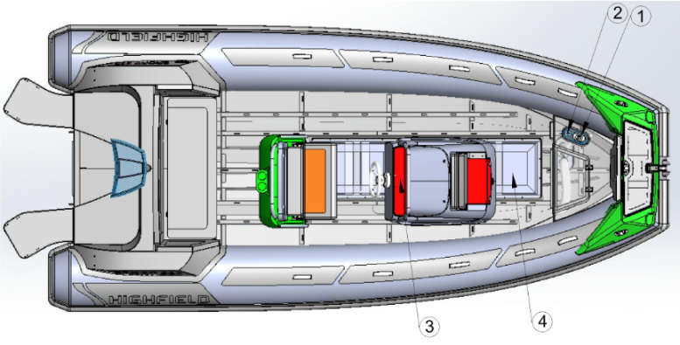
Kraftstoffsystem

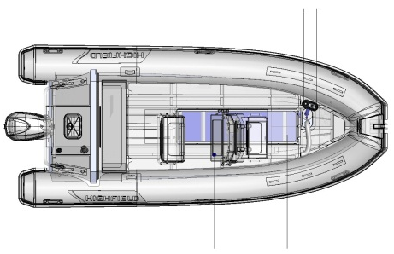 Darstellung Kraftstoffsystem
Nummer | Bezeichnung
1 | Überlaufschutz
2 | Einfüllstutzen für Benzin und Tankentlüftung
3 | Tankanzeige
4 | Benzintank

Informationen zur Gefahr von Flutung und Verlust der Stabilität
- Öffnungen im Rumpf

Nummer | Bezeichnung
1 | Lüftungsgitter
2 | Ankerkasten
3 | Kraftstofffilter
4/8 | Speigatten für Cockpit/Deck
5 | Flansch für Motormontage
6/9 | Motorwannenentwässerung
7 | Bilgenablassstopfen

Verwendung des Ablassstopfens
Ihr Boot verfügt über den nachfolgend angegebenen Ablassstopfen. Öffnen Sie während der Fahrt den Ablassstopfen, um das Wasser am Boden abzulassen. Das Wasser fließt durch den Venturi-Effekt automatisch ab. Wir empfehlen, den Stopfen beim zu Wasser lassen des Bootes oder bei Stopps auf dem Wasser verschlossen zu halten. Wird das Boot angehoben, verstaut, gelagert, transportiert oder nicht genutzt, ist der Ablassstopfen offen zu halten, damit jegliches Wasser ablaufen kann.
Nummer | Bezeichnung | Position | Gebrauchsanweisungen |  |  | Abbildung
 |  |  | Im Wasser, Stillstand | Im Wasser, in Bewegung | An Land
1 | Speigatt | Bootsspiegel | k. A. | k. A. | k. A.
2 | Bilgenablassstopfen | Bootsspiegel | Geschlossen | Geschlossen | Offen
3 | Stopfen für Cockpit | Senkrechte Wand am Rücksitz | Geschlossen | Offen | Offen

Achtung
Halten Sie den Bilgenablassstopfen offen, wenn das Boot sich an Land befindet. Regenwasser könnte das Boot füllen und zu Belastungen und Schäden führen.

Gefahr
Halten Sie den Bilgenablassstopfen geschlossen, wenn das Boot sich im Wasser befindet.
Versuchen Sie nicht, bei laufendem Motor den Bilgenablassstopfen zu erreichen. Der Propeller kann zu schweren Verletzungen führen.

- Stabilität und Auftrieb
Dieses Boot wurde als fähig geprüft, auch bei Flutung das Gewicht der Besatzung tragen zu können.
- Die Verdrängung im voll beladenen Zustand wurde zur Evaluierung von Stabilität und Auftrieb des Bootes genutzt. Der Wert der Verdrängung ist im Abschnitt „Spezifikationen“ angegeben.
- Jegliche Änderungen der Gewichtsverteilung an Bord (beispielsweise durch Hinzufügen von Aufbauten für Fischereibetrieb, Radaranlage oder Beschlagvorrichtung im Mast, Wechseln des Motors usw.) können sich erheblich auf Stabilität, Trimmung und Leistung des Bootes auswirken.
- Es ist wichtig, den Wasserstand in den Bilgen minimal zu halten.
- Zusätzliches Gewicht durch Aufbauten wirkt sich auf die Stabilität des Bootes aus.
- Während der Fahrt sind Klappen, Fächer und Türen geschlossen zu halten, um die Gefahr der Flutung zu minimieren.
- Das Schleppen eines Bootes oder die Verwendung eines Davits oder Auslegers zum Heben schwerer Lasten können die Stabilität des Bootes beeinträchtigen.
- Die Luftkammern dürfen nicht beschädigt werden.
- Brechende Wellen sind eine ernste Gefahr für die Stabilität des Bootes.

Warnung
Passen Sie Geschwindigkeit und Kurs Ihres Bootes immer den Gegebenheiten auf dem Wasser an.
Alle wasserdichten Klappen und der Bilgenablassstopfen sind geschlossen zu halten, solange sich das Boot im Wasser befindet.

Informationen zu Brand- und Explosionsgefahr
- Antriebsmotor
- Stellen Sie sicher, dass der Kühlwasserkreislauf am Motor ordnungsgemäß funktioniert.
- Stellen Sie sicher, dass die Entlüftungsöffnungen für den Kraftstofftank nicht blockiert sind.
- Stellen Sie während des Auftankens den Motor ab und rauchen Sie nicht.
- Lassen Sie die Kraftstoffanlage regelmäßig von einem Fachmann prüfen.
- Vermeiden Sie den Kontakt zwischen brennbaren Materialien und heißen Motorteilen.
- Schalten Sie das elektrische Bordnetz nie ab, während der Motor läuft.
- Der Zugang zum Kraftstoffventil darf nicht blockiert werden.
- Blockieren oder modifizieren Sie nicht das Entlüftungssystem. Prüfen Sie, ob die Lüftungsleitungen frei sind.
- Lassen Sie den Motor nicht laufen, wenn sich das Boot an Land befindet.
- Kanister mit Kraftstoff müssen an einem gut belüfteten Ort gelagert werden.
- Prüfen Sie regelmäßig, ob der Tankraum sauber und trocken ist.
- Treffen Sie die zur Vermeidung des Kontakts mit offener Flamme und anderen, heißen Flächen nötigen Maßnahmen.

Darstellung der Tankraumbelüftung
Warnung
Kanister sind außerhalb des Bootes zu befüllen.
Füllen Sie den Tank immer an einem belüfteten Ort und bei abgeschaltetem Motor.
Rauchen Sie nicht während der Tank befüllt wird.
- Brandschutz und Brandbekämpfungsmittel
- Tragbare Feuerlöscher und Feuerlöschdecke (nicht enthalten)
- Während des Betriebs muss das Boot mit tragbaren Feuerlöschern ausgestattet sein, die über die nachfolgend angegebene Löschkapazität verfügen und sich an den angegebenen Positionen befinden.
- Die Position des tragbaren Feuerlöschers ist in der folgenden Abbildung angegeben:

Position des tragbaren Feuerlöschers
Nummer | Bezeichnung | Position | Mindest-Löschkapazität
1 | Tragbarer Feuerlöscher | Sitz | 8A/6B

Warnung
Boote, die über einen Außenbordmotor mit einer Leitung von 25kW oder mehr verfügen, müssen mit einem oder mehreren, tragbaren Feuerlöschern mit einer Löschkapazität von insgesamt mindestens 86/6B ausgerüstet sein.
Der Tankraum verfügt über eine Öffnung zur direkten Einleitung des Feuerlöschmittels. Diese Feuerlöschöffnung ist so ausgelegt, dass die Düse des tragbaren Feuerlöschers eingeführt und das Feuerlöschmittel in den Tankraum eingeleitet werden kann.

Feuerlöschöffnung auf der Backbordseite der Konsole
- Wartung der Brandbekämpfungsmittel
Der Besitzer/Bootsführer muss:
- Die Brandbekämpfungsmittel zu den auf den Geräten jeweils angegebenen Daten prüfen lassen.
- Tragbare Feuerlöscher, die das Ablaufdatum überschritten haben oder entleert wurden, mit Geräten von identischer Löschkapazität ersetzen.
- Fest installierte Anlagen neu befüllen oder ersetzen lassen, wenn das Ablaufdatum überschritten haben oder entleert wurden.
- Verantwortlichkeit des Besitzers/Bootsführers
- Sicherstellung der leichten Zugänglichkeit der Brandbekämpfungsmittel bei belegtem Boot.
- Sicherstellung der leichten Zugänglichkeit von Abflüssen im Tankraum.
- Information von Besatzungsmitgliedern über: Position und Handhabung der Brandbekämpfungsmittel, Position der Ablauföffnung zum Motorraum sowie Anordnung von Fluchtwegen und Ausgängen.
Achtung
Halten Sie die Bilge sauber und prüfen Sie regelmäßig auf etwaige Benzin- oder Gasdämpfe und austretenden Kraftstoff. Beim Austausch von Teilen der Feuerlöschanlage müssen passende Teile mit gleicher Bezeichnung oder äquivalenten technischen und Feuerlöscheigenschaften verwendet werden.

Elektrische Anlage
Gefahr
Bei unsachgemäßem Umgang mit den Gleich- und Wechselstromanlagen besteht Brand- und Explosionsgefahr.
Bei unsachgemäßem Umgang mit der Wechselstromanlage besteht die Gefahr eines Stromschlags.

Warnung
Arbeiten Sie nicht an der elektrischen Anlage, solange diese unter Spannung steht.
Modifizieren Sie die elektrische Anlage oder die entsprechenden Schaltpläne nicht: Es ist wichtig, dass Installation, Wartung und jegliche Modifikationen von einem auf Schiffselektrik spezialisierten Fachmann vorgenommen werden.
Ändern Sie nicht die Stärke der Schutzeinrichtungen gegen Überstrom..
Vermeiden Sie den Einbau von oder den Austausch elektrischer Geräte oder Materialien mit Komponenten, welche die elektrische Nennleistung der Anlage übersteigen.
Lassen Sie das Boot nicht unbeaufsichtigt, solange die elektrische Anlage unter Spannung steht, mit Ausnahme des Betriebs der automatischen Bilgenpumpe und des Feuerlösch- und Sicherheitssystems.
SP300-460

Nummer | Beschreibung | Anzahl | Nummer | Beschreibung | Anzahl
① | Leistungsschalter 5026B | 1 | ⑦ | Netzschalter | 1
② | Halbautomatischer Schalter | 1 | ⑧ | Batterie | 1
③ | Handschalter | 5 | ⑨ | Leistungsschalter 5064B | 1
④ | USB 1039B | 1 | ⑩ | Kraftstoffanzeige | 1
⑤ | Steckdose 1011B | 1 | ⑪ | Motor | 1
⑥ | Anschluss 2406B | 1 | ⑫ | Isolierung | 1
SP520-800

Nummer | Beschreibung | Anzahl | Nummer | Beschreibung | Anzahl
① | Leistungsschalter 5025B | 1 | ⑦ | Netzschalter | 1
② | Halbautomatischer Schalter | 1 | ⑧ | Batterie | 1
③ | Handschalter | 3 | ⑨ | Kollektor 2303B | 1
④ | USB 1039B | 1 | ⑩ | Kraftstoffanzeige | 1
⑤ | Steckdose 1011B | 1 | ⑪ | Motor | 1
⑥ | Anschluss | 1 | ⑫ | Isolierung | 1
 |  |  |  | Leistungsschalter 5064B | 1

Transport
Für ein optimales Handling muss der Bootsanhänger ordnungsgemäß beladen und ausbalanciert werden.
- Halten Sie für die beste Handhabung den Schwerpunkt möglichst weit unten.
- Circa 60% des Gewichts des Bootes sind auf der vorderen Hälfte und 40% auf der hinteren Hälfte des Bootsanhängers zu platzieren.
- Das Boot ist auch seitlich auszubalancieren. Verfügt das Boot über seitlich angebrachte Kraftstoff- oder Wassertanks und nur eine Seite ist befüllt, führt dies zu eingeschränkter Manövrierbarkeit des Gespanns. Ein geeignetes Ausbalancieren verlängert auch die Lebensdauer der Reifen Ihres Anhängers.
- Das Boot ist mit mindestens zwei Spanngurten zu sichern. Um ein Verrutschen des Bootes nach vorn zu verhindern, ist ein Gurt vom Anhänger durch die Ösen am Heck und der zweite Gurt durch die Öse am Bug zu führen. Die Bugöse ist auch mit der Winde des Anhängers zu verbinden, die sich vor dem Bug befindet. Stellen Sie immer ausreichend Platz sicher, um Beschädigungen des Motors oder des Bootes beim Transport zu verhindern.
- Klassische Modelle lassen sich auf einem Dachträger unterbringen/transportieren. Wir empfehlen, das Boot vor direktem Kontakt mit dem Dachträger zu schützen, da dieser das Schlauchmaterial beschädigen könnte. Das Boot sollte mit der Unterseite nach oben verstaut werden. Ruder, Sitzbänke und Geräte sind aus dem Boot zu entfernen. Das Boot ist mit zuverlässigen Nylon-Spanngurten zu sichern. Für zusätzliche Sicherheit empfehlen wir außerdem, den Bug mit einem kurzen Seil zu sichern.

Starten des Motors
Vor dem Starten des Motors sind die folgenden Schritte auszuführen:
- Kraftstoffventil öffnen
- Batterieversorgung mittels Batterietrennschaltern einschalten
- Bedienhebel in Neutralstellung bringen
- Notstoppleine anlegen
Gewöhnen Sie sich an, zu prüfen, ob bei Motorstart der Kühlwasserstrahl austritt. Tritt kein Wasser aus, stoppen Sie den Motor sofort und prüfen Sie, weshalb der Motor keine Kühlung hat. Lassen Sie den Motor gegebenenfalls von Ihrem Fachhändler überprüfen.

Gefahr
Lesen Sie vor Gebrauch des Motors das Handbuch des Motorenherstellers sorgfältig durch.
Starten Sie den Motor immer mit dem Bedienhebel in Neutralstellung.
Lernen Sie, die Strecke einzuschätzen, die das Boot benötigt, um zum vollständigen Stillstand zu kommen (der Rückwärtsgang ist keine Bremse).
Verwenden Sie die Notstoppleine.

Betrieb
1. Aufpumpen
a- Ventilkappe
b- Stößel

- Zum Aufpumpen der Kammer entfernen Sie zunächst die Ventilkappe durch eine Vierteldrehung entgegen dem Uhrzeigersinn. Prüfen Sie, dass das Ventil mit dem Stößel in der Mitte geschlossen ist (obere Position). Falls offen, also bei zusammengedrückter Feder, untere Position, drücken Sie den Stößel nach unten und drehen Sie ihn um 45° zur geschlossenen Position.
- Verbinden Sie die Luftpumpe mit dem Ventil, indem Sie den Anschluss in das Ventil drehen, und beginnen Sie mit dem Aufpumpen. Achten Sie bei Verwendung gleich welcher Art von Pumpe darauf, den empfohlenen Druck von 0,2 bar je Luftkammer nicht zu überschreiten.
- Messen Sie den Druck im Schlauch mit einem Druckmessgerät.

- Achten Sie darauf, die Kammern abwechselnd gemäß nachfolgend abgebildeter Reihenfolge aufzupumpen. Pumpen Sie nicht eine Kammer komplett auf, bevor Sie zur nächsten wechseln. Beginnen Sie mit den hinteren Kammern. Wiederholen Sie den Vorgang, bis alle Kammern gleichmäßig auf den empfohlenen Betriebsdruck aufgepumpt sind.

- Achten Sie beim Aufpumpen auf einen gleichmäßigen Luftdruck zwischen den Kammern, um Beschädigungen der Trennwände zu vermeiden.
- Schlauchboote können durch zu hohen Innendruck beschädigt werden. Temperaturschwankungen können einen solchen zu hohen Druck verursachen. Der Druck in einem am Morgen vorschriftsmäßig aufgepumpten Boot kann im Tagesverlauf bei steigenden Temperaturen gefährlich ansteigen. Der Innendruck kann sich mit steigender Oberflächentemperatur vervielfachen. In der Folge können Nähte reißen und verklebte Materialien sich ablösen. Vermeiden Sie es, Ihr Boot diesen Bedingungen auszusetzen, indem Sie bei steigenden Temperaturen den Druck in allen Kammern verringern, bevor das Boot der heißen Mittagssonne ausgesetzt ist. Es wird dringend empfohlen, das Boot bei Nichtgebrauch im Schatten oder unter einer Abdeckung zu lagern.
- Die Verwendung des Bootes bei nicht ausreichend aufgepumpten Schläuchen kann zu schweren Beschädigungen, einschließlich Bruch des Bootsspiegels, führen.
Achtung
Verwenden Sie keine Druckluft zum Aufpumpen, um Nähte und interne Trennwände nicht zu beschädigen. Schäden an Nähten und internen Trennwänden, die durch unsachgemäßes Aufpumpen entstanden sind, sind nicht durch die Gewährleistung abgedeckt..
2. Leistung
- Für die beste Leistung muss das Boot im Wasser gleiten. Gleitet das Boot nicht, prüfen Sie die folgenden Punkte:
- Stellen Sie sicher, dass Bilge und Deck trocken sind. Lassen Sie andernfalls das Wasser ab.
- Stellen Sie sicher, dass das Boot korrekt aufgepumpt ist.
- Stellen Sie sicher, dass das Gewicht korrekt im Boot verteilt ist. Die Bedingungen im Wasser können erfordern, dass Passagiere sich im Boot nach vorn bewegen, um das Boot zum Gleiten zu bringen, bevor sie wieder zu ihrer ursprünglichen Sitzposition zurückkehren.
- Stellen Sie sicher, dass Sie einen für das Boot geeigneten Außenbordmotor verwenden.
- Der Außenbordmotor ist ein wichtiger Faktor für die Leistung des Bootes. Stellen Sie daher bitte sicher, dass Sie einen für das Boot geeigneten Außenbordmotor verwenden.
- Während der Bootsfahrt müssen Sie das Boot zwischen Bug und Heck ausbalanciert halten. Hierfür müssen Sie den Trimmwinkel des Bootes anpassen. Ein ordnungsgemäß getrimmtes Boot bietet zwei große Vorteile: reduzierter Kraftstoffverbrauch und höhere Geschwindigkeit.
- Die meisten Außenbordmotorren mit mehr als 30 PS Leistung verfügen über ein Trimm- und Kippsystem, das über einen in der Mitte der Motoraufnahme befindlichen Hydraulikzylinder betrieben wird. Dieses System dient zum Anheben und Absenken des Motors und wird über eine in die Drosselsteuerung integrierte „nach oben/nach unten“-Schaltwippe bedient, die sich zur leichten Zugänglichkeit direkt unter Ihrem rechten Daumen befindet. Im „Kipp“-Modus hebt das System den Motor komplett aus dem Wasser, wenn er nicht genutzt wird. Es kann auch zum Anheben des Motors beim Fahren durch sehr flaches Wasser verwendet werden, um Schäden am Propeller zu vermeiden.
Im „Trimm“-Modus stellt das System den Winkel des Motors ein, um so den Fahrtwinkel des Bootes zu ändern. Mit steigender Geschwindigkeit wird das Boot über den Winkel des Motors für optimale Leistung in die Gleitfahrt gebracht. In der untersten Position ist der Motor „negativ getrimmt“, das heißt, der Winkel von Motorwelle und Propeller liegt im Verhältnis zu einer gedachten, durch den Bootsspiegel verlaufenden Senkrechte leicht bugwärts. Der Motor sollte sich vor dem Beschleunigen aus dem Stillstand heraus in dieser Position befinden. Durch negative Trimmung wirkt eine nach unten gerichtete Kraft auf den Bootskörper und reduziert das Aufsteigen des Bugs, das bei den meisten Booten in Gleitfahrt während der anfänglichen Beschleunigung zu beobachten ist. Je stärker die Anfangsbeschleunigung, desto stärker auch die Tendenz zum aufsteigenden Bug. Bei starker Beschleunigung aus dem Stillstand heraus steigt der Bug bei einigen Bootsrümpfen vorübergehend mit extremem Winkel auf, bis die durch den Motor verursachte, abwärts gerichtete Kraft den Aufstieg ausgleicht.
- Der Trimmwinkel des Außenbordmotors kann zur Verbesserung des Gleitens und der allgemeinen Leistung angepasst werden. Stellen Sie den Trimmwinkel des Außenbordmotors im Verhältnis zum Bootsspiegel mit der Trimmstange ein. Testen Sie verschiedene Trimmwinkel, um die für Ihr Boot und die Umgebungsbedingungen am besten geeignete Position zu finden.

Motor mit negativer Trimmung

Motor mit positiver Trimmung

3. Schleppen
Ihr Boot kann mittels der am Bug befindlichen Schleppöse geschleppt werden. Stellen Sie sicher, dass ein Schleppseil verwendet wird, das für mindestens das fünffache Gewicht des geschleppten Bootes ausgelegt ist. Das Boot darf nur über die Schleppöse geschleppt werden. Haltegriffe, Rettungsleinen und Klampen sind nicht für die Verwendung beim Schleppen vorgesehen.
- Es wird empfohlen, das Boot unter Führung von Leinen durch die beidseitig am Bug angebrachten D-Ringe zu schleppen.
- Eine zusätzliche Sicherheitsleine ist durch die unter dem Bug angeschweißte Aluminiumöse zu führen.
- Bitte beachten Sie, dass geschleppte Schlauchboote besonders bei Nacht konstant zu überwachen sind.
- Während des Schleppens können sich die Umgebungsbedingungen stark ändern, der Bootsführer ist daher voll für die Sicherheit verantwortlich.
Warnung
Das Boot darf nur in leerem Zustand geschleppt werden.
Entfernen Sie Außenbordmotor, Kraftstofftank und sonstige Ausrüstung vor dem Schleppen.
Es dürfen sich keine Passagiere an Bord befinden.
Das Boot darf nur langsam geschleppt werden.
4. Anheben
Bei Einsatz einer Hebevorrichtung zum Anheben des Bootes ist diese Hebevorrichtung mit den 3 (oder 4, je nach Bootstyp) am Boot angeschweißten Hebeösen zu verbinden. Entfernen Sie sämtliche Ausrüstung aus dem Boot und stellen Sie sicher, dass sich während des Hebevorganges keine Personen an Bord befinden. Stellen Sie sicher, dass Deck und Bilge vor dem Anheben trocken sind. Entfernen Sie während des Verstauens des Bootes den Ablassstopfen, um das Ablaufen von Wasser zu ermöglichen. Haltegriffe, Rettungsleinen und Klampen sind nicht für die Verwendung beim Anheben vorgesehen. Achten Sie darauf, dass sich während des Anhebens und Schwenkens keine Personen unter dem Boot aufhalten.
5. Auf Strand setzen
Wir empfehlen, das Boot nicht unter Motorkraft auf den Strand zu setzen, und es nicht über Steine, Felsen, Sand, Schotter oder Pflaster zu ziehen, da dies zu Schäden am Material und/oder Rumpf führen kann.
- Außenbordmotor
Installieren Sie den Außenbordmotor so mittig wie möglich am Bootsspiegel. Ziehen Sie die Klemmschrauben am Spiegel gleichmäßig fest an. Prüfen Sie die Klemmschrauben regelmäßig auf festen Sitz, während der Außenbordmotor in Betrieb ist, da sich die Schrauben durch Motorvibrationen lösen könnten. Stellen Sie vor jeder Fahrt sicher, dass der Außenbordmotor sicher am Bootsspiegel befestigt ist. Es ist ratsam, den Motor auch unter Verwendung von Leinen und den vorgesehenen Ösen am Spiegel zu befestigen. Verwenden Sie die Notstoppleine immer vorschriftsmäßig.
Der tragbare Tank ist zum Befüllen vom Boot zu entfernen. Das Befüllen des Tanks muss in einem gut belüfteten Bereich erfolgen. Rauchen Sie nicht an Bord des Bootes.
Warnung
Die Verwendung eines Motors mit zu hoher Leistung kann zu schweren Verletzungen, Tod und Schäden am Boot führen. Verwenden Sie keinen Außenbordmotor, dessen Leistung die auf der Motorplakette angegebene Höchstleistung übersteigt.

Verhütung von Mann-über-Bord-Unfällen und Bergung
- Verhütung von Mann-über-Bord-Unfällen

- Außerhalb des Arbeitsdecks liegende Bereiche sind in der Abbildung oben rot markiert.
- Das „Arbeitsdeck“ umfasst die Bereiche, in denen sich Personen während des normalen Betriebs des Bootes aufhalten.
- Das Stehen auf dem Bug oder der Sonnenliege ist verboten.
- Bergung – Wiedereinstieg in das Boot
Die Mittel, um an Bord zurückzukommen, müssen von einer Person, die sich im Wasser befindet, alleine benutzt werden können, ohne andere Hilfe. Wir empfehlen die optional erhältliche Highfield Badeleiter, fest installiert am Spiegel .
Gefahr
Stellen Sie sicher, dass diese Rettungsmittel leicht zugänglich und durch eine einzelne Person im Wasser einfach zu nutzen sind.
- Gefahr durch sich bewegende Teile
Motorkasten/Klappen/Abdeckungen Motor dürfen nur bei abgeschaltetem Motor geöffnet werden. Motorkasten/Klappen/Abdeckungen Motor dienen zum Schutz des Geräts. Kleidung oder Körperteile können sich in bewegenden Teilen verfangen und zu schweren Verletzungen oder Tod führen.
Halten Sie Abstand zu sich bewegenden Teilen.

Gefahr
Kontakt mit sich drehendem Propeller kann zu schweren Verletzungen oder Tod führen.
Begeben Sie sich nicht in das oder aus dem Wasser, solange der Motor läuft und der Propeller sich dreht.
Begeben Sie sich nicht auf die Badeplattform, solange der Motor läuft.
Schwimmen Sie nicht zum Heck des Bootes, solange der Motor läuft.

Wartung
- Allgemeine Pflege
Ihr Schlauchboot wurde so entworfen, dass Wartungsprobleme so weit wie möglich vermieden werden. Besonders vor der Einlagerung für die Winterperiode trägt regelmäßiges Säubern zur Erhaltung des guten Zustands Ihres Bootes bei. Reinigen Sie das Boot und waschen Sie es gründlich mit Seifenwasser ab. Spülen Sie es sorgfältig aus und stellen Sie sicher, dass sich kein Schmutz oder Gegenstände wie Muscheln, Sand oder Angelhaken im Boot befinden, die das Material schädigen können. Verwendung Sie zur Entfernung von Flecken einen milden, nicht scheuernden Reiniger wie Geschirrspülmittel, oder einen bei den meisten Bootsausrüstern erhältlichen und für die Verwendung mit Schlauchbooten empfohlenen Reiniger.
Für die Polsterung verwendet Highfield ein seewasserbeständiges Material, um den besten Schutz gegen UV-Einstrahlung und Verwitterung zu erreichen. Regelmäßiges Abwaschen mit einem milden Reiniger und warmem Wasser erhält das gute Aussehen der Polsterung am besten. Verwenden Sie Vinyl-Spezialreiniger bei hartnäckigen Flecken. Bei konstantem Einfluss durch die Elemente hält kein Material unbegrenzt.
Kein Material hält ewig, wenn es ständig der Sonne ausgesetzt ist. Um sicherzustellen, dass Ihre PVC-Schläuche halten, muss zweimal im Jahr eine UV-Protektorlösung auf den Schlauch aufgetragen werden. Wir empfehlen den Einsatz von 303 ® Aerospace Protectant ™.
Achtung
Verwenden Sie keine Scheuermittel oder aggressive, chemische Reiniger.
Warmes Seifenwasser ist in den meisten Fällen am besten geeignet.
Verwenden Sie keine Lösungsmittel, Benzin usw. (PVC-Modelle).
Verwenden Sie bei Hypalon-Modellen Lösungsmittel nur sparsam.
Testen Sie den Reiniger im Zweifelsfall zuerst an einem Flicken.
- Ablassen der Luft
Zum Ablassen der Luft aus einer Kammer entfernen Sie zunächst die Ventilkappe durch eine Vierteldrehung entgegen dem Uhrzeigersinn. Prüfen Sie, dass das Ventil mit dem Stößel in der Mitte geschlossen ist (obere Position). Drücken Sie den Stößel nach unten und drehen Sie ihn um 45° zur offenen Position.
Verbinden Sie die Luftpumpe mit dem Ventil, indem Sie den Anschluss in das Ventil drehen, und beginnen Sie mit dem Ablassen der Luft.
Lassen Sie nicht eine Kammer komplett ab, bevor Sie zur nächsten wechseln. Beginnen Sie mit den hinteren Kammern. Wiederholen Sie den Vorgang, bis die Luft aus sämtlichen Kammern vollständig entwichen ist.
Achtung
Dies ist keine vollständige Liste der Empfehlungen: Ihr Händler gibt Ihnen nötige Ratschläge und führt die technische Instandhaltung Ihres Bootes durch.
- Lagerung
Wir empfehlen, das Boot abzudecken, wenn es nicht in Gebrauch ist.
- Ist das Boot nicht in Gebrauch, sollte es an Land gebracht werden.
- Vor dem Einlagern ist das Boot mit Frischwasser zu säubern und abzuspülen.
- Decken Sie das Boot nicht ab, bevor es vollständig trocken ist. Ansonsten kann sich Schimmel unter der Abdeckung bilden und das Schlauchmaterial schädigen.
- Die Abdeckung sollte belüftet sein und der Ablassstopfen nicht angebracht werden.
- Prüfen Sie Ablaufdaten der Sicherheitsausrüstung.
- Lassen Sie das Boot überholen.
- Schmieren und schließen Sie sämtliche Ventile und Bordwanddurchführungen.
- Schmieren Sie alle mechanischen und beweglichen Teile (Schrauben, Scharniere, Verschlüsse...).
- Schließen Sie sämtliche Seeventile am Boot.
- Bringen Sie die Abdeckungen an elektronischen Bildschirmen an.
- Lassen Sie alle Sitzkissen und Polsterungen gut auslüften, bevor Sie sie wieder an Bord bringen. Lagern Sie sie mit möglichst wenig Oberflächenkontakt.
- Entfernen Sie bewegliche Polster.
- Klemmen Sie die Batterien ab. Stellen Sie sicher, dass die Batterien im Winter geladen werden, wenn das Boot für längere Zeit nicht genutzt wird.
Achtung
Der Motor ist nur durch einen Fachmann winterfest zu machen: Bitte kontaktieren Sie Ihren Händler.
Dies ist keine vollständige Liste der Empfehlungen: Ihr Händler gibt Ihnen nötige Ratschläge und führt die technische Instandhaltung Ihres Bootes durch.
- Schlauchreparatur
- Inhalt des Reparatursatzes:
- Gewebeflicken; b ) Tube mit gebrauchsfertigem Spezialkleber
- Bedingungen für eine erfolgreiche Reparatur:
- Max. Luftfeuchtigkeit von 60%.
- Temperaturen zwischen 18 und 25 Grad Celsius.
- Reparatur nicht bei direkter Einwirkung von Sonne, Wind oder Regen durchführen.
- Reparatur in einem gut belüfteten Bereich durchführen.
- Reparatur von PVC-Booten:
Highfield-Schlauchboote, die über Schläuche aus mit Valmex PVC beschichteten Materialien verfügen, erfordern Kleber auf PU-Basis und RC-Härter. Es wird empfohlen, die zu reparierende Oberfläche vor dem Kleben mit Aceton-Lösungsmittel zu behandeln. Verwenden Sie nur die empfohlenen Lösungsmittel und Kleber.
- Identifizieren Sie den zu reparierenden Bereich. Dies kann mittels über den Bereich laufendes Wasser oder durch Sprühen von oder Bürsten mit Seifenwasser erfolgen.
- Schneiden Sie bei kleinen Löchern einen Flicken von nicht weniger als 60 mm Durchmesser zurecht. Größere Löcher oder Schnitte erfordern proportional größere Flicken. Stellen Sie aber immer sicher, dass der Flicken überall mindestens 30 mm über den Rand des Loches oder Schnittes hinausgeht und auch gekrümmte Ränder gut abgedeckt werden.
- Halten Sie nun den Flicken auf den Schlauch und markieren Sie den Umriss mit einem Stift.
- Reinigen Sie beide Oberflächen mit Lösungsmittel und bringen Sie eine dünne Kleberschicht auf. Achten Sie darauf, dass keine Klumpen entstehen.
- Fühlt sich die erste Schicht trocken an (nach 10 bis 15 Minuten), bringen Sie eine zweite, dünne Schicht auf.
- Warten Sie 5 oder 6 Minuten, dann berühren Sie die Kleberschicht mit der Rückseite Ihrer Hand. Fühlt sie sich nicht mehr feucht an, erhitzen Sie beide Flächen mit einem Heißluftfön, um den Kleber zu reaktivieren. Bringen Sie den Flicken auf das Boot auf und klemmen oder rollen Sie die Oberflächen aufeinander. Verwenden Sie einen geeigneten Rollkörper oder den unteren Bereich einer Flasche, um die beste Haftung des Flickens zu erreichen.
Achtung
Pumpen Sie das Boot für 24 Stunden nicht vollständig auf.
- Reparatur von Hypalon-Booten:
Highfield-Schlauchboote, die über Schläuche aus mit Orca Hypalon beschichteten Materialien verfügen, können nicht mit Kunststoffkleber oder Schweißen repariert werden. Sie erfordern Kleber auf Neopren-Basis und RFE-Härter. Es wird empfohlen, die Oberfläche vor dem Kleben mit MEK-Lösungsmittel zu behandeln. Verwenden Sie nur die empfohlenen Lösungsmittel und Kleber.
- Identifizieren Sie den zu reparierenden Bereich. Dies kann mittels über den Bereich laufendes Wasser oder durch Sprühen von oder Bürsten mit Seifenwasser erfolgen.
- Schneiden Sie bei kleinen Löchern einen Flicken von nicht weniger als 60 mm Durchmesser zurecht. Größere Löcher oder Schnitte erfordern proportional größere Flicken. Stellen Sie aber immer sicher, dass der Flicken überall mindestens 30 mm über den Rand des Loches oder Schnittes hinausgeht und auch gekrümmte Ränder gut abgedeckt werden.
- Halten Sie nun den Flicken auf den Schlauch und markieren Sie den Umriss mit einem Stift.
- Verwenden Sie ein Schleifgerät, grobes Sandpapier oder Kratzstein und rauen Sie die Rückseite des Flickens und den markierten Bereich auf.
- Reinigen Sie beide Oberflächen mit Lösungsmittel und bringen Sie eine dünne Kleberschicht auf. Achten Sie darauf, dass keine Klumpen entstehen.
- Fühlt sich die erste Schicht trocken an (nach 10 bis 15 Minuten), bringen Sie eine zweite, dünne Schicht auf. Warten Sie 5 oder 6 Minuten, dann berühren Sie die Kleberschicht mit der Rückseite Ihrer Hand. Fühlt sie sich nicht mehr feucht an, erhitzen Sie beide Flächen mit einem Heißluftfön, um den Kleber zu reaktivieren. Bringen Sie den Flicken auf das Boot auf und klemmen oder rollen Sie die Oberflächen aufeinander. Verwenden Sie einen geeigneten Rollkörper oder den unteren Bereich einer Flasche, um die beste Haftung des Flickens zu erreichen.
Gefahr
Für die Reparatur verwendete Kleber und Lösungsmittel sind leicht entzündlich. Führen Sie Reparaturen in einem gut belüfteten Bereich durch. Atmen Sie die Dämpfe nicht ein und tragen Sie Schutzkleidung (Schutzbrille, Atemschutzfilter, Latex-Schutzhandschuhe).

Garantie
Für das von Ihnen erworbene Produkt gewährt Highfield Inflatables eine beschränkte Garantie. Die Garantiebedingungen sind im Abschnitt „Garantie“ dieses Handbuchs enthalten. Die Garantieerklärung enthält eine Beschreibung der durch die Garantie abgedeckten und nicht abgedeckten Sachverhalte sowie die Garantiedauer. Bitte beachten Sie diese wichtigen Informationen. Die hier enthaltenen Spezifikationen und Beschreibungen haben zum Zeitpunkt der Freigabe dieses Handbuchs für den Druck Gültigkeit. Highfield Inflatables, als Unternehmen um ständige Verbesserung bemüht, behält sich das Recht vor, Modelle jederzeit einzustellen und Spezifikationen, Design, Methoden und Verfahren ohne Vorankündigung und ohne daraus entstehende Verpflichtungen zu ändern.
Schreiben Sie sich die Hull Identification Number (Kennnummer des Bootes, HIN) auf.
Die HIN befindet sich am Bootsspiegel Ihres Bootes. Sie benötigen diese Nummer bei der Beschaffung von Teilen, für Garantieleistungen oder für den Fall, dass Ihr Boot gestohlen wird.

Highfield Boats—Beschränkte Garantie
- WAS IST DURCH DIE GARANTIE ABGEDECKT
Es wird garantiert, dass Highfield-Boote während der nachfolgend aufgeführten Zeiträume frei von Material- und Verarbeitungsfehlern sind:
- GARANTIEDAUER
- Die Garantie gilt für einen Zeitraum von zwei (2) Jahren ab dem Verkaufsdatum des Produkts für das gesamte Boot.
- Für den Bootsrumpf gilt eine Garantiedauer von fünf (5) Jahren.
- Bei gewerblicher Nutzung oder Vermietung gilt für das gesamte Boot eine Garantiedauer von einem (1) Jahr.
- PULVERBESCHICHTUNG
Es wird garantiert, dass die Pulverbeschichtung für einen Zeitraum von zwei (2) Jahren frei von Herstellungsfehlern ist.
Fälle von durch Zweckentfremdung des Bootes und durch chemische oder mechanische Einwirkung entstandene Schäden sind von der Garantie ausgeschlossen. Dazu zählen:
- Kollisionen, Feuer, Diebstahl, Ausschreitungen usw.
- Abänderungen, Modifikationen und unerlaubte Eingriffe.
- Korrosion durch Umwelteinflüsse und Schäden durch sauren Regen, chemischen Niederschlag, industrielle Umweltverschmutzung, Verschmutzungen durch Vögel, Baumsäfte, Hagel, Unwetter usw.
- EINZUHALTENDE GARANTIEBEDINGUNGEN
Die Garantie gilt nur für von Kunden bei zugelassenen Highfield-Händlern erworbene Produkte. Die rechtzeitige Durchführung routinemäßiger Wartung, wie im Handbuch beschrieben, ist Voraussetzung für die Gültigkeit der Garantie. Führt der Kunde diese Wartung durch, behält sich Highfield Boats das Recht vor, zukünftige Garantieleistungen vom Nachweis sachgemäßer Wartung abhängig zu machen.
- PFLICHTEN VON HIGHFIELD BOATS
Highfield Boats ist im Rahmen dieser Garantie ausschließlich und nach eigener Maßgabe zur Reparatur defekter Teile, deren Austausch oder Erstattung des Kaufpreises für das Highfield Boats-Produkt verpflichtet. Reparatur, Austausch von Teilen oder Serviceleistungen im Rahmen dieser Garantie verlängern nicht die Garantiedauer über das ursprüngliche Ablaufdatum hinaus.
- INANSPRUCHNAHME VON GARANTIELEISTUNGEN
Der Kunde muss Highfield Boats im angemessenen Rahmen die Möglichkeit zur Reparatur sowie geeigneten Zugang zum Produkt zur Durchführung der Garantieleistungen gewähren. Garantieansprüche werden durch Lieferung des Produkts zur Überprüfung an einen Highfield Boats-Händler, der für die Instandhaltung des Produkts zugelassen ist, geltend gemacht. Sind die durchgeführten Servicearbeiten keine Garantieleistungen, trägt der Käufer sämtliche Arbeits-, Material- und sonstige, in Verbindung mit den Servicearbeiten anfallenden Kosten. Solange nicht durch Highfield Boats anderweitig angegeben, schickt der Kunde das Produkt oder Teile davon nicht direkt an Highfield Boats. Zur Inanspruchnahme von Garantieleistungen ist dem Händler, bei dem die Leistungen eingefordert werden, der Eigentumsnachweis für das Produkt vorzulegen.
- WAS IST DURCH DIE GARANTIE NICHT ABGEDECKT
- Diese beschränkte Garantie gilt nicht bei Schäden durch unsachgemäßen Gebrauch, Missbrauch, unsachgemäßen Transport oder Lagerung und in Fällen, in denen ein Highfield-Boot auf eine im Widerspruch zu den Anweisungen des Highfield-Handbuchs stehende Weise genutzt wird.
- Diese Garantie gilt nicht für routinemäßig zu wartende Teile, Einstellungen, normalen Verschleiß, Durchstiche, Verfärbungen, Oxidation, Abnutzung, Schimmel oder Schäden durch Diebstahl, Verlust, Modifikationen oder Abänderungen.
- Diese Garantie gilt nicht für Verschleißteile. Dazu gehören unter anderem Scheuerleisten, Kielschutz, Seile.
- Diese Garantie gilt nicht, falls das Boot unsachgemäß aufgepumpt und dann genutzt wurde, oder mit einem Außenbordmotor betrieben wurde, dessen Leistung die auf der Plakette am Bootsspiegel angegebene, maximal zulässige Motorleistung übersteigt.
- Aufgrund der spezifischen Art des Produkts gilt unsere Garantie nicht für die Pulverbeschichtung.
- Stellen Sie für den besten Langzeitschutz sicher, dass die Oberflächen nach jeder Nutzung mit Frischwasser abgespült und sofort von jeglichen Verschmutzungen befreit werden, die Verfärbungen oder Schäden an der Oberfläche verursachen könnten.
- Wir empfehlen, Kratzer und Druckstellen schnellstmöglich auszubessern.
- Die Nutzung des Produkts für Rennen oder sonstige Wettkampfaktivitäten führt zum Erlöschen der Garantie.
- Diese Garantie gilt nicht für Kosten, die in Zusammenhang mit dem Heben, zu Wasser lassen, Schleppen, Lagern, Transport, Telefon, Vermietung, Unkosten, Slipgebühren, Versicherungsschutz, Krediten, Verlust von Zeit oder Einkommen entstehen sowie für jegliche Neben- und Folgeschäden.
- ABTRETUNG DER GARANTIEANSPRÜCHE
Die beschränkte Garantie ist auf einen nachfolgenden Käufer übertragbar, gilt jedoch nur für den noch verbleibenden Teil der ursprünglichen Garantiedauer. Dies gilt nicht in Fällen von Vermietung oder gewerblicher Nutzung.
Zur Abtretung der Garantieansprüche schicken Sie bitte eine E-Mail mit den folgenden Angaben an warranty@highfieldboats.com.
- Kopie des Verkaufsvertrags.
- HIN des Bootes
- Name, Anschrift und E-Mail-Adresse des neuen Besitzers.

Produktinformationen
Modell
HIN
Kaufdatum
Händlerdaten
Name
Anschrift
Tel.
Stempel des Händlers
Kundendaten
Name
Anschrift
E-Mail-Adresse
Tel.

Kundendienst
Falls Sie Unterstützung benötigen, kontaktieren Sie bitte Ihren Highfield-Händler und besuchen Sie die Highfield Inflatable Internetseite:
www.highfieldboats.com

